
08

08
Fall

Fall

Paragon 8.0 Release Enhancements

3 July 2024

1. Corrected Paragon Issues 2
2. MLS Customizations and Administration 3
2.1. Agent Mobile App now includes Forgot Password and External SSO 3
3. Paragon Professional 3
3.1. Paragon Professional Improvements 3
4. Paragon Connect 3
4.1. Paragon Connect Corrections and Improvements 3
4.2. New Dashboard Layout and Search 4

Corrected Paragon Issues
Ticket# | Module | Organization | Summary
TK-18988 | Data | CGMLS - Central Georgia MLS | PC displays incorrect data value when Keyword field is filled with decimal values
TK-18892 | Search | NTREIS - North Texas REIS | PC: Status-specific Date fields not in search template misbehave
TK-18808 | View/Reports | CGMLS - Central Georgia MLS;NSAR - NS and PEI Real Estate Associations;NTREIS - North Texas REIS;NWBORMLS - Northwest Wyoming Board of REALTORS;OBARMLS - Outer Banks AOR;PACMLS - Pacific Regional MLS;PRIMEMLS - Prime MLS (NEREN);SILVERCITY - Silver City-Grant BOR;WYO - Wyoming MLS | P5: No updates can be made to the AFD
TK-18595 | CMA | NA - Not Applicable | P5 CMA - Remove document due to commission language and charts (Where the Dollars go)
DEV-13516 | Hotsheet | BCRES - REB2 Residential | Hotsheet LAST RUN date missing the time in the UI
DEV-13512 | CMA | PRIMEMLS - Prime MLS (NEREN) | EasyCMA: Suggested Price not Calculating Correctly

MLS Customizations and Administration

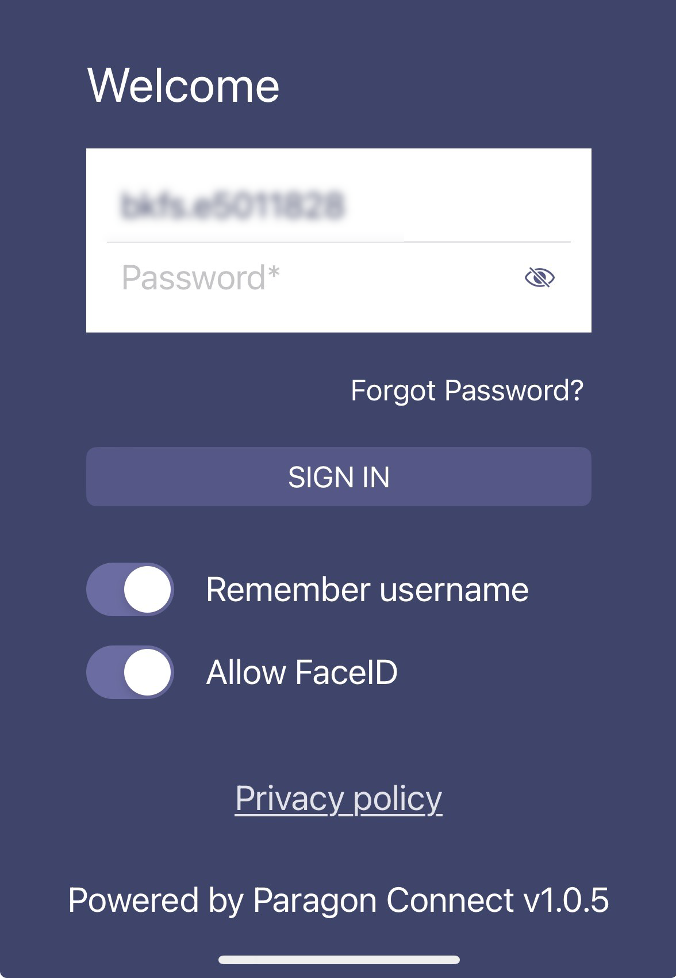
Agent Mobile App now includes Forgot Password and External SSO
Action Item: Contact SSM for mobile app login options
For customers using the Paragon Connect Agent Mobile App, the native built-in login page now supports the Forgot Password feature. This feature allows users the ability to request a password change directly from the app. This option can be supported even if external SSO is enabled for the web-based Paragon and Paragon Connect sites.
The mobile app also supports the ability to frame in an External SSO page in place of the native login page. Biometrics and remember-me features are not supported at this time.

Paragon Professional

Paragon Professional Improvements
- Removal of the optional CMA document called “Where to Dollars Go” to be in alignment with NAR regulations

Paragon Connect

Paragon Connect Corrections and Improvements
- Improvement to include the “All” option for Status Lookups
- Improvement to include access to EasyCMA from Contacts; ability to see CMAs assigned to the Contact and ability to start a new CMA
- Improvement to display and manage any Agent/Office/System Links under Resources > Website Links (available in Paragon Pro under Resources > My Links)
- Improvement to hide Field Labels on the Detail View if access to the Field Values is restricted
- Improvement to Restb.ai generated labels to include spacing between words

New Dashboard Layout and Search
The Paragon Connect Dashboard has been updated based upon essential user feedback. There are several dashboard changes included in this release.

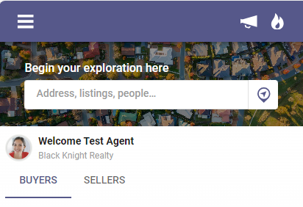
First, the top bar options have been streamlined, moving out “Near Me” and “Powersearch”, and keeping “System Messages” and “Hotsheet Alerts”.

Second, a new Search Bar option is prominently displayed at the top of the page. This new Search Bar provides a simplified, single starting point for quickly initiating a search.

On the bar you have two starting options, click the Map Icon to instantly start a Near Me search or click into the Search Box to start searching by address, Listing ID, etc.

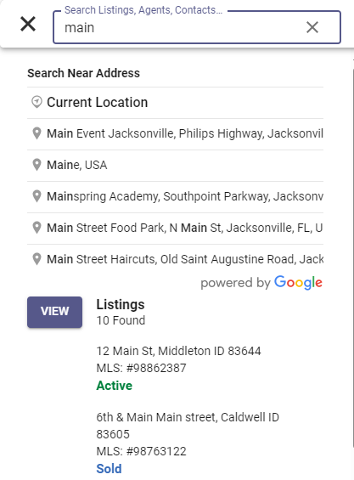
The Search Box option now combines the power of a Google Address search and PowerSearch.

Once you type into the Search Box the top set of results will display any Address or Locations matching the entered text. Selecting any of the returned options will launch you to a map search near that address/location. From the map you can continue to refine your search.

Below the Address options, any standard PowerSearch results including specific listings, contacts, users, and saved searches will be displayed. Selecting any of these PowerSearch results will open the selected options.

