
08

08
Fall

Fall

Paragon 8.1 Release Enhancements

18 July 2024

1. Corrected Paragon Issues 2
2. MLS Customizations and Administration 3
2.1. Remarks in ConnectView 3
2.2. Cleanup of Contact Matched Listings Data 3
3. Paragon Connect 4
3.1. Paragon Connect Corrections and Improvements 4
3.2. Unlimited Results 4
3.3. Zero Result Filter 5

Corrected Paragon Issues
Ticket# | Module | Organization | Summary
TK-19118 | WebAPI | BORMLS - St Augustine & St Johns County MLS | OPENMLS/INTERNET TRACKING: Multiple RESO Fields in InternetTracking are Not Declared as Lookups
TK-19075 | Membership/Roster | CAPEMAY - Cape May County BOR | Cape May: Agent and Membership Roster giving "Error" with or without search criteria
TK-18972 | LIM | NWBORMLS - Northwest Wyoming Board of REALTORS | NWBORMLS PC LIM - Unable to save a listing after editing
TK-18765 | View/Reports | PRIMEMLS - Prime MLS (NEREN) | Round 2 - Apostrophe in street address Breaks the 'Driving Direction' Feature
TK-18596 | CMA | REALCOMP - Realcomp II Ltd | Realcomp - EasyCMA Printed Comparable Report missing photos
TK-18499 | Print | SDMLS - San Diego MLS | SDMLS - Agent Preferred 1 Print Error
TK-16722 | Admin | WYO - Wyoming MLS | WYO (Casper) Billing Administration

MLS Customizations and Administration

Remarks in ConnectView
Action Item: Change preferred field value in P5 > Admin > Classes
The ConnectView, listing detail report, has been updated to allow system-level customization of the highlighted Remarks field.
The Class table and Paragon Administration have been updated to include a new remarks customization option for the Paragon Connect view. This new feature allows administrators to select which remarks field appears in the top section of the listing detail report within Paragon Connect, enabling further customization of the report. All systems are currently set to use the previously defined Public Remarks field option. Administrators may modify their selection to choose the appropriate Private Remarks field instead.
Please note that each class must be updated to utilize this new feature.

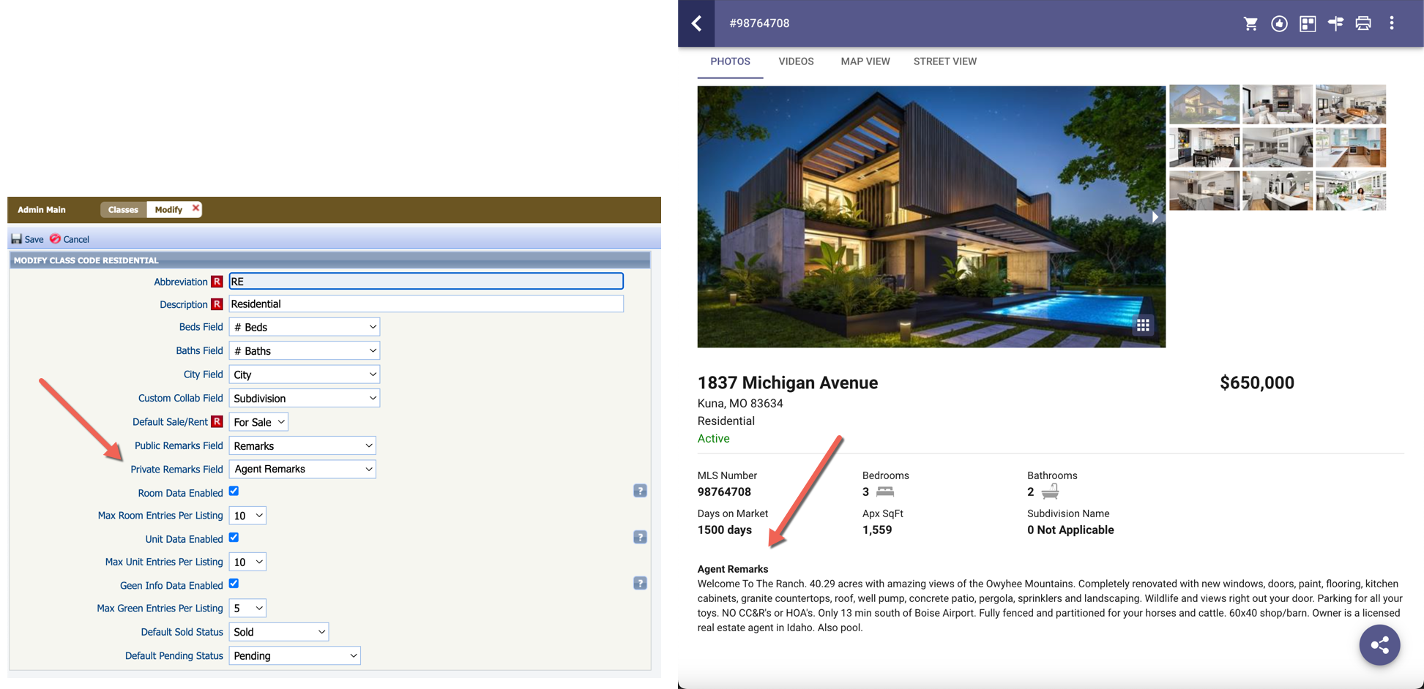

Cleanup of Contact Matched Listings Data
Action Item: No action needed
A review of the Contact Matched Listings data uncovered the presence of some outdated records. To improve performance and efficiency of the prospecting service we are cleaning up these old records This change will remove any listing previously matched that no longer meet the current criteria for any search saved to a Contact. In rare instances some Agents or Consumers may see a difference in the Matched Counts values shown in Paragon, Connect, or the CollabCenter.

Paragon Connect

Paragon Connect Corrections and Improvements
- Improvement to the Contact Comments modal to include the full contact’s name

Unlimited Results
Great news! Paragon Connect no longer requires your result count to be under 5,000 listings. In fact, there are no restrictions, allowing you to search as many listings as you want without pesky warning messages prompting you to update your criteria.

The map has seen the most significant impact. To enable searching for more than 5,000 listings, we’ve made some adjustments to how clustering works. Instead of showing you a color-based cluster with a count, you will now see red dots. These red dots indicate there are more listings in the area. As you zoom in or pan around, the map will re-search and display the listings in that specific area.
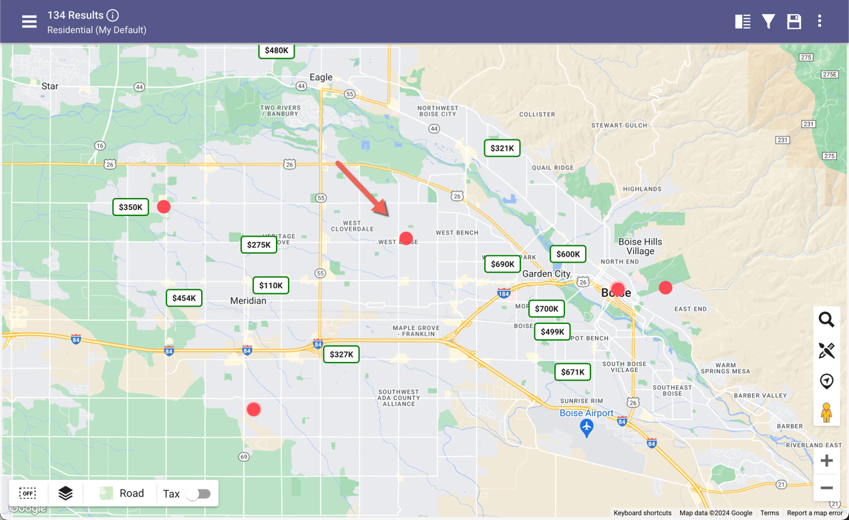
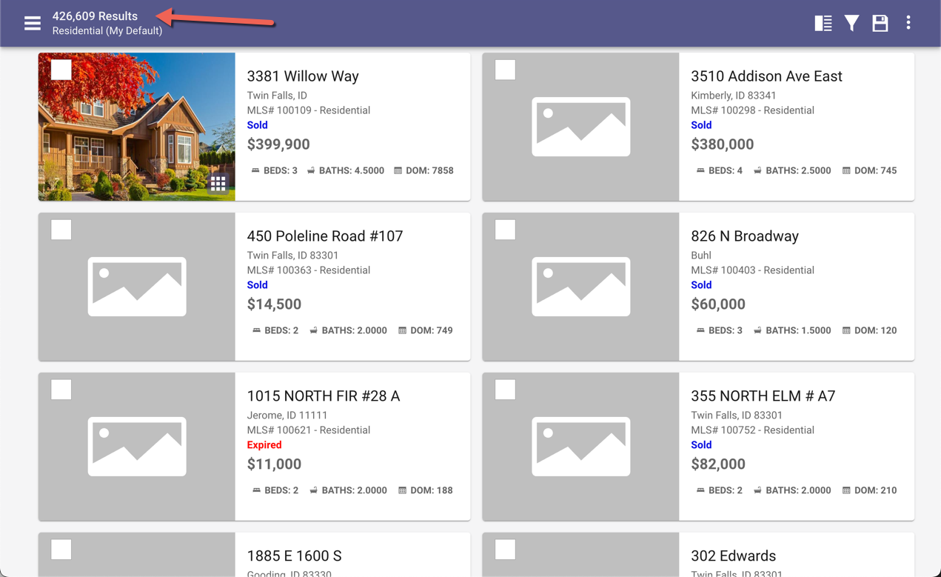
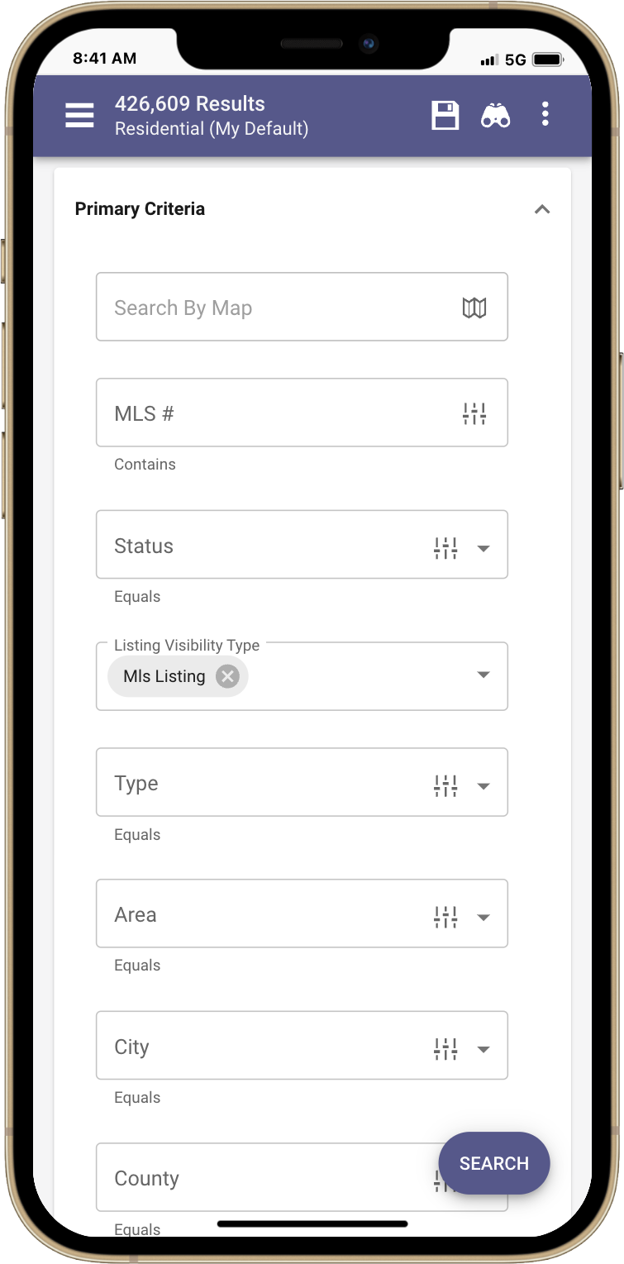

Zero Result Filter
Another great search update has been made recently, specifically impacting the map filter option. Previously, if you had zero results and tried to add criteria, you couldn't hit apply because there were no results. Now, you can modify your criteria even if it initially returns zero results, allowing you to pan and zoom on the map to locate those listings.

