
08

08
Fall

Fall

Paragon 8.3 Release Enhancements

15 August 2024

1. Corrected Paragon Issues 2
2. MLS Customizations and Administration 3
2.1. New Quick Actions – Detail View 3
3. Paragon Connect 4
3.1. Paragon Connect Corrections and Improvements 4
3.2. Updated Interface for CollabLink 4
3.3. New Listing Maintenance Spreadsheet View 5
3.4. Update to Agent Roster Card 5
3.5. New Quick Actions View – Listing Maintenance 6
3.6. Printing Performance 6

Corrected Paragon Issues
Ticket# | Module | Organization | Summary
TK-19662 | Assume Identity | PRIMEMLS - Prime MLS (NEREN) | PC - Assume Identity: Return to Account Issues
TK-19622 | View/Reports | RASE - REALTOR Assoc of the Sioux Empire | Connect report showing the incorrect value for Lot Size (SqFt)
TK-18717 | Search | NTREIS - North Texas REIS | NTREIS - Parcel ID Results will not display when searched

MLS Customizations and Administration

New Quick Actions – Detail View
Action Item: Work with SSM to identify Third-Party Integrations to highlight via Detail Quick Actions

We heard through user-feedback that some third-party integrations are more essential than others and agents need an easier way to access these options. To help solve this pain point, we are excited to introduce a new Quick Actions feature to our detail report.

A new section can appear on your ConnectView that will display up to 5 of your most essential third-party integrations. When enabled, using a new Third-Party Integration setup option, links to these frequented integrations appear near the top of the detail view with the same seamless functionality they currently use from the menu.

You must notify your SSM of any integration you want to promote on your ConnectView within the new Detail Quick Actions section. You may choose to highlight 1, or up to 5.

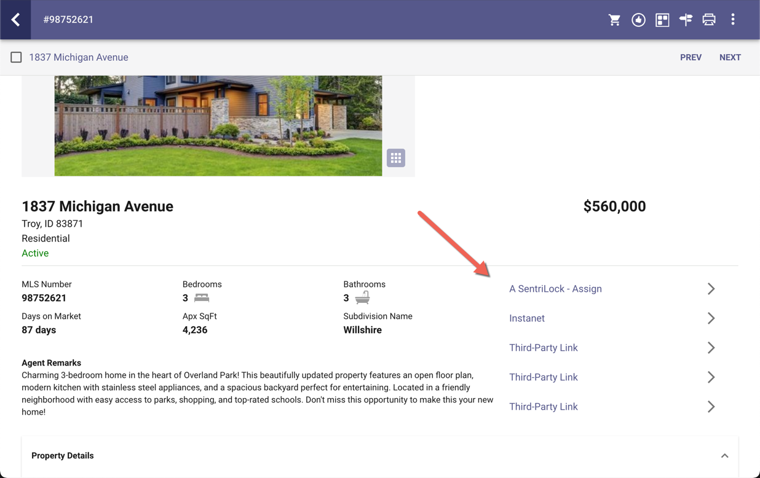

Paragon Connect

Paragon Connect Corrections and Improvements
- Improvement to change the “Half Bath” label in EasyCMA to use the RESO label “Partial Bath”
- Correction for intermittent error when returning to Account after assuming identity

Updated Interface for CollabLink
CollabLink is getting a stunning makeover! All the features you love are still there—now faster, more responsive, and more intuitive than ever.
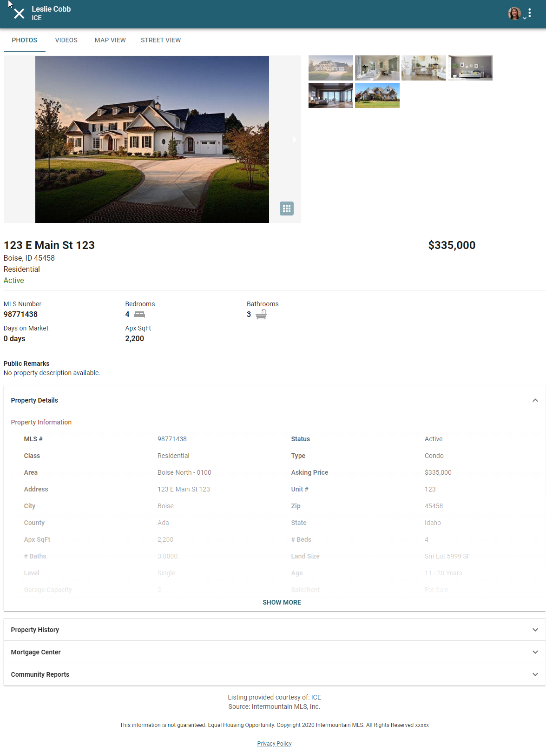
Sending just one listing? Now clients are instantly directed to the detailed report. Mobile users, get ready to experience a seamless, new UI and workflow that’s designed just for you!"

What is Collablink? The CollabLink is the website where your clients are taken when you email them links to listings from Paragon Professional or Paragon Connect.

The new CollabLink displays the same listing data in an updated format. All existing CollabLinks will automatically be redirected to the new layout, no settings or workflow changes needed.

New Listing Maintenance Spreadsheet View
Introducing the new Spreadsheet View in Paragon Connect's Listing Maintenance module. Designed to elevate your experience, this feature allows you to effortlessly view more listings and comprehensive listing data than ever before. Whether you're on your desktop, tablet, or smartphone, this dynamic view is accessible to all users across all devices.
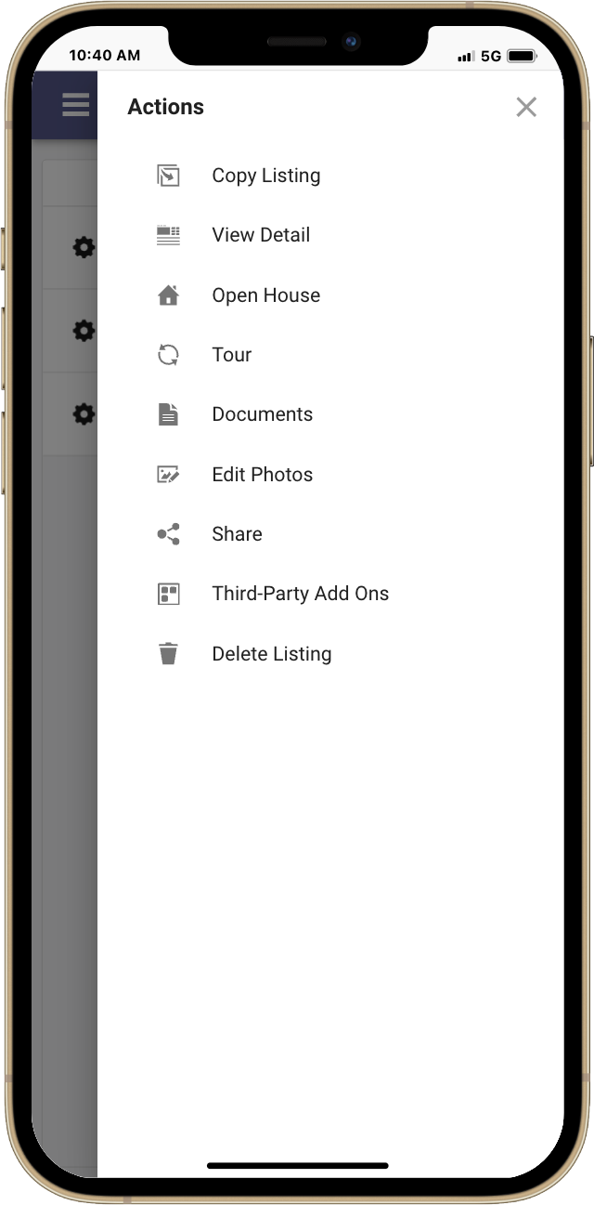
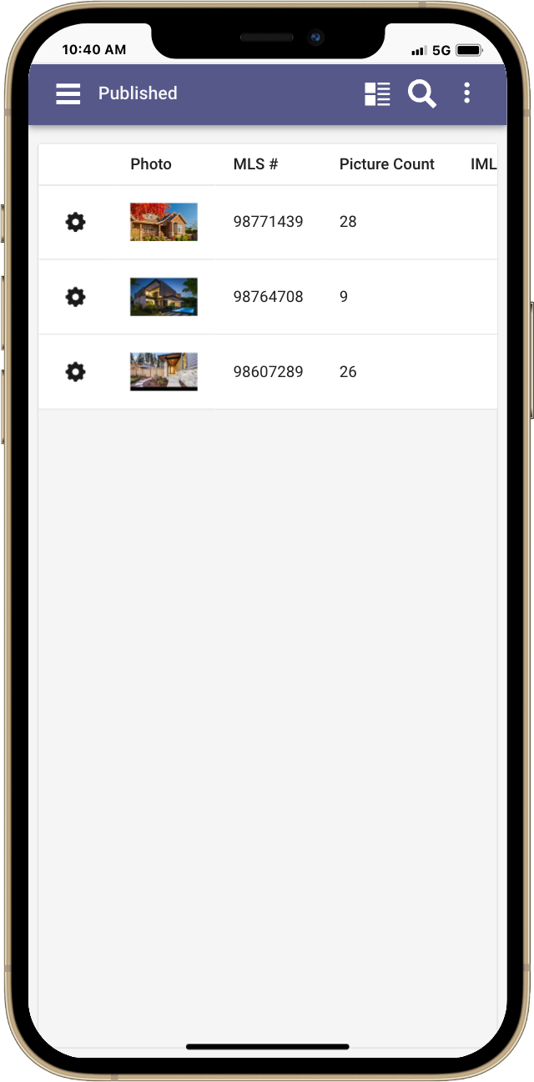
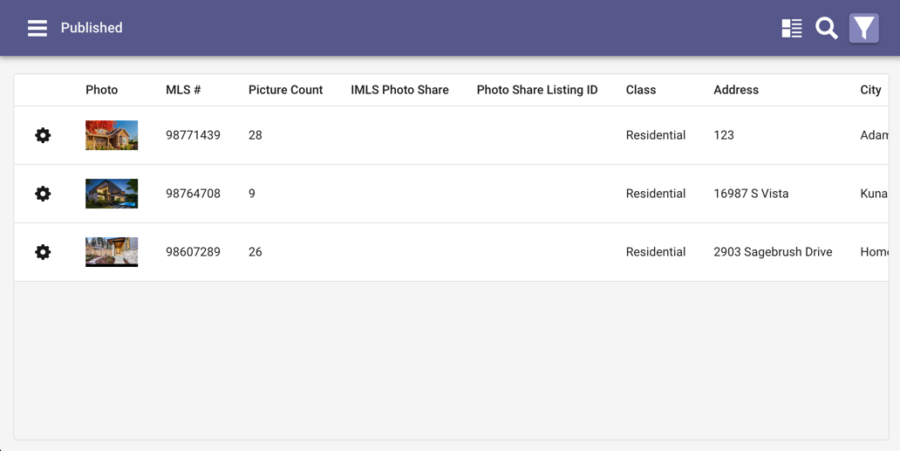
Easily switch to the Spreadsheet View with a simple click or tap on the toggle in the app bar. Enjoy the convenience of sortable columns and click on any photo to enter edit mode instantly. Plus, streamline your workflow with quick actions at your fingertips, thanks to the intuitive gear icon on each listing. Enhance your productivity with this smart, efficient way to manage your listings.

Update to Agent Roster Card
We've refined the agent and office card to deliver a cleaner, more streamlined experience! Now, only the most relevant details are displayed, with any empty fields automatically hidden. This update not only saves valuable space but also makes the information easier to read, so you can focus on what matters most without unnecessary clutter. It's a smarter, more efficient way to access the details you need.
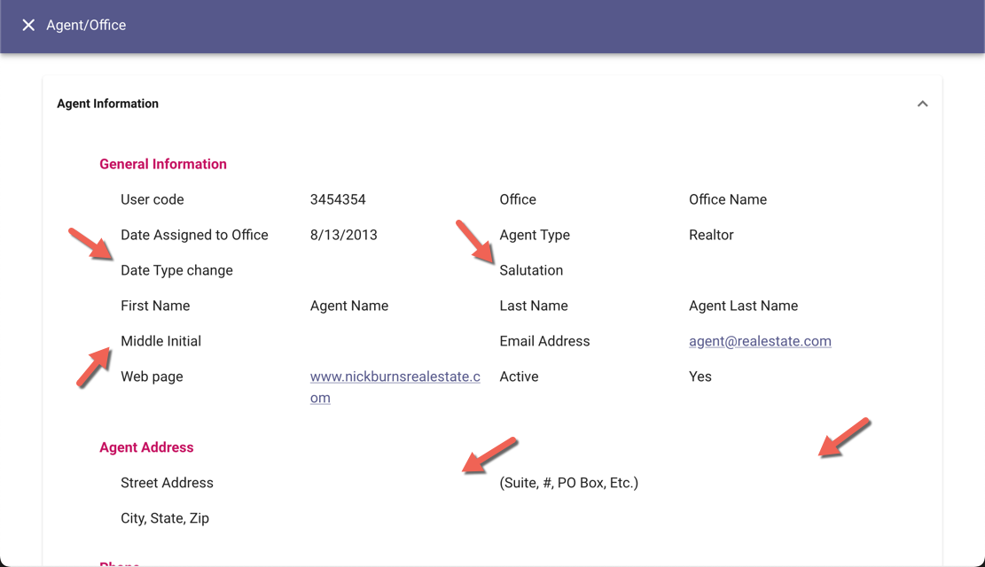
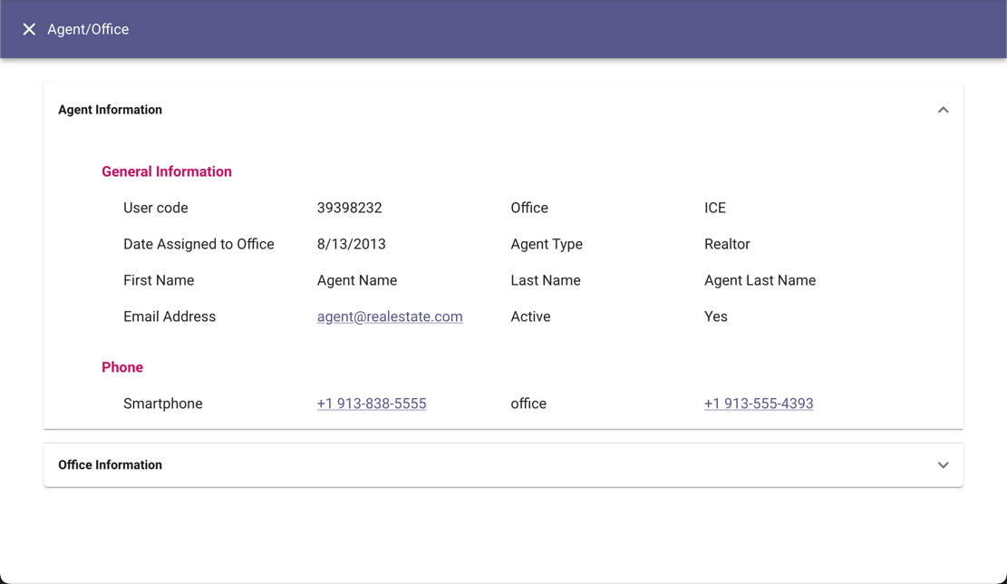
Before After

New Quick Actions View – Listing Maintenance
We're excited to announce an enhanced way to manage your growing list of quick actions in the Listing Maintenance module! As our features expand, we've reimagined the overflow icon on each listing thumbnail to better serve your needs. Now, when you tap the overflow icon, a sleek side sheet slides open, giving you quick, easy access to all your actions with plenty of room for future enhancements. This streamlined approach ensures you can handle your tasks efficiently, with everything you need just a click away.

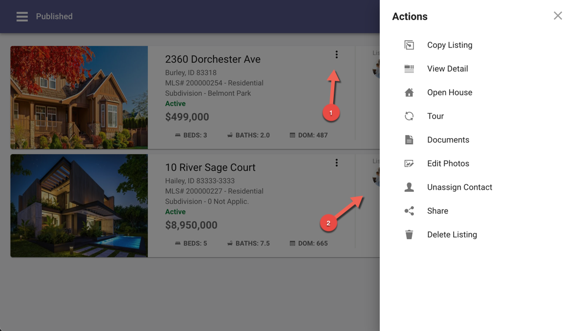

Printing Performance
We've made significant enhancements under the hood to supercharge the speed and performance of printing your ConnectView report. Our latest tests reveal that printing is now a remarkable 52% faster, delivering results in record time and boosting your efficiency like never before.
