08

08

**Fall**

**Fall**

Paragon 8.4 Release Enhancements

29 August 2024

1. Corrected Paragon Issues 2

2. MLS Customizations and Administration 3

2.1. Upcoming changes for RETS Restrictions 3

2.2. Upcoming Redesign for Collaboration Center 3

3. Paragon Connect 4

3.1. Paragon Connect Corrections and Improvements 4

3.2. New Recommend with Comments 4

# Corrected Paragon Issues

|  |  |  |  |
| --- | --- | --- | --- |
| Ticket# | Module | Organization | Summary |
|  |  |  |  |
| TK-19433 | Third Party | MLSBOX - Greater Baton Rouge AOR | MLSBOX: Showing Time Multiple Listing Link Error in Paragon Connect |
| TK-18596 | CMA | REALCOMP - Realcomp II Ltd | Realcomp - EasyCMA Printed Comparable Report Missing Photos |
|  |  |  |  |
|  |  |  |  |
|  |  |  |  |
|  |  |  |  |
|  |  |  |  |
|  |  |  |  |
|  |  |  |  |
|  |  |  |  |
|  |  |  |  |
|  |  |  |  |

# MLS Customizations and Administration

## Upcoming changes for RETS Restrictions

**Action Item:** No Action

We are working to modify the RETS restriction options for photo access. With this release you will see a new option in the administration section of RETS within Paragon called: GetObject Media Permission Access.

**This new option is not yet functional but will be supported in the next release.**

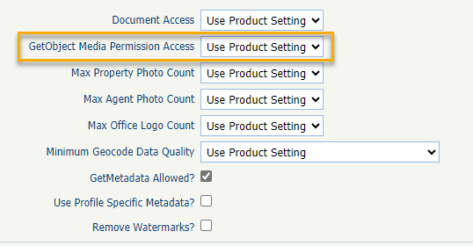The new restriction will offer options for restricting getobject photo access using a new Permission value where photo records can be defined as Public vs Private. Additional details regarding this new feature will be included in the next release notes.

## Upcoming Redesign for Collaboration Center

**Action Item:** No Action

A new version of the Collaboration Center is coming in September.

The Collab Center is getting a fresh redesign using a fully mobile-responsive layout and updated backend to match Paragon Connect.

All the same features consumers have come to love will remain, but with a new look and feel. Educational and marketing materials will be sent via email and in-app notifications will appear within Paragon Professional and the current CollabCenter giving agents and consumers a preview of the coming changes.

# Paragon Connect

## Paragon Connect Corrections and Improvements

* Improvement to display the ShowingTime widget on Seller Reports if enabled
* Correction to hide additional empty fields on the Roster Card view

## New Recommend with Comments

Elevate your client experience! Now, when you recommend listings, you can add personalized comments to highlight exactly why each property is a perfect match. The comment appears along with the listing in the Collaboration Center. Keep your clients informed and engaged with every recommendation you send their way!

