
08

08
Fall

Fall

Paragon 8.5 Release Enhancements

12 September 2024

1. Corrected Paragon Issues 2
2. MLS Customizations and Administration 3
2.1. Redesigned Collaboration Center 3
2.2. Admin Support for Private Photos 4
3. Paragon Features 5
3.1. Paragon Corrections and Improvements 5
3.2. New Private Photos – Paragon Connect & Paragon Pro 5
3.3. The all-new Collaboration Center 6
3.4. New Theme Colors 7
3.5. Multiple Parcel - Detail View 10
3.6. Texting from Desktop 11
3.7. Updates to managing Agent Recommended listings 12

Corrected Paragon Issues
Ticket# | Module | Organization | Summary
TK-20088 | LIM | MAXEBRDI - MAXEBRDI MLS | PC LIM - Ownership for Firm level timing out
TK-20232 | LIM | BCRES - REB2 Residential | PC LIM does not follow Field Rules targeting Status and Agent Type
TK-19828 | Admin |  | Login agreements that are not yet launched cannot be edited in anyway
TK-20214 | Data |  | PC/CCR - Facebook share > no listing data displays in FB post
TK-12763, TK-19979 | WebAPI | OBARMLS - Outer Banks AOR, PRIMEMLS - Prime MLS (NEREN), SCWMLS - South Central Wisconsin (Madison) | OpenMLS: Error 500 When a Field in a Disabled Class is Used in $select Statement
DEV-14281 | Print | PRIMEMLS - Prime MLS (NEREN) | PC > Printing from the listing detail page opens multiple tabs
DEV-14119 | Assume Identity | PRIMEMLS - Prime MLS (NEREN) | Chrome > PC> Assume Identity> Name is not highlighted when selected
DEV-14121 | Assume Identity | PRIMEMLS - Prime MLS (NEREN) | PC> Assume Identity> Agent type field is blank for all users
DEV-14249 | LIM | PRIMEMLS - Prime MLS (NEREN) | LIM Spreadsheet > Assign/Unassigned Contact is missing from Actions

MLS Customizations and Administration

Redesigned Collaboration Center
Action Item: No action needed
The new, redesigned Collaboration Center will be available to PreRelease customers with the 8.5 deployment the morning of Tuesday, September 17 and for all remaining customers the morning of Thursday, September 26.
An email sent September 5 includes marketing materials for promoting the new Collaboration Center. The new site includes a Help section with new videos demonstrating the new site features.
Please note, if any user or consumer previously bookmarked an original Collaboration Center link, it is likely that link has expired and will result in a message like the screenshot shown below. The new links do not expire! Users may open a new notification email for the Collaboration Center and bookmark the new link to have quick, uninterrupted access to their updated Collab Center site.
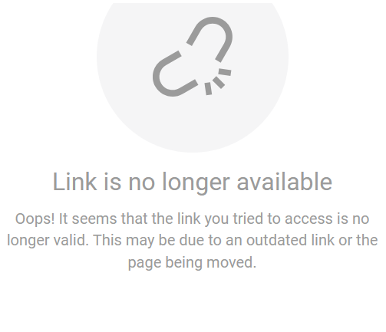

Admin Support for Private Photos
A new field has been added to the Paragon Media table called Permission. This field will allow any listing photo entries to be identified as Public or Private.
All existing listing photos will be set to Public. Users will have the option within Paragon Pro or Paragon Connect photo management to set the Permission value for any photo:
- Professional applications, like Paragon and Connect, will continue to display all photos, Public and Private.
- Consumer applications, like CollabLink and Collaboration Center, will be updated to only display Public photos.
- Export applications, like RETS and WebAPI, will be updated to provide access to the new Permission field value and allow new options to restrict photo download access to only Public photos.

Action Items:
- Request and schedule a RETS Refresh to expose the new Permission field within the Media Resource
- Review RETS Profiles if any new Private Photo restrictions should be applied
With this release the previous Max Property Photo Count restriction for RETS has been replaced with a new GetObject Media Permission Access. The previous restriction provided options to limit listing photo access by the number of photos. The new restriction includes GetObject options for limiting access to all, primary, or no photos plus a new option for restricting access to Public Only photos.
Here are the previous values and how they are set automatically with the new option:
Max Property Photo Count: None GetObject Media Permission: None
Max Property Photo Count: 1 GetObject Media Permission: Primary Only
Max Property Photo Count: 2 or greater GetObject Media Permission: All
Max Property Photo Count: All GetObject Media Permission: All

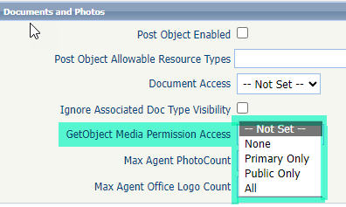
Once your RETS metadata has been refreshed to expose the new Permission field, you may choose to update any RETS Product or Profile settings to use “Public Only” to restrict GetObject functions to only return listing photos marked as public.

Paragon Features

Paragon Corrections and Improvements
- Update to Paragon Professional logo
- Improvement to rename Archive Matches to Preserved Listings to match new Collab Center
- Improvements the display of messages in the Message Center
- Correction to include Assign Contact to LIM Spreadsheet menu options
- Correction for Firm Ownership filter under Listings taking long time to load
- Corrections to use the RESO Standard label “Close Date” in EasyCMA layouts

New Private Photos – Paragon Connect & Paragon Pro
Introducing a powerful new feature: the ability to mark listing photos as private or public! Now available in both Paragon Connect and Paragon Pro, this tool gives agents full control over their listing photos. Easily mark any photo as private, ensuring it remains visible within Paragon & Paragon Connect, but hidden from all public applications, including system feeds and exports.
To set a photo as private, simply access your photo administrator, select the photos you wish to keep private, and apply the "Mark as Private" action. A clear label will indicate which photos are private, giving you peace of mind that your content is managed exactly as you want.
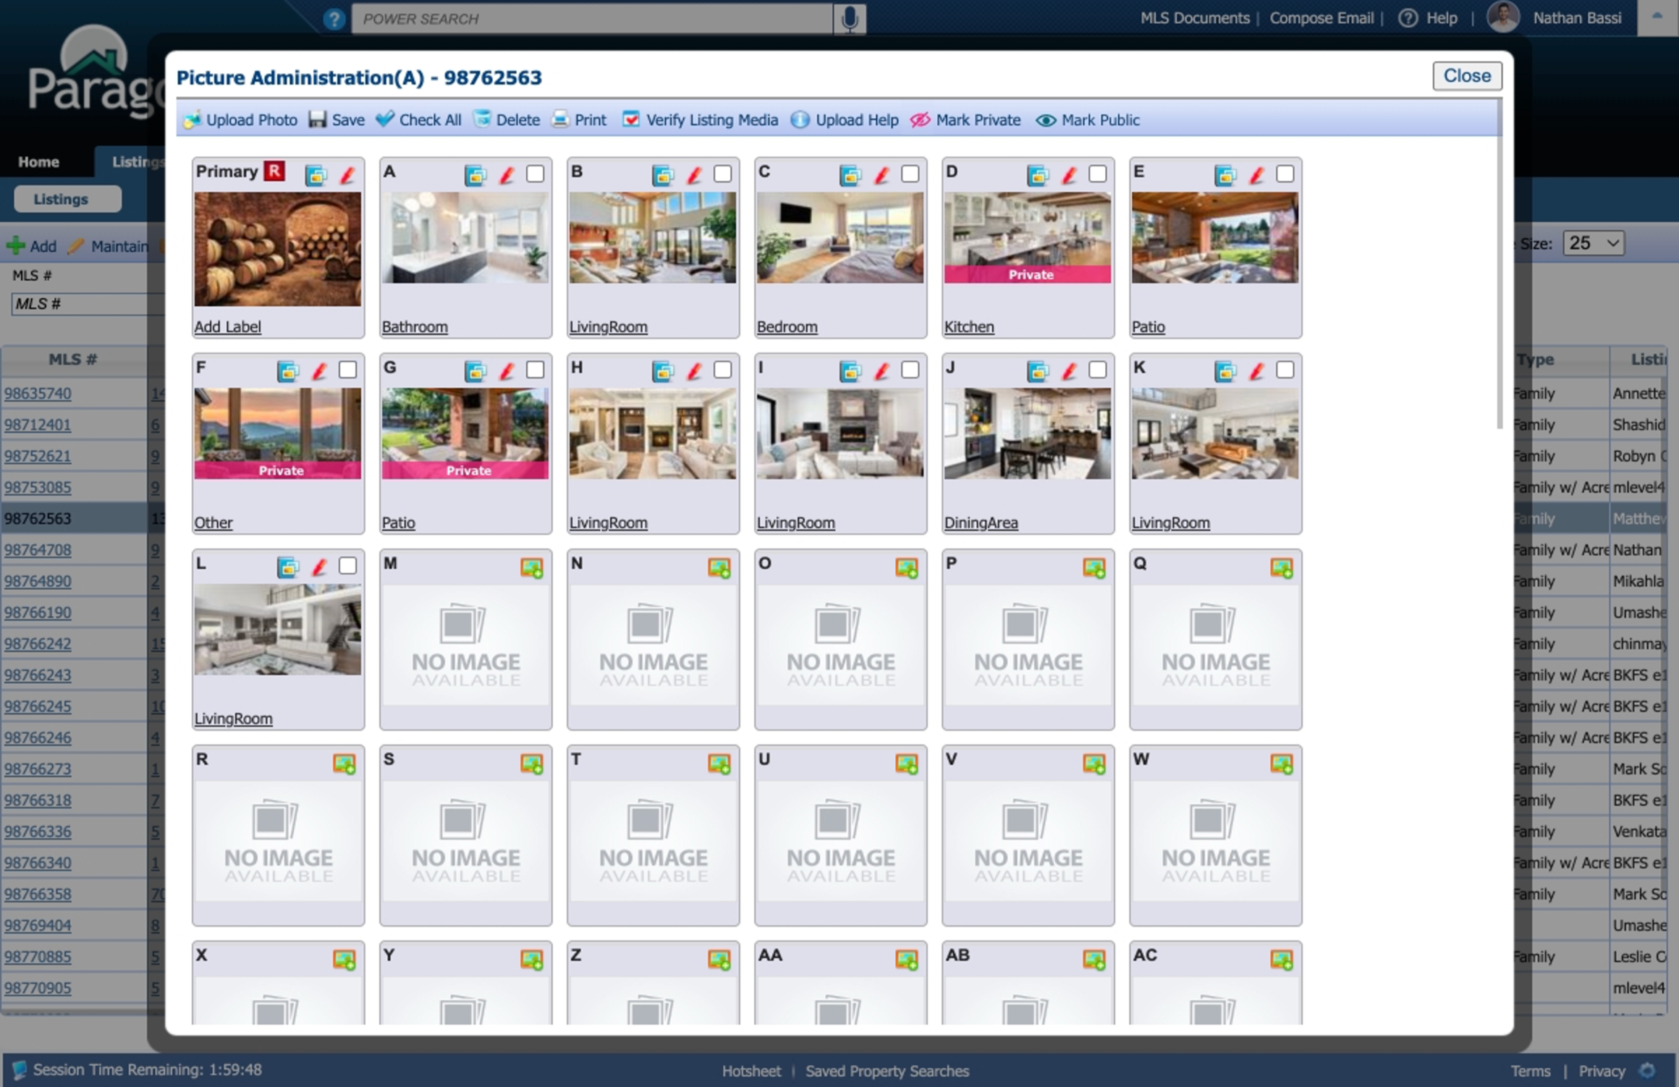
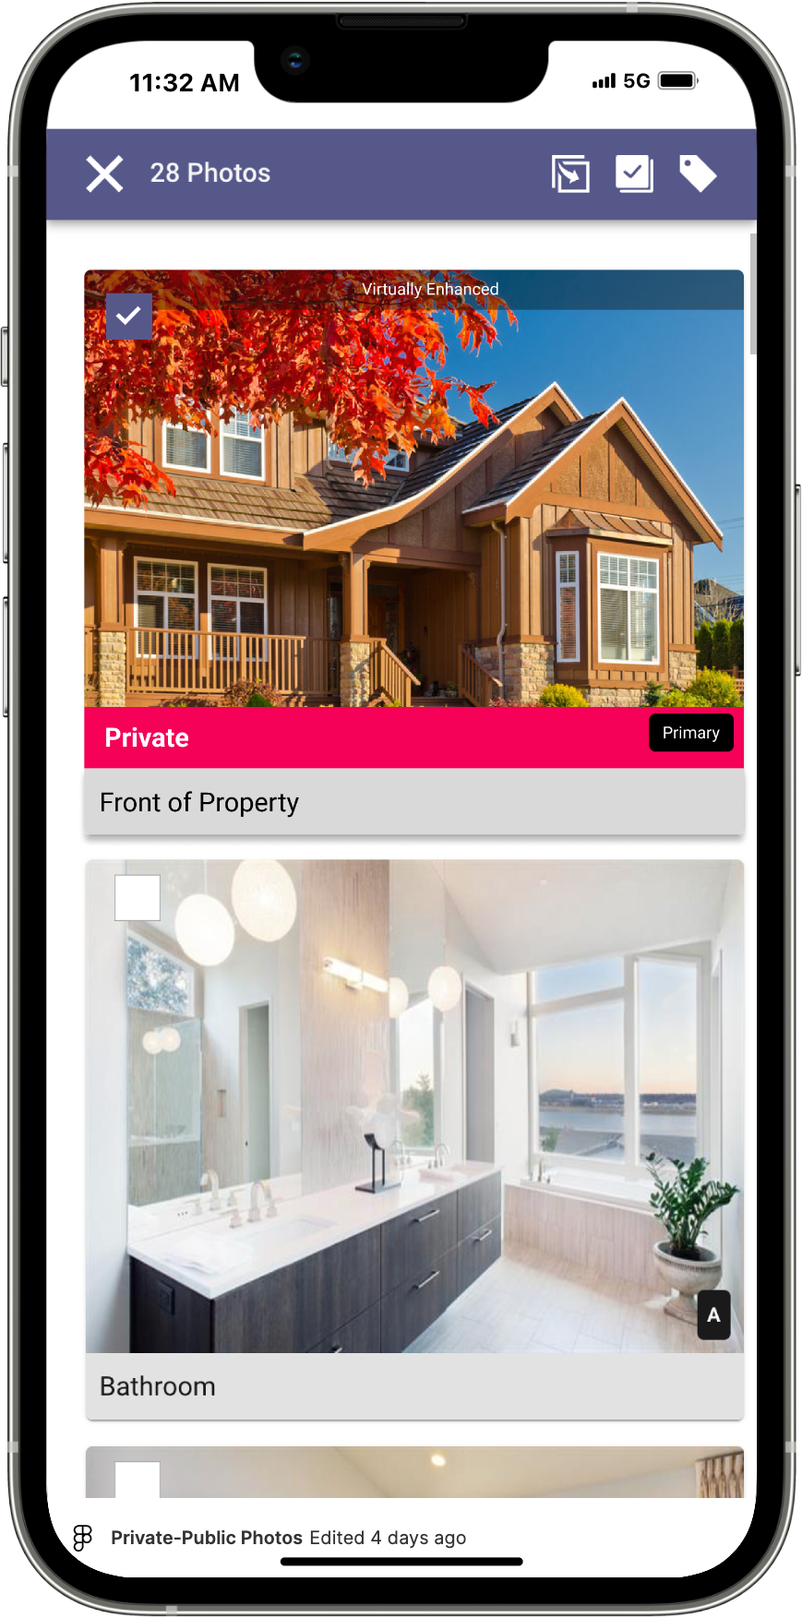

The all-new Collaboration Center
Introducing the all-new Collaboration Center—now with faster, turbocharged performance to give your clients a seamless, enhanced experience. All searches, listings, and favorites will stay the same, with no changes to the setup process or email links. This upgrade is all about making things better and faster without disrupting what works.

Some of the exciting new features include a refreshed dashboard for easy navigation, a banner address search for quicker results, and updated mapping capabilities to make finding properties a breeze. Clients can now compare up to 10 listings at once, ensuring informed decision-making. Plus, the bookmark site feature lets them easily save their favorite pages, while an improved mobile experience ensures everything looks and works perfectly, no matter what device they use. It’s a whole new level of real estate collaboration!
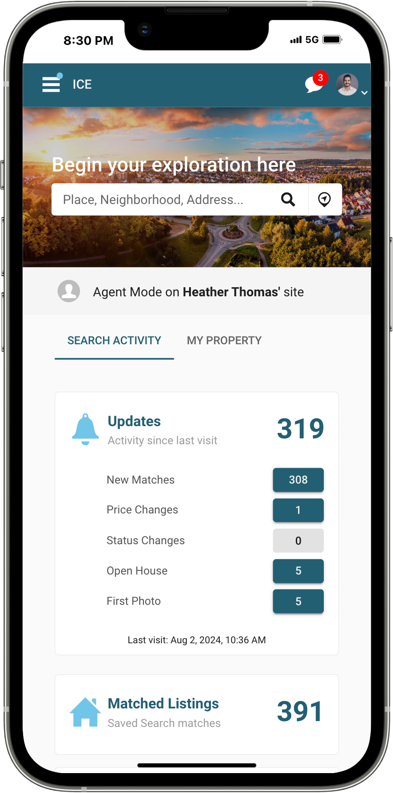
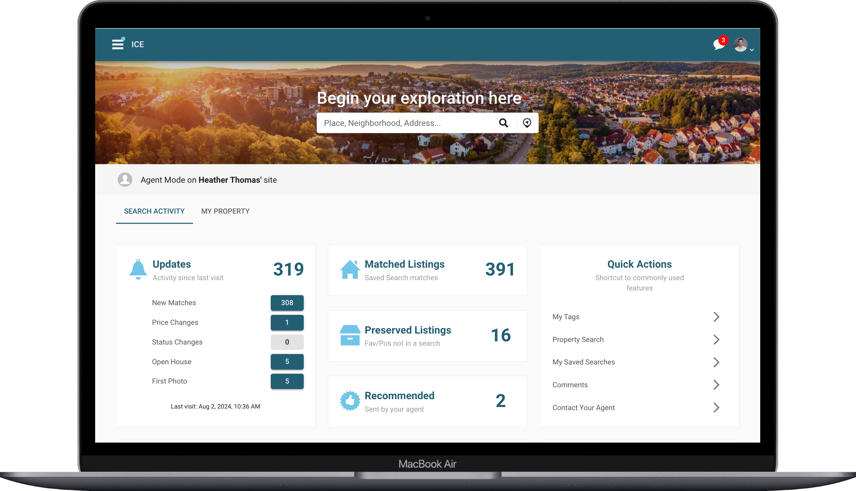

New Theme Colors
Why should Paragon Pro have all the fun? We've just added five exciting new themes to Paragon Connect! Now, you can personalize your Paragon Connect experience by updating the UI color theme directly from the system settings page. Dive in and choose your favorite from the latest theme options:

- Ice Glacier
- Galactic Force
- Sugar Blast
- Green Smash
- Blue Blaze
- Plumtastical (Current purple)

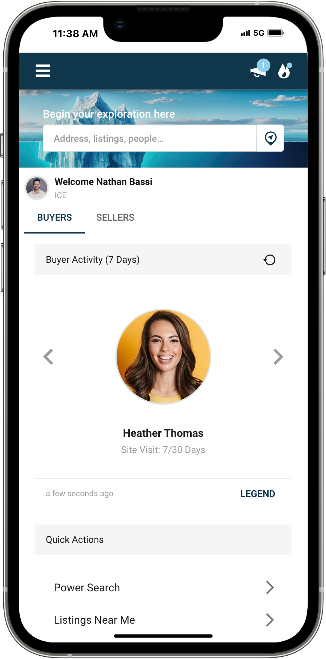

Ice Glacier
Step into the crisp elegance of the ICE Glacier theme, where corporate sophistication meets a stunning palette of light and dark ice blues.

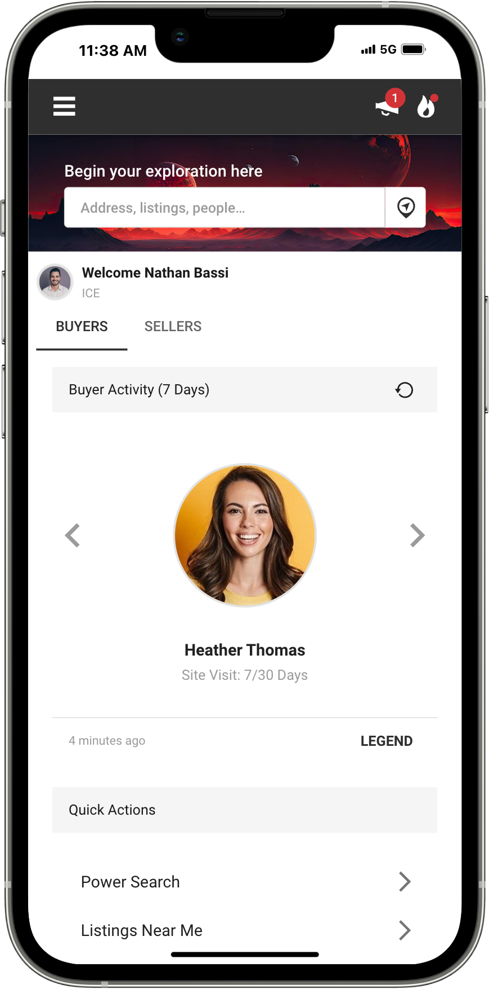

Galactic Force
Unleash the power of the Galactic Force theme, where the galaxy's enigmatic blacks and reds create a mysterious allure.

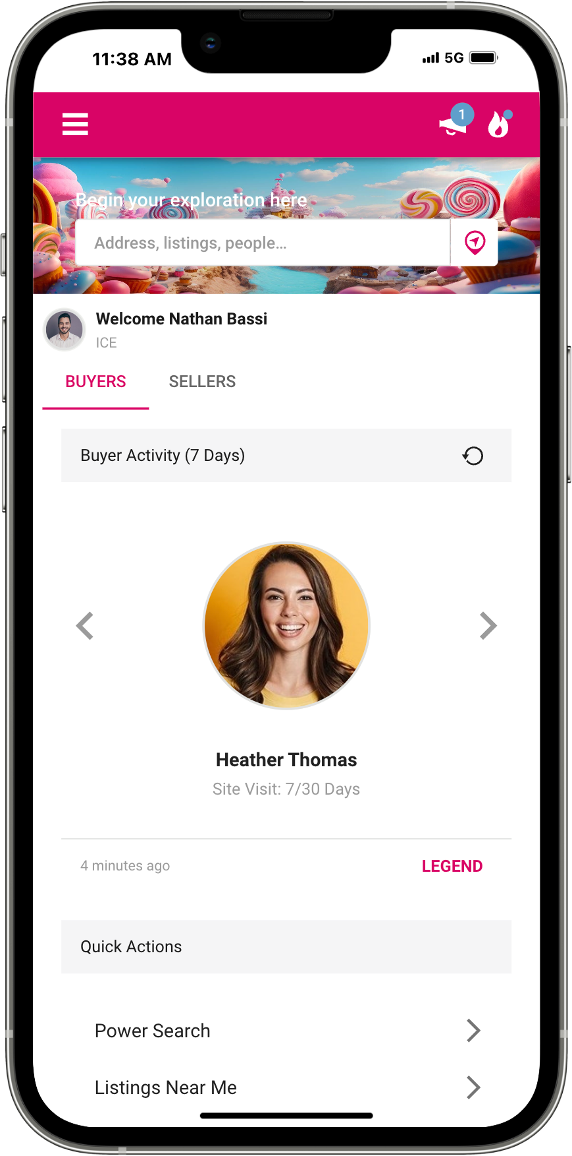

Sugar Blast
Unwrap a world of candy-coated fun with the Sugar Blast theme, where pink and blue sweet tooth dreams come true!

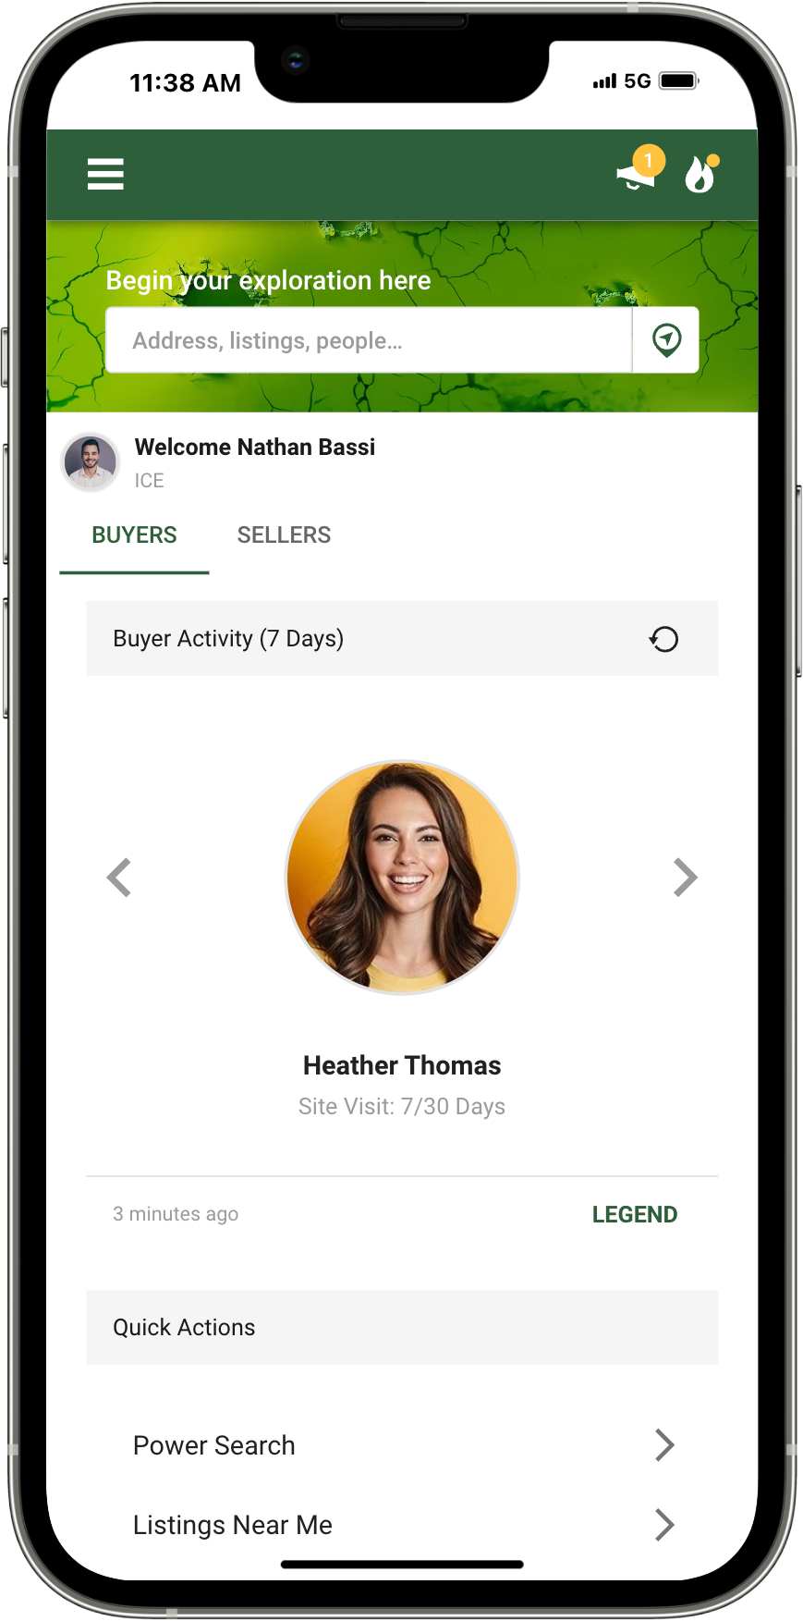

Green Smash
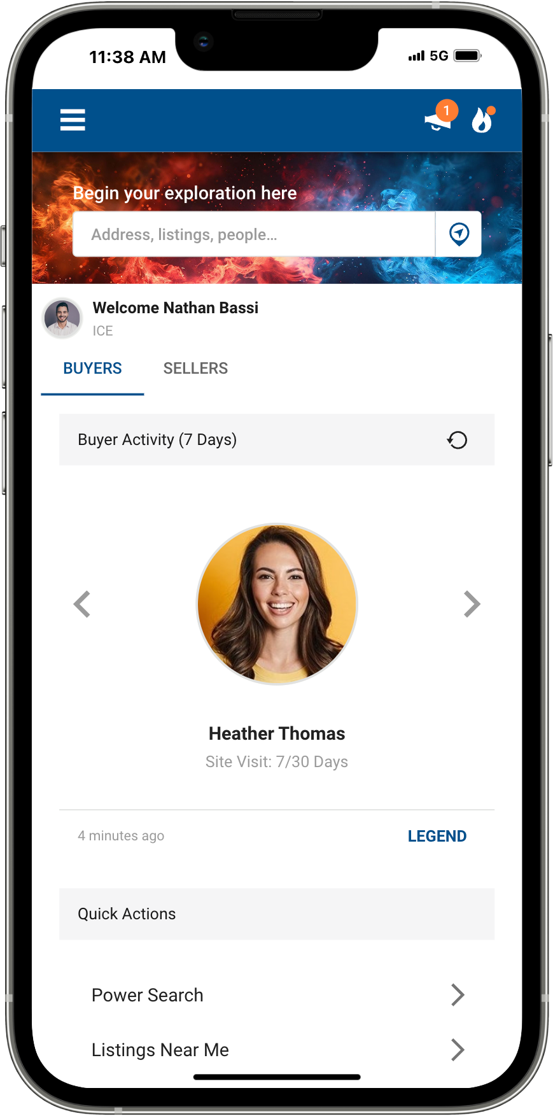
Break through the ordinary with the Green Smash theme, smashing your way through the day with electrifying greens and vibrant yellows.

Blue Blaze
Ignite your application with the Blue Blaze theme, where cool meets fiery for a strikingly dynamic look.

Multiple Parcel - Detail View
When browsing condos or multi-unit listings, it’s essential to have all the details at your fingertips. Now, when viewing the listing detail report, you’ll find that each unit’s public record data is just a click away. We’ve enhanced the public records section to display all available units, giving you the freedom to select and view the specific records you need. This update ensures you have complete access to every unit’s information, making your search more efficient and thorough.

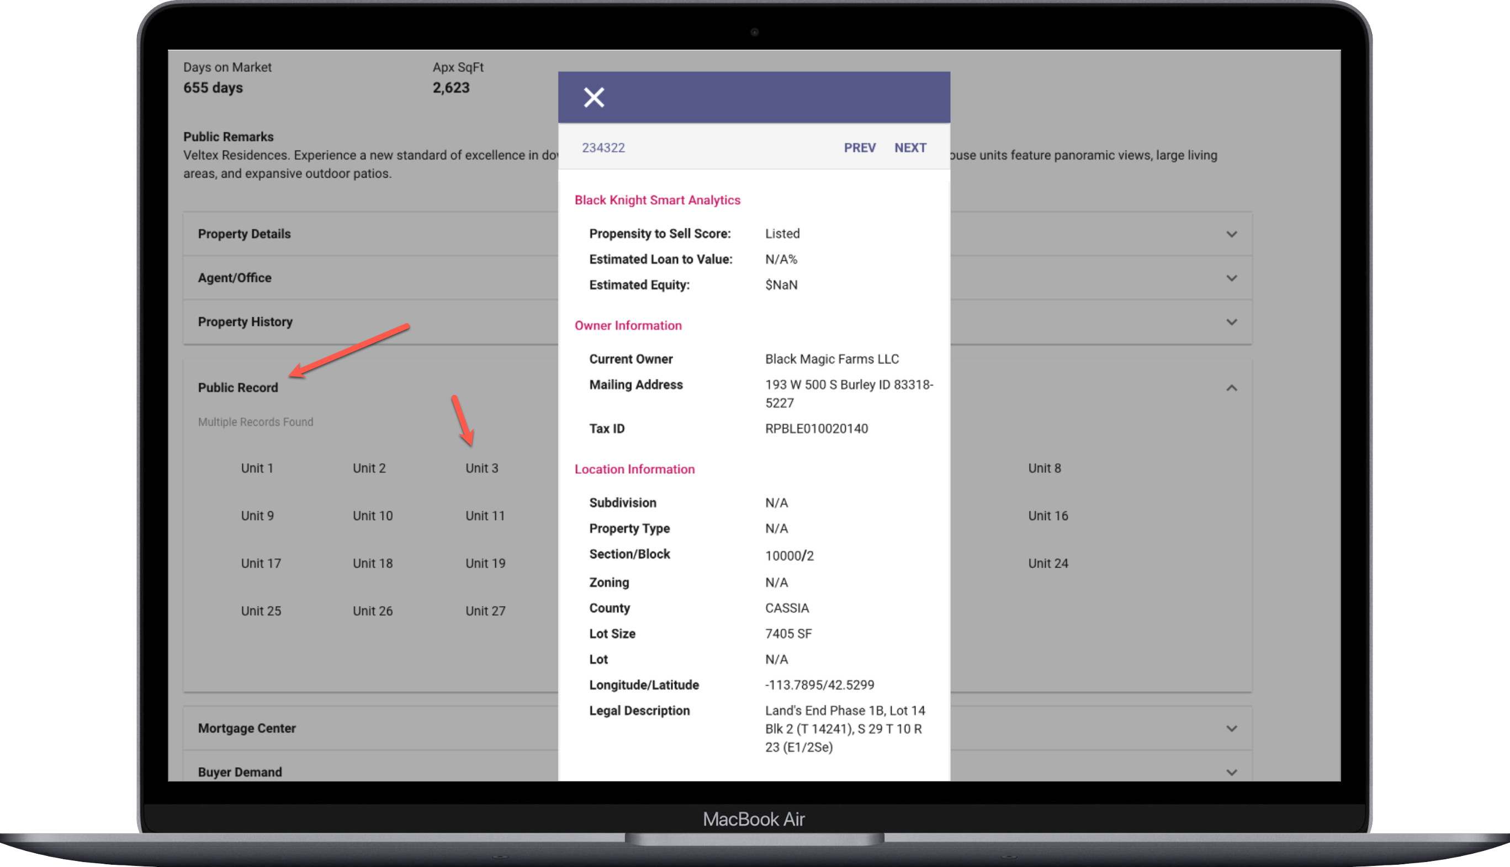

Texting from Desktop
Texting is a game-changer in our applications, and we’ve just made it even better! Previously, users could effortlessly text from any mobile or MAC device. But with this latest update, we’re taking it a step further. Now, you can send texts directly from any device, including Windows desktop machines, through Paragon Connect. Stay connected and communicate seamlessly, no matter what device you’re using!

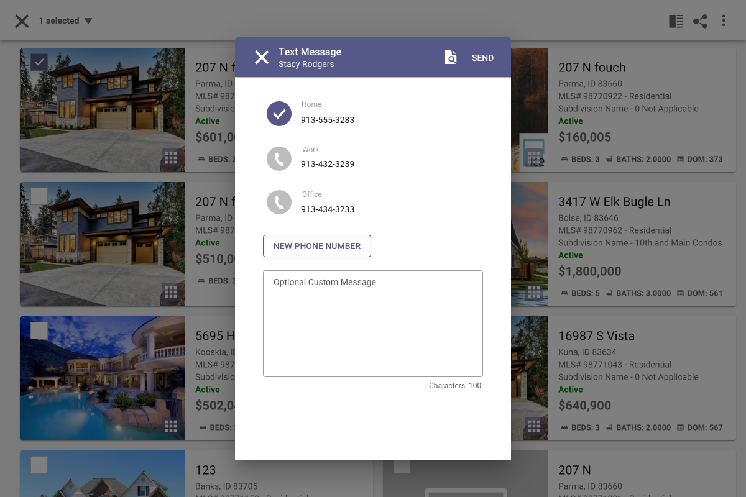

Updates to managing Agent Recommended listings
We’ve streamlined the Agent Recommended section in your Contacts' Buyer Activity! Previously, you had to navigate through the “Manage Listings” option within the Agent Recommended Listings card to add, remove, or create notes. Now, all that functionality is right at your fingertips in any of the View Results options. Managing your recommended listings has never been easier!
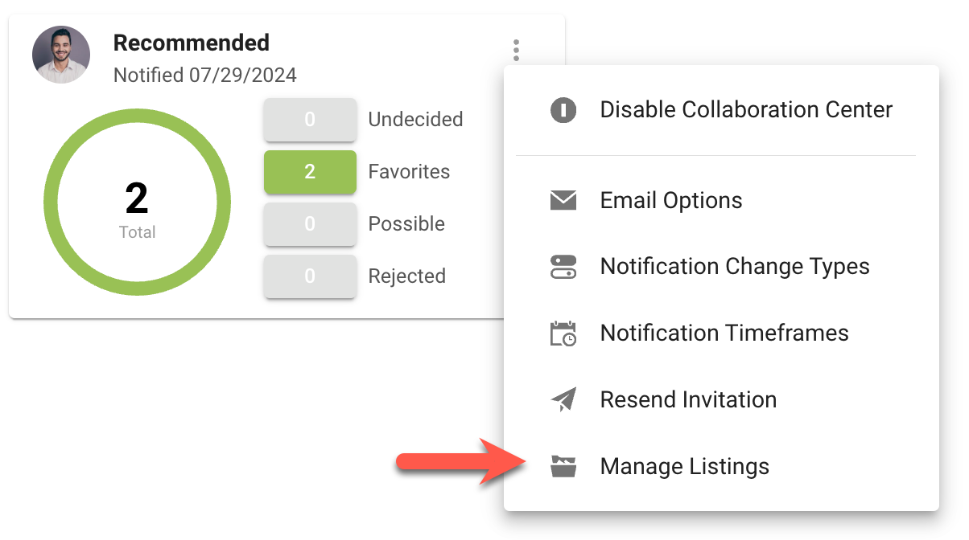

Prior to this release, you could only manage listings from the overflow.

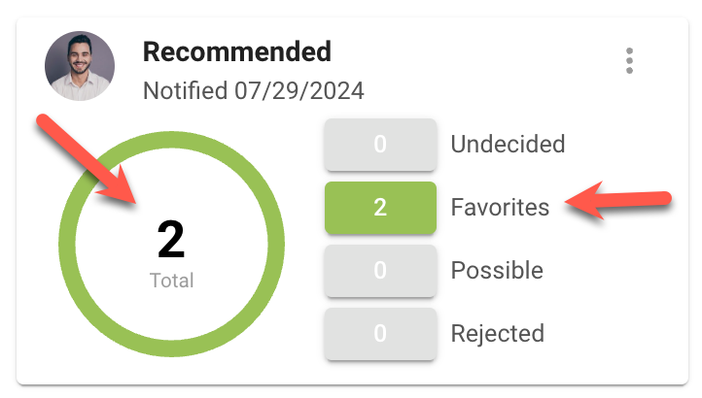
Now, you get the same manage listing options just by clicking on any of the views from the agent recommend card.

