08

08

**Fall**

**Fall**

Paragon 9.0 Release Enhancements

September 2024

1. Corrected Paragon Issues 2

2. MLS Customizations and Administration 3

2.1. Paragon Professional Menu Link from Paragon Connect 3

3. Paragon Features 4

3.1. Paragon Corrections and Improvements 4

3.2. Manually Add Listing IDs for Comparables 4

# Corrected Paragon Issues

|  |  |  |  |
| --- | --- | --- | --- |
| Ticket# | Module | Organization | Summary |
| TK-20254 | Field Rules | COLUMBIA - ConsolidatedMLS, SCWMLS - South Central Wisconsin (Madison) | PC: Field rules targeting multiple phrases in remarks field not triggering |
| TK-19502 | View/Reports | CR - California Regional MLS | Error generated when attempting to page through large result count |
| TK-20313 | Third Party | RAE - REALTOR Assoc of Edmonton | TPI Point Type=PCCalculator not honoring Public flag for CollabLink |
| TK-20385 | View/Reports | GPRMLS - Great Plains Regional MLS | Fields 507 & 508 do not display in PC detail |
| TK-20436 | View/Reports | RAE - REALTOR Assoc of Edmonton | MLS# label appearing on Collab |
| TK-20314 | LIM | TRIANGLE - Triangle MLS | CDOM is not linking after Property History is linked after creation |
|  |  |  |  |
|  |  |  |  |
|  |  |  |  |
|  |  |  |  |
|  |  |  |  |

# MLS Customizations and Administration

## Paragon Professional Menu Link from Paragon Connect

**Action Item:** Contact your SSM if you would like to enable

Administrators, you now have the option to enable a new *Paragon Professional* link in the Paragon Connect left navigation. When activated, this link allows users to seamlessly access Paragon Pro in a new browser tab, enhancing workflow and ease of navigation between the platforms. This feature is off by default, but you can configure its visibility based on users' security levels, ensuring the right access for the right roles. Customize it to fit your organization’s needs and give your users a more streamlined and efficient experience!

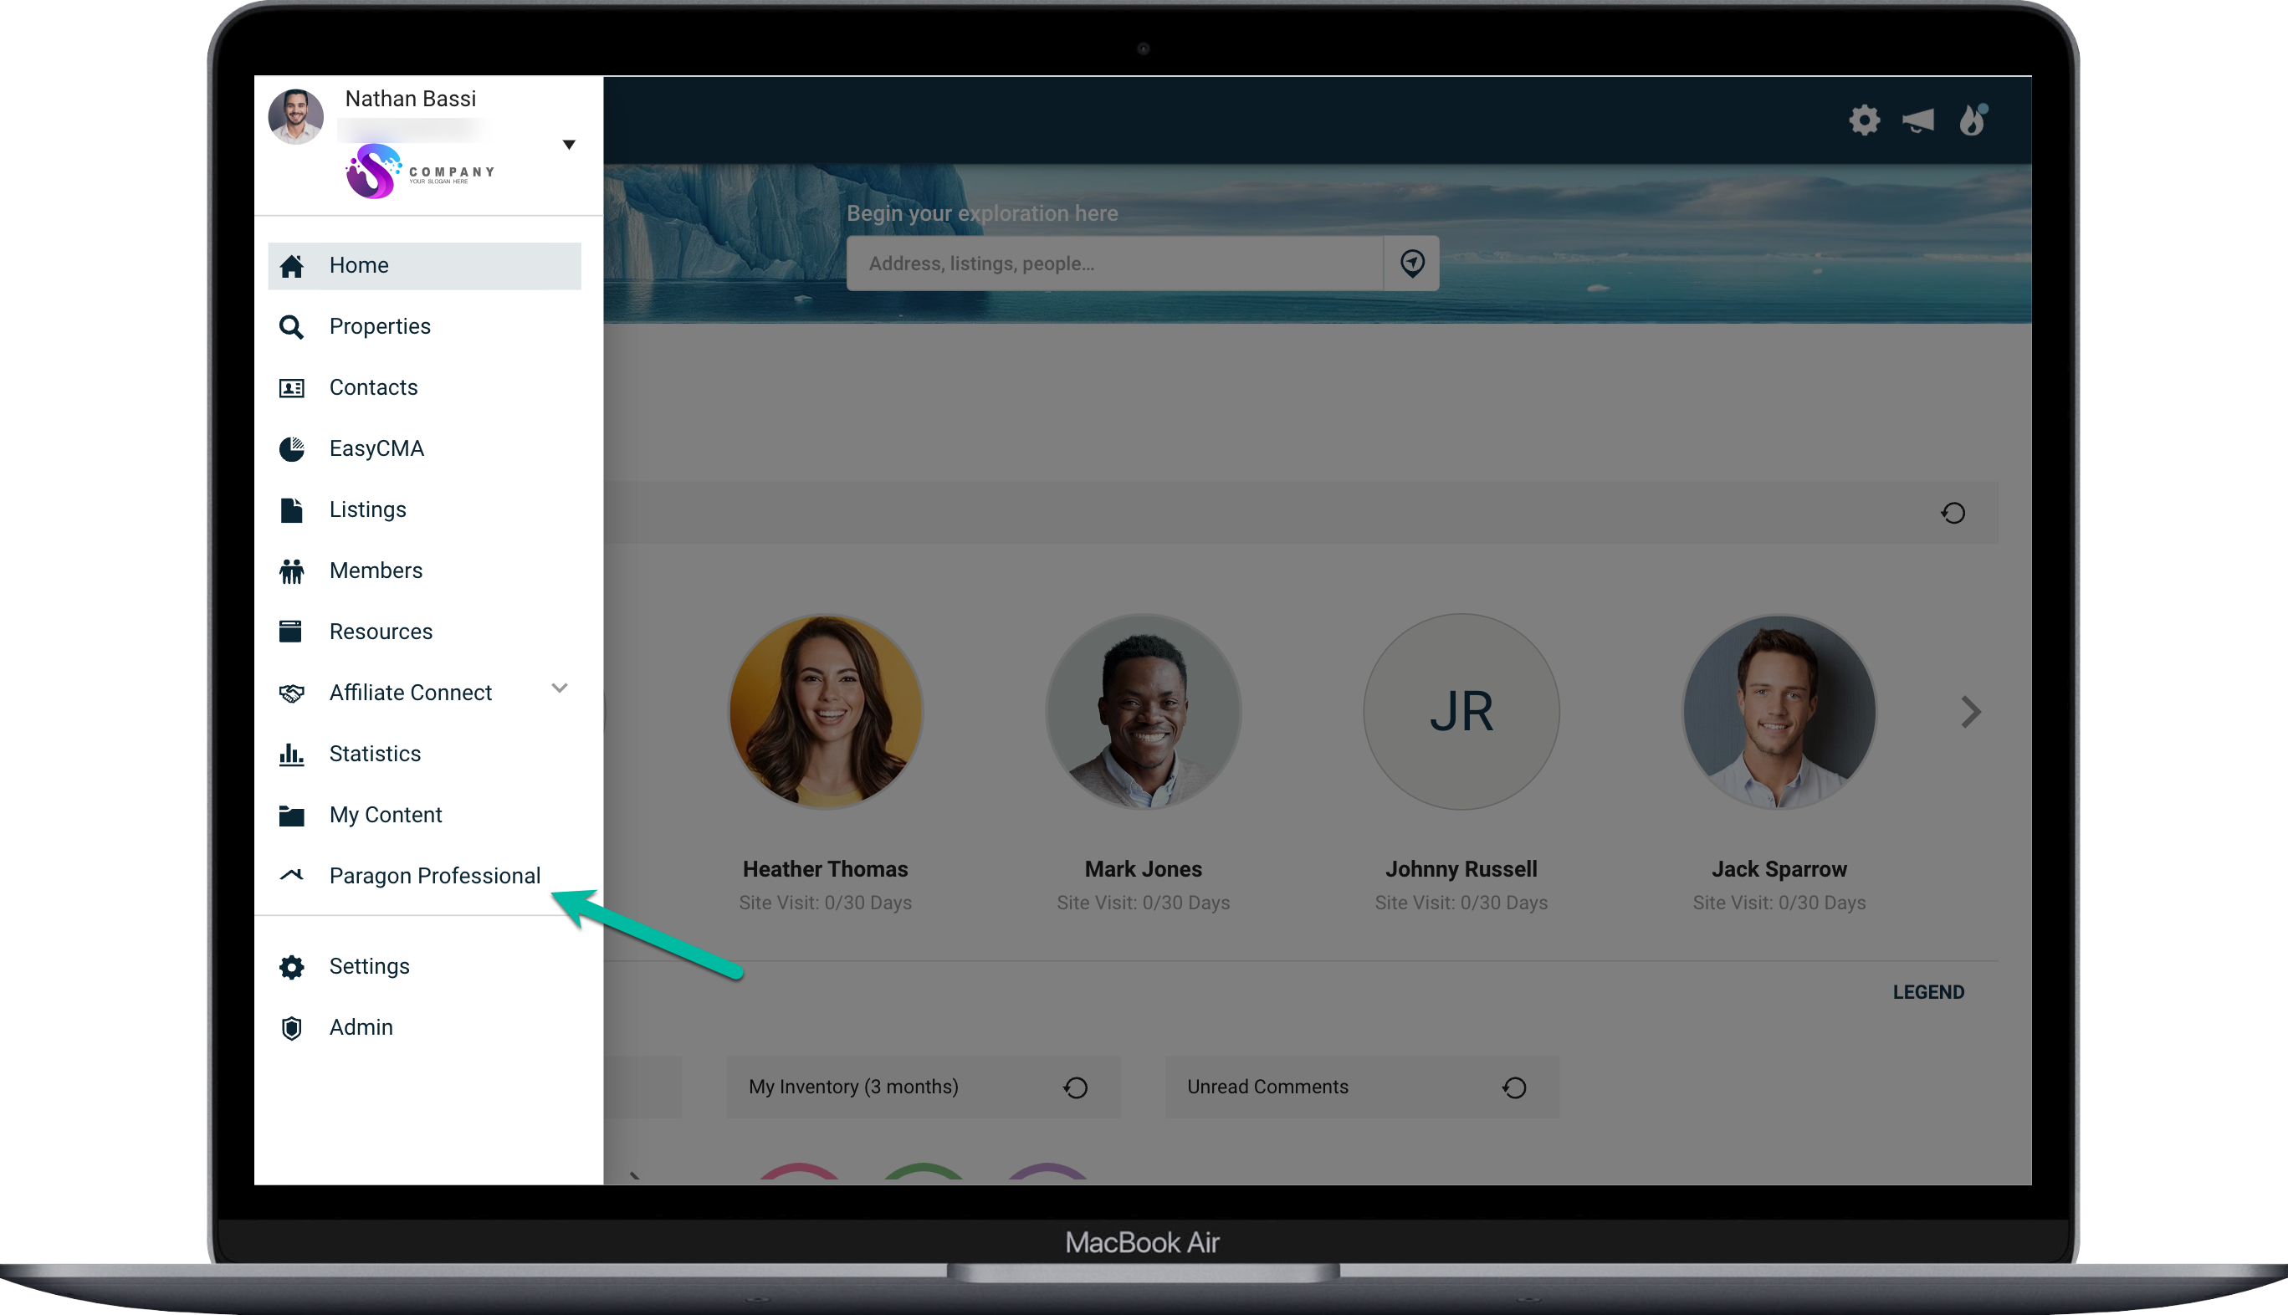

# Paragon Features

## Paragon Corrections and Improvements

* Improvement to update the Twitter icon in EasyCMA
* Improvement to replace the MLS Number label on CollabLink to use custom label
* Improvement in Paragon Pro to indicate the secondary Agent Image for CollabCenter is no longer in use
* Correction to show the native Price per Sqft fields on detail view if enabled
* Correction to make the To: field un-editable when using the Contact Agent form in CollabCenter
* Correction to PC field rules to identify the use of specific words or phrases
* Correction for intermittent issue in Paragon Pro when advancing through large sets of listing results

## Manually Add Listing IDs for Comparables

Now, while reviewing your CMA report, you can effortlessly add existing listings as comparables. Just click the “Manually Enter Comps” button, choose the "Listing ID" option, enter the IDs of the listings you’d like to include, and voilà! Your selected listings are seamlessly added to your CMA presentation, helping you deliver precise, tailored insights to your clients in no time. Simplify your process and impress your clients with EasyCMA!



