
08

08
Fall

Fall

Paragon 9.2 Release Enhancements

24 October 2024

1. Corrected Paragon Issues 2
2. MLS Customizations and Administration 4
2.1. Consumer App Invite Code - UI Tour and Invitation Code Options 4
2.2. Office - Search by Office ID 5
2.3. Teams - View Office ShortCode 5
3. Paragon 6
3.1. Paragon Connect Corrections and Improvements 6
3.2. Support for HEIF photos in Paragon Connect 6
3.3. New Welcome Email Templates (Buyer & Seller) 7
4. Collaboration Center 8
4.1. Recent Sales Update 8

Corrected Paragon Issues
Ticket# | Module | Organization | Summary
TK-3295 | Photos | BCCLS - REB2 Commercial;BCRES - REB2 Residential;GAMLS - Georgia MLS;HLMLS - Highland Lakes AOR;IMLS - Intermountain MLS;SCWMLS - South Central Wisconsin (Madison);SJSR - South Jersey Shore Regional MLS | PC: Requesting Enhancement of Photo types for ios devices
TK-20807 | Search | GPRMLS - Great Plains Regional MLS | PC Custom Field Drag and Drop window does not auto scroll when moving fields up or down
TK-20863 | CollabCenter | RASE - REALTOR Assoc of the Sioux Empire | CCR app bar automatically capitalizing the office name first letter
TK-20882;TK-20284 | UI | BCRES - REB2 Residential;NNRMLS - Northern Nevada Regional MLS;SDMLS - San Diego MLS | Five Calculators display a blank page when user attempts to print the calculator report
TK-20575 | CollabCenter | WVMLS - Willamette Valley MLS | AVM's not showing in the Collab Center
TK-15342 | LIM | LASSEN - Lassen AOR | PC LIM - Hotsheet creating multiple records when saved via PC
TK-20277 | WebAPI | OBARMLS - Outer Banks AOR | OpenMLS: Lookups Not Being Generated for Office and Agent Endpoint with Paragon Dataset
TK-20553 | LIM | FMLS - First MLS | PC & P5 - Public Remarks Field not accepting all 4000 characters when initially entering text.
TK-17312 | Email | BCCLS - REB2 Commercial;BCRES - REB2 Residential;CR - California Regional MLS;MAXEBRDI - MAXEBRDI MLS | Reporting loss of formatting when client gets Collab Center update messages.

MLS Customizations and Administration

Consumer App Invite Code - UI Tour and Invitation Code Options
For organizations adopting the new Collaboration Center mobile app, users will see a few new options with this release.
First, we’ve introduced a UI-Tour dialog box on the dashboard in Paragon Pro. This feature is designed to guide agents on how consumers can connect the app to their agent using an invitation code. The dialog includes a helpful video link that explains what the invitation code is and how it works, ensuring a smooth onboarding experience for both agents and consumers.
We also updated the Contacts pages within Paragon Pro and Connect to offer multiple ways for agents to view, copy, and send the mobile app Invitation Code to their Contacts. Additional details for these options have been provided during the Mobile App Suite Webinars and marketing materials.
Action Item: none
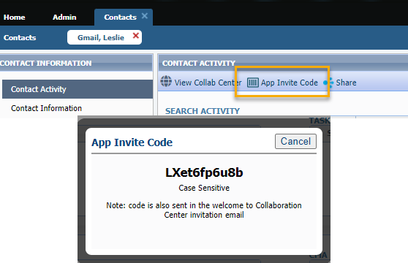
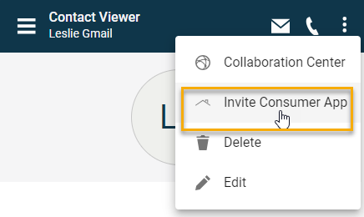
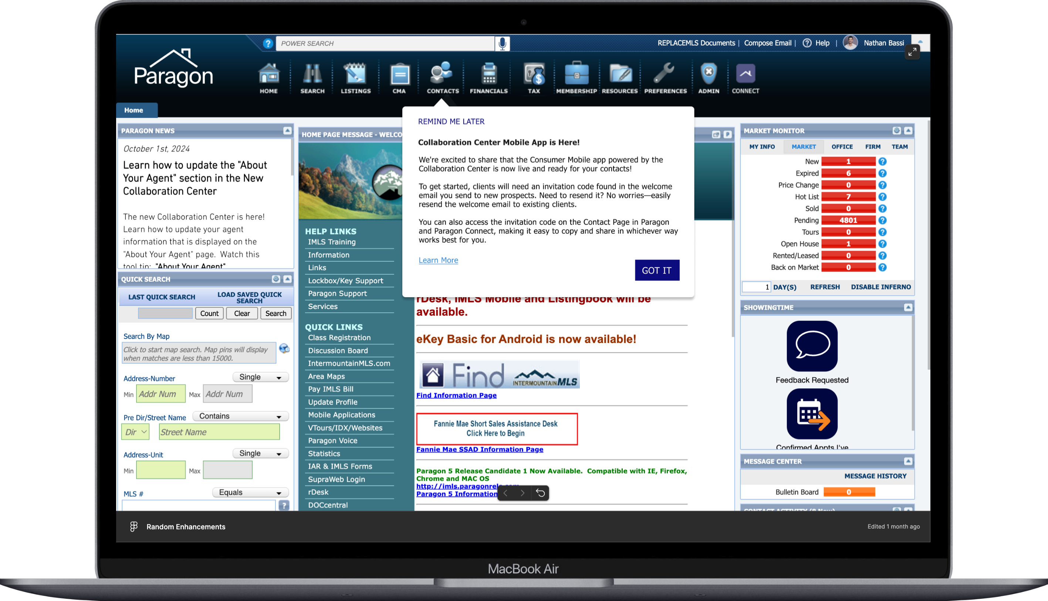

Office - Search by Office ID
With this release, admin staff now have the ability to search by Office ID in Paragon Admin—something that was previously unavailable. This enhancement is particularly valuable for RETS feeds, where only specific agent or office listings are sent. Now, staff can easily verify the correct office by searching directly using the Office ID, streamlining the process and improving accuracy.
Action Item: none
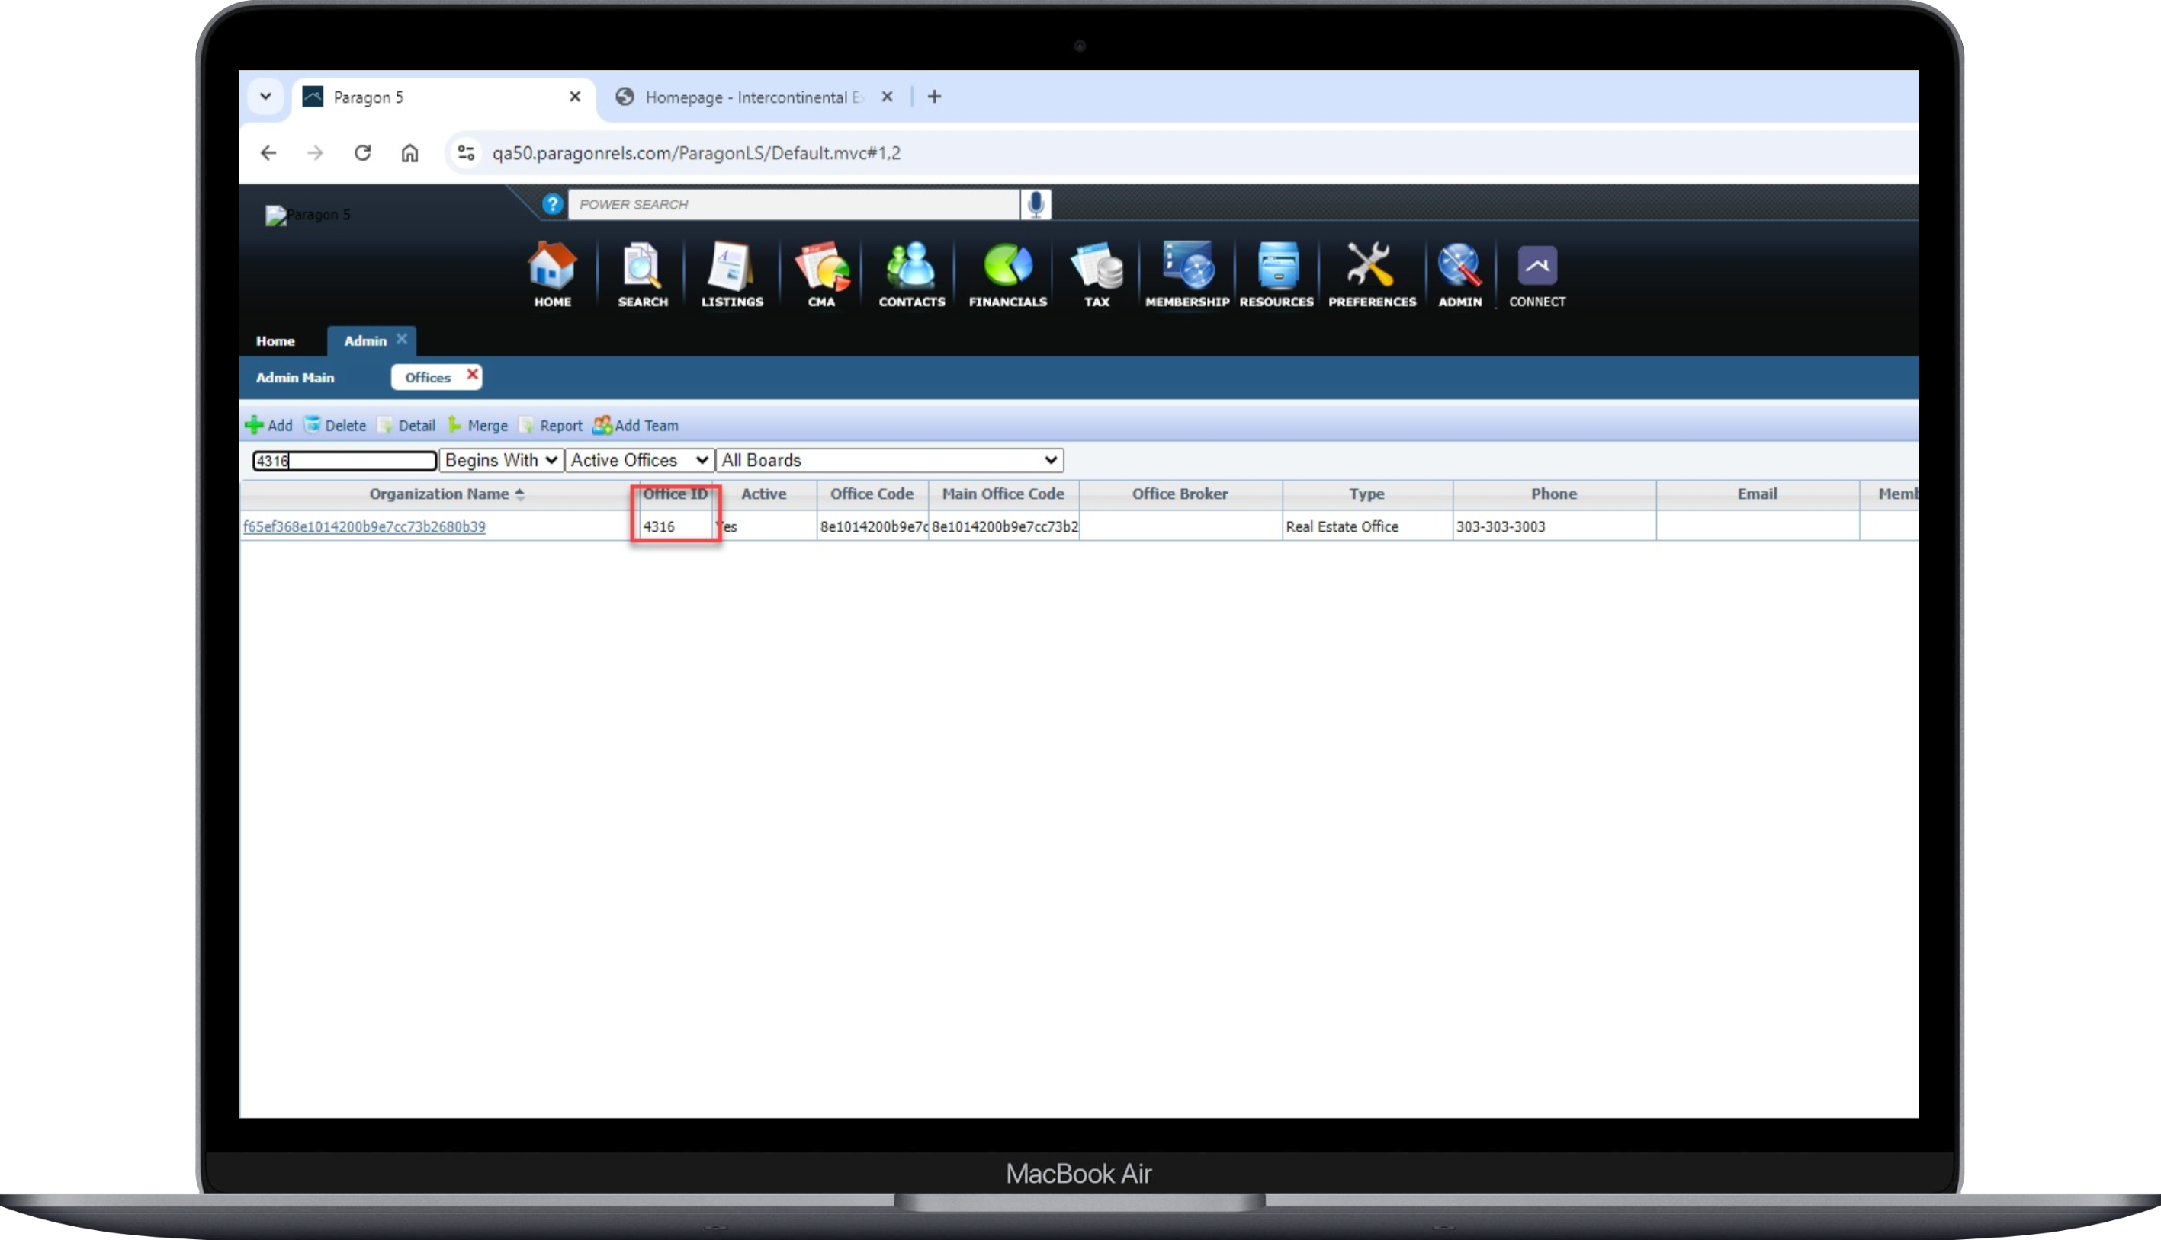

Teams - View Office ShortCode
With this release, admin staff can now see the Office ShortCode alongside the Office Name when setting up Teams in P5. This addition provides greater clarity and convenience, making it easier to manage teams with accurate office details right at your fingertips.
Action Item: none
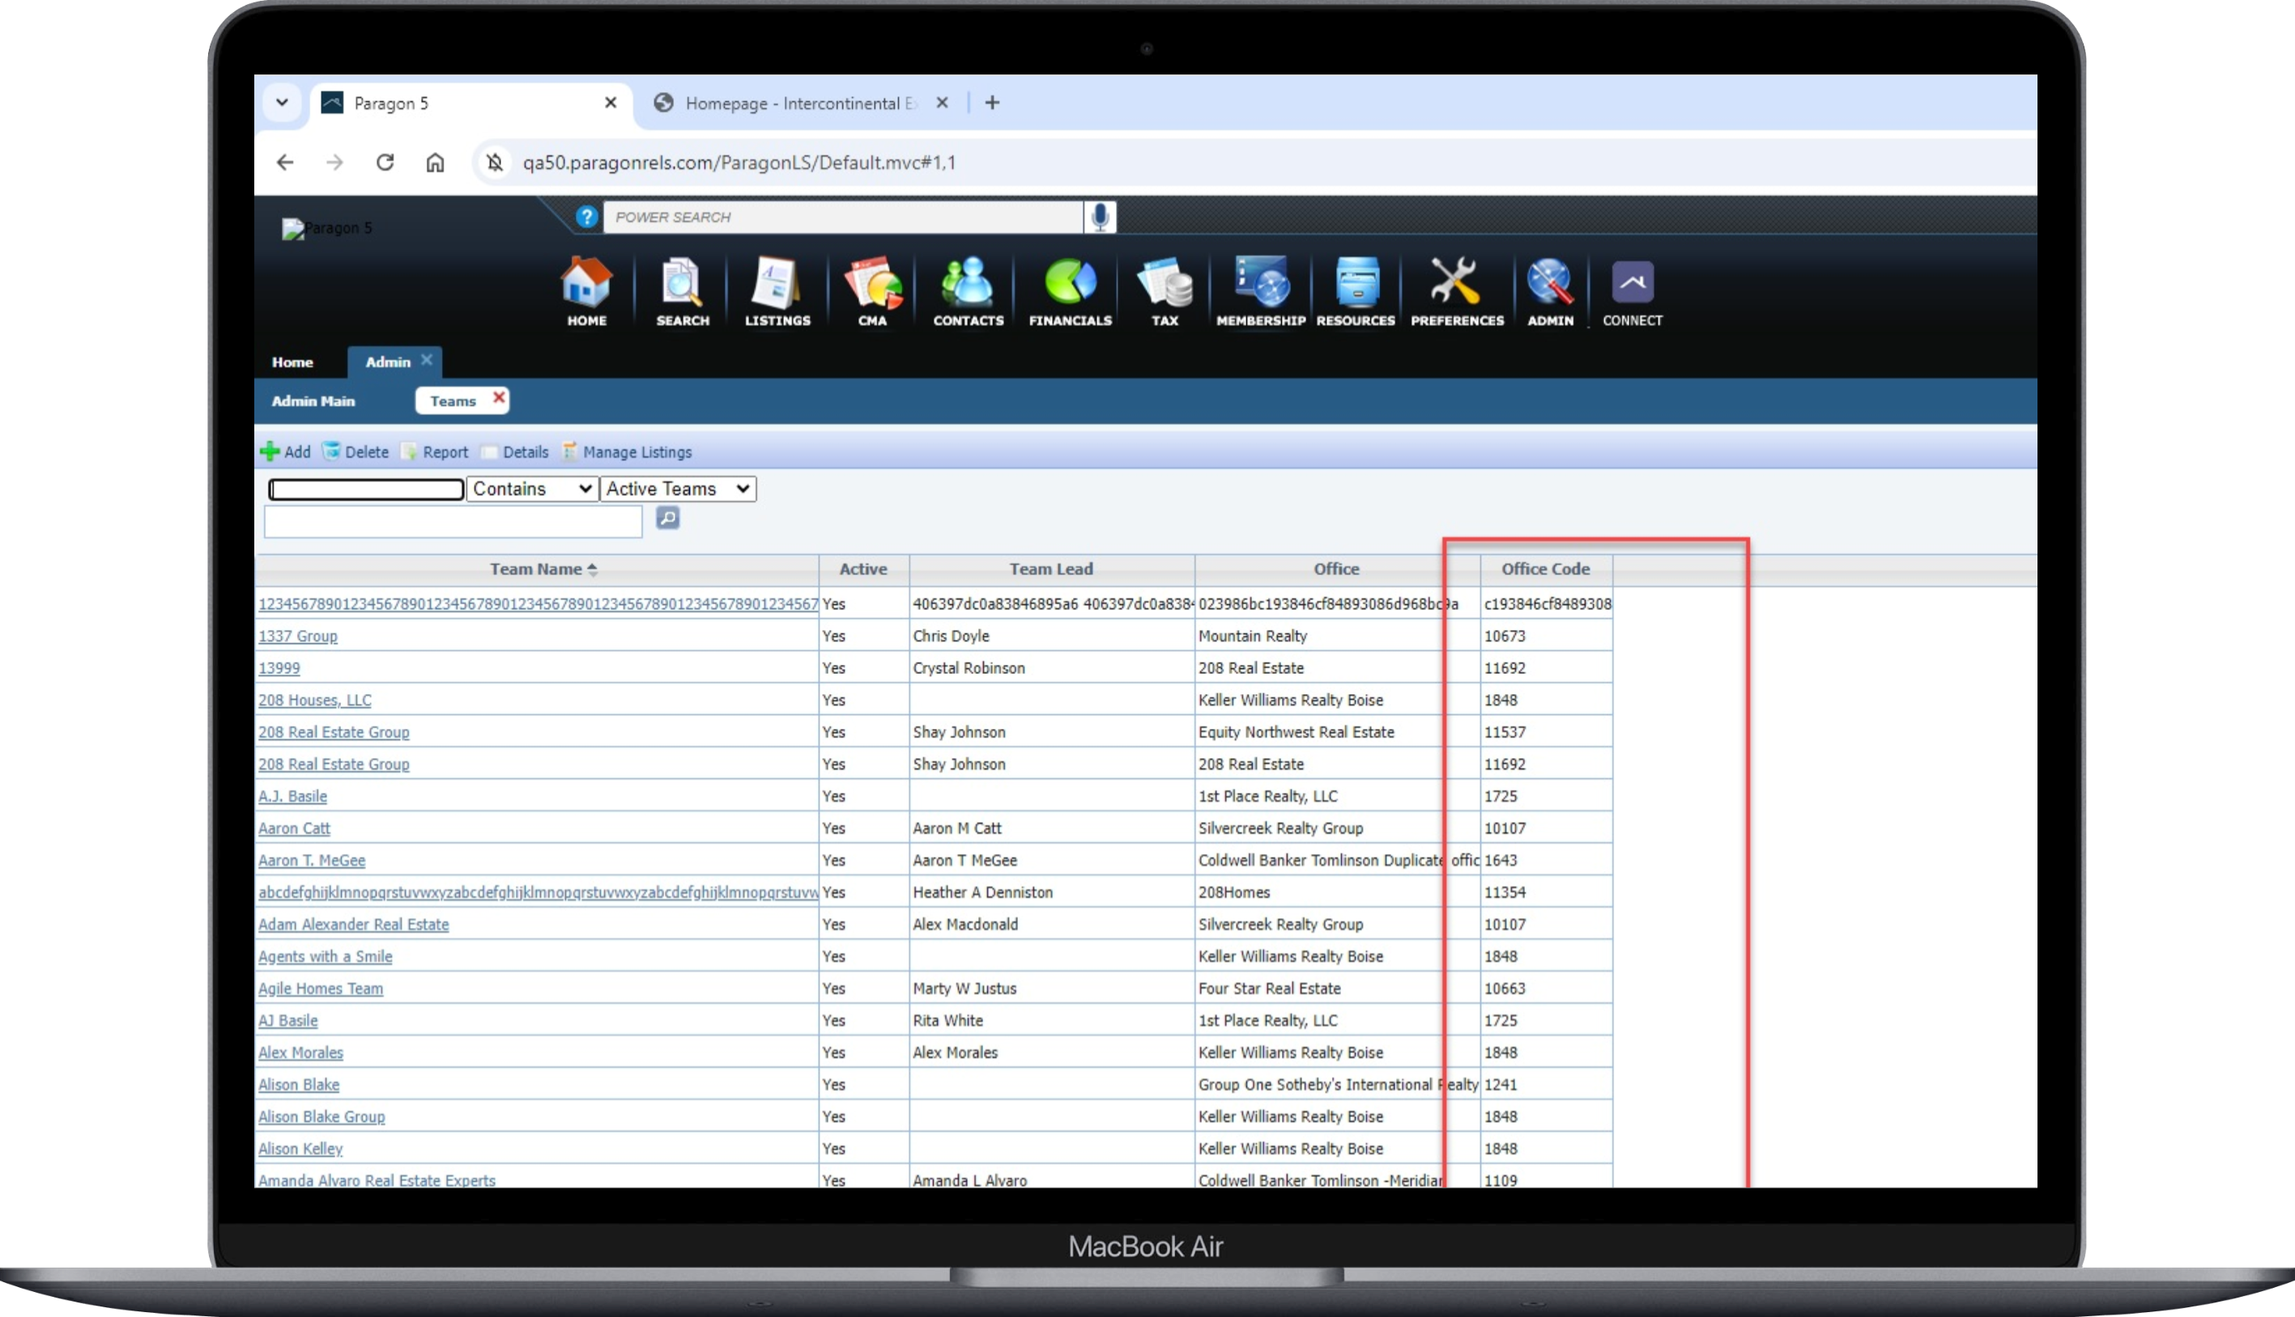

Paragon

Paragon Connect Corrections and Improvements
- Correction to show proper case for Office name on CollabCenter
- Correction to scroll when using the drag-n-drop feature for customizing search fields
- Correction for AVMs not consistently showing on the CollabCenter
- Correction for maintenance not accepting all 4000 characters for some remarks fields

Support for HEIF photos in Paragon Connect
Paragon Connect now supports HEIF image formats for uploading listing photos, contact images, and agent profile photos, staying ahead with the latest technology for high-quality, space-saving images.
HEIF (High Efficiency Image Format) is a type of photo format that helps keep pictures high-quality while using less space on your phone. It's commonly used for photos taken with newer smartphones, especially iPhones, to save storage without losing image quality. So, if you take pictures on your phone, chances are they're saved in HEIF to help you fit more photos without filling up your storage as quickly!
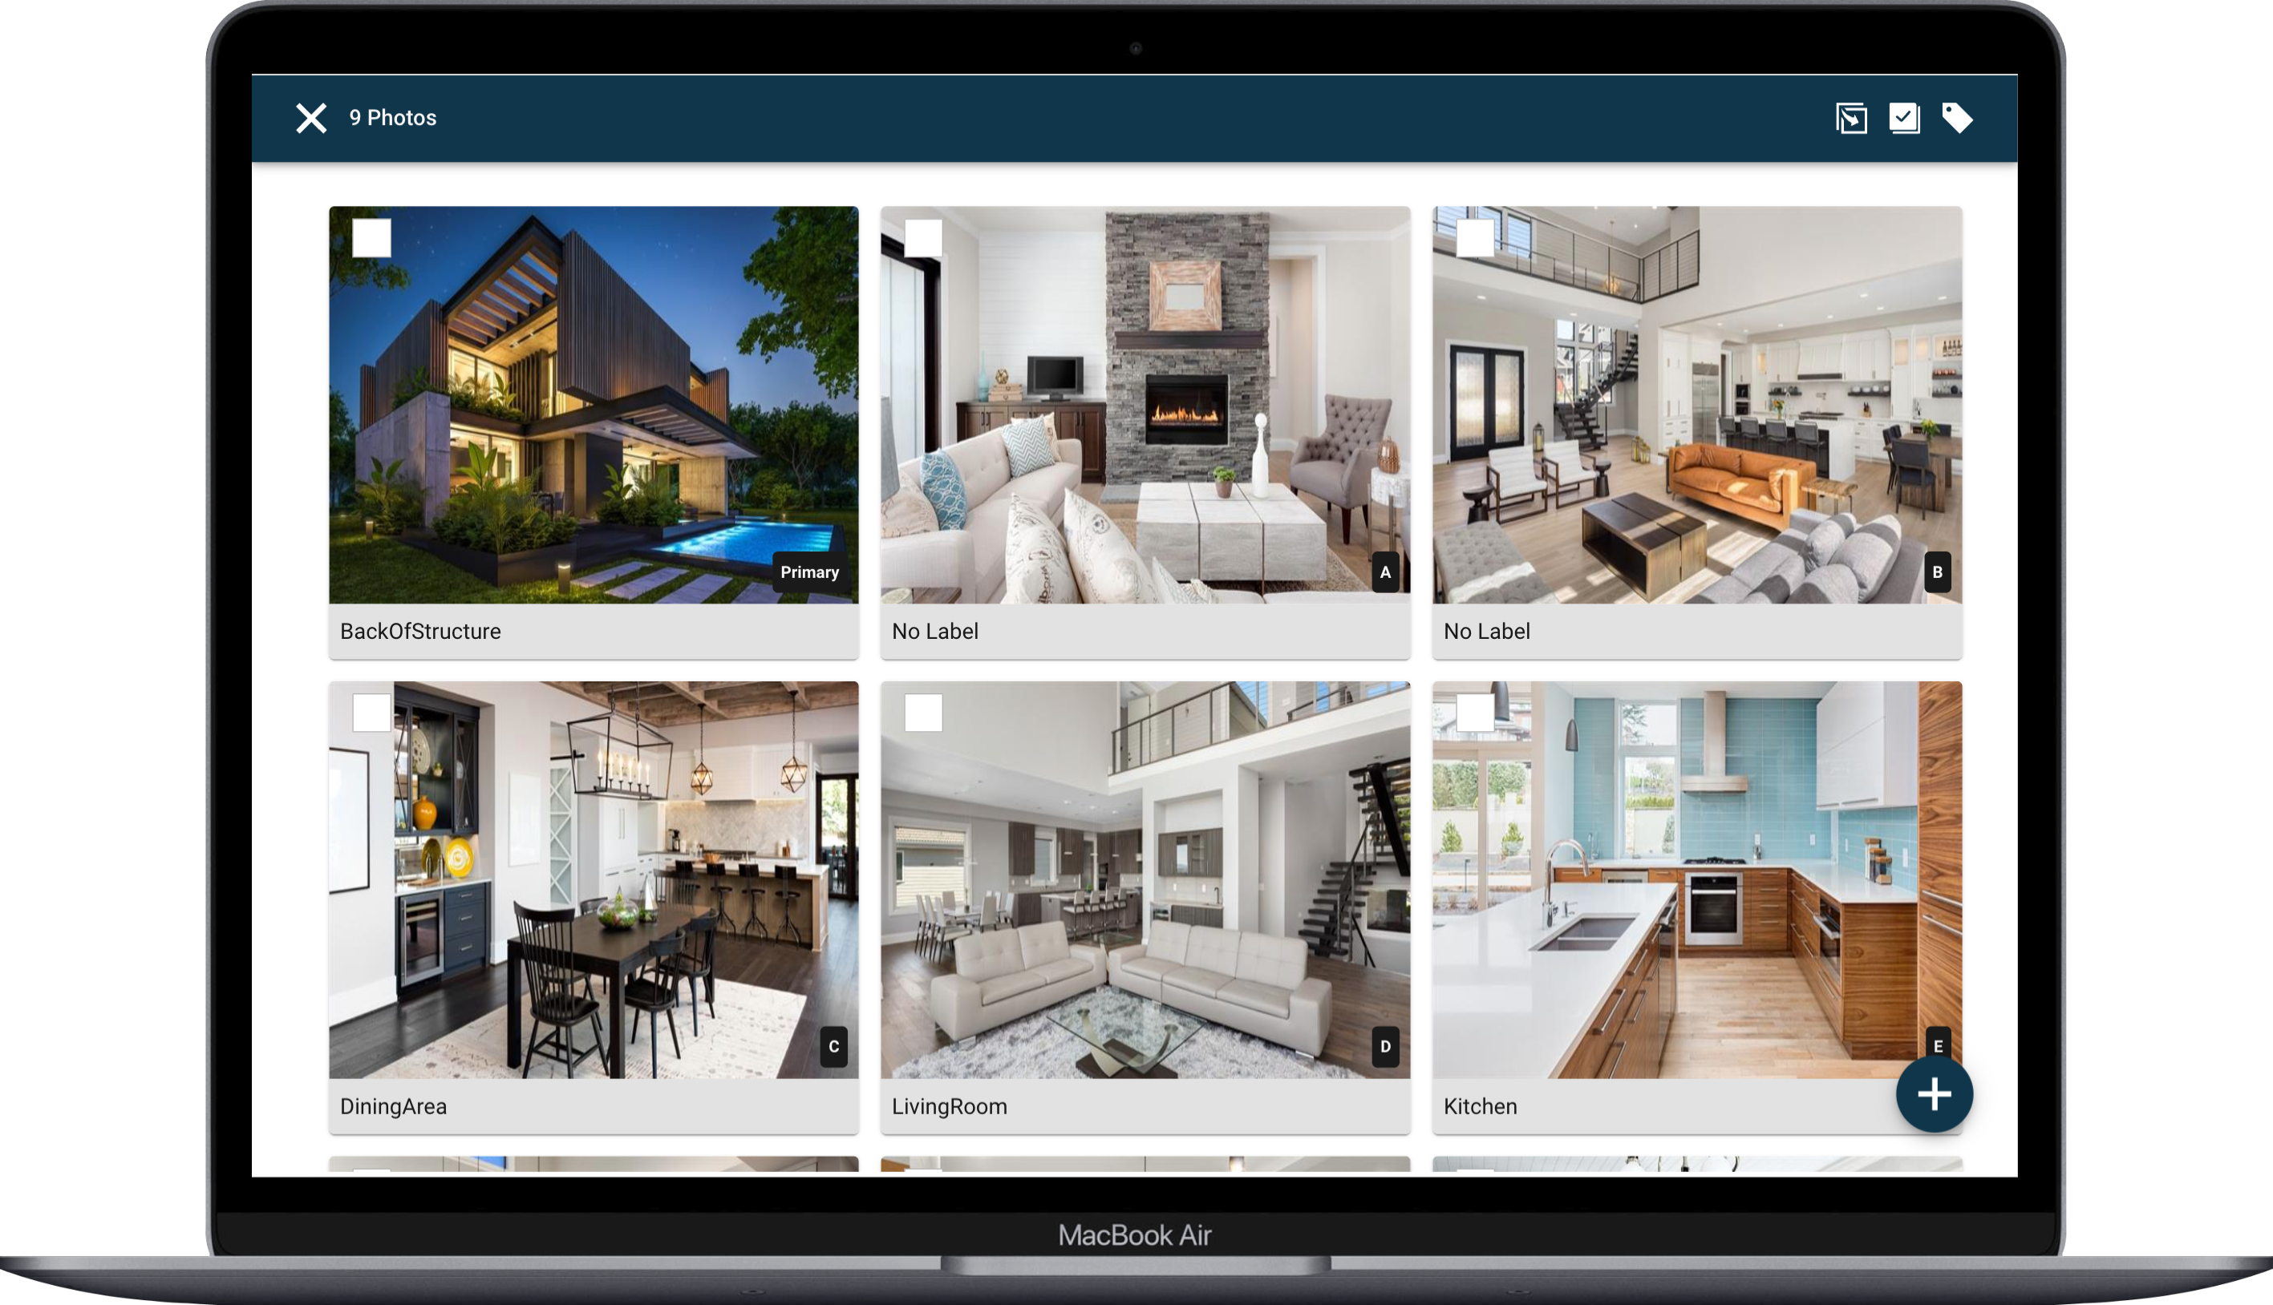

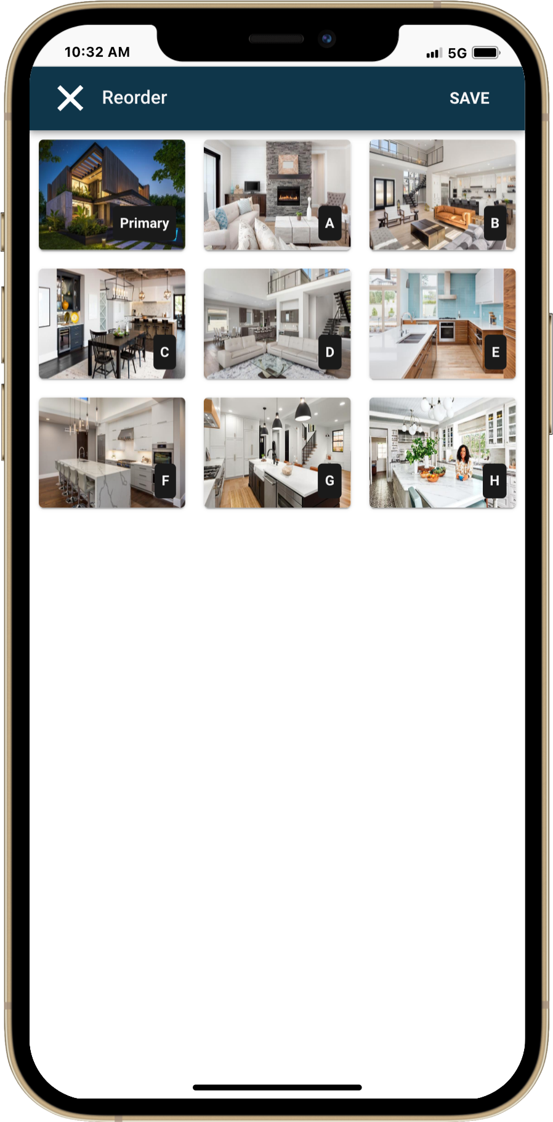

New Welcome Email Templates (Buyer & Seller)

As part of our Collaboration Center upgrade, we are redesigned the email templates, starting with the buyer and seller welcome emails, with more updates on the way. The content has been simplified for clarity, and the design is optimized for both small and large screens. We’ve also placed a stronger emphasis on office and broker branding, along with an enhanced email signature for a more polished, professional look. Plus, the new templates seamlessly adapt to both light and dark modes, ensuring a perfect display on any device.
Collaboration Center App section only visible if your organization has the app enabled.
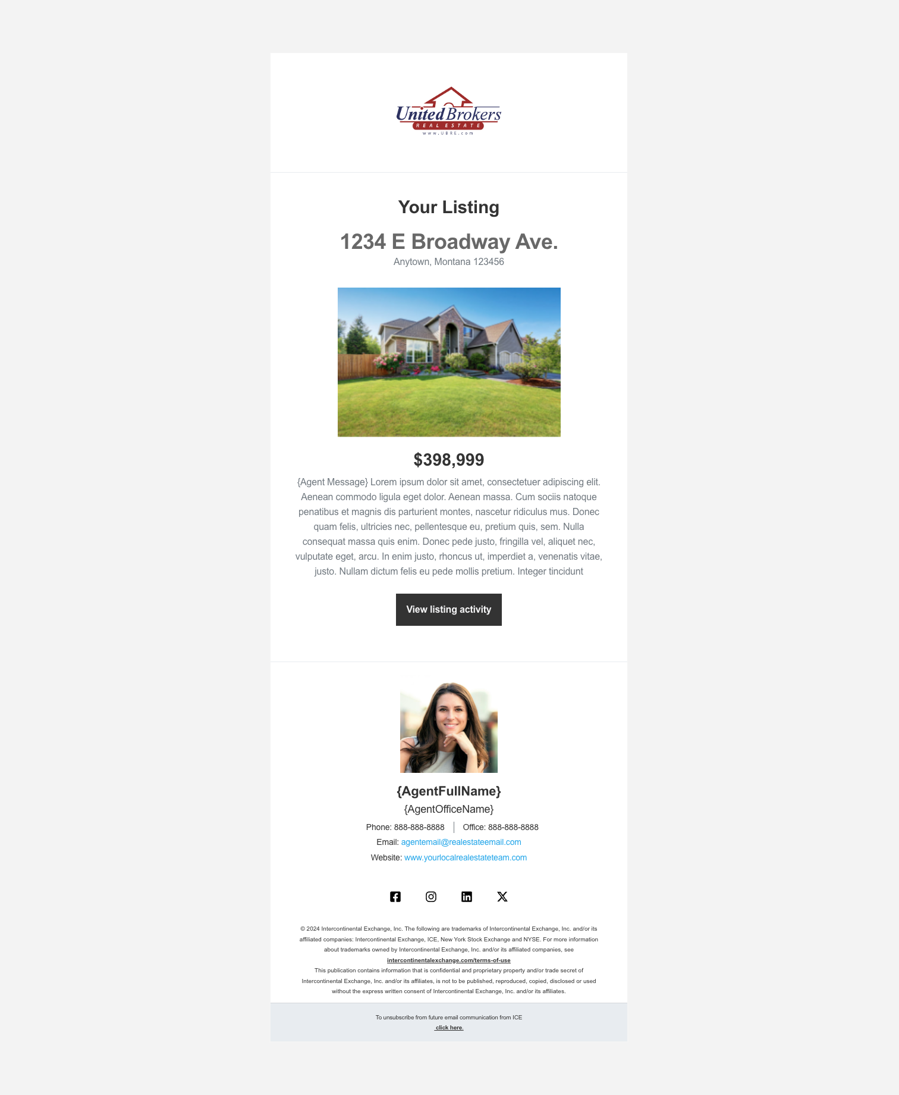
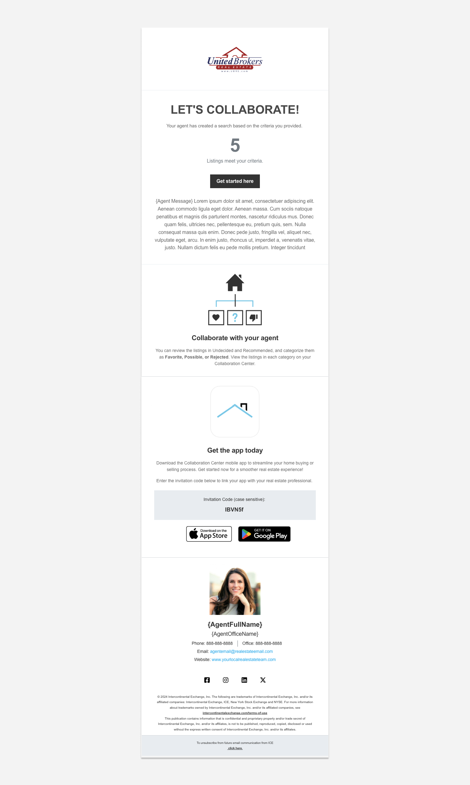
Seller Welcome Email

Buyer Welcome Email

Collaboration Center

Recent Sales Update
The Recent Sales search now features an enhanced filter, allowing you to narrow results based on specific saved searches rather than viewing all combined, making it easier to find recent sales based on a specific search. We’ve also updated the info tip to provide clearer details on what 'Recent Sales' results represent, ensuring a more seamless and informed user experience.
