08

08

**Fall**

**Fall**

Paragon 9.3 Release Enhancements

7 November 2024

1. Corrected Paragon Issues 2

2. MLS Customizations and Administration 3

2.1. No MLS Customizations and Administration 3

3. Paragon Features 3

3.1. Paragon Corrections and Improvements 3

3.2. Paragon Connect Mapping – Side Sheets 3

3.3. Restb.ai Photo Upload Compliance for RETS 4

3.4. Paragon Connect Listing Cart Updates 4

3.5. Consumer App Invitation Code – Collaboration Center Prospect Emails 5

# Corrected Paragon Issues

|  |  |  |  |
| --- | --- | --- | --- |
| Ticket# | Module | Organization | Summary |
| [TK-19487](https://jirabkmls.atlassian.net/browse/TK-19487?atlOrigin=eyJpIjoiMjBhNWIzMmFjMjdiNGE1YzhhZTE4YmM0ZjA0MDM4ZWYiLCJwIjoiZXhjZWwtamlyYSJ9) | WebAPI | GALMLS - Greater Alabama MLS | OpenMLS: nextLink Responses are Not Consistent [P90:GALMLS] |
| [TK-21134](https://jirabkmls.atlassian.net/browse/TK-21134?atlOrigin=eyJpIjoiMjBhNWIzMmFjMjdiNGE1YzhhZTE4YmM0ZjA0MDM4ZWYiLCJwIjoiZXhjZWwtamlyYSJ9) | Hotsheet | PRIMEMLS - Prime MLS (NEREN) | Error Received when Attempting to Update Default Template for Hotsheet in Connect |
| [TK-20428](https://jirabkmls.atlassian.net/browse/TK-20428?atlOrigin=eyJpIjoiMjBhNWIzMmFjMjdiNGE1YzhhZTE4YmM0ZjA0MDM4ZWYiLCJwIjoiZXhjZWwtamlyYSJ9) | Email | NGLRMLS - Northern Great Lakes MLS;RASM - REALTOR Assoc of Southern MN;RMLSA - Regional MLS Alliance (Peoria);SMLSA - Strategic MLS Alliance;TBRMLS - Tallahassee;VALLEYMLS - ValleyMLS | Wrong Agent picture displaying in Collab links and Collab Center |
| [TK-20930](https://jirabkmls.atlassian.net/browse/TK-20930?atlOrigin=eyJpIjoiMjBhNWIzMmFjMjdiNGE1YzhhZTE4YmM0ZjA0MDM4ZWYiLCJwIjoiZXhjZWwtamlyYSJ9) | View/Reports | RANM - New Mexico MLS | PC Detail View gives error when House Agent (ID -1) is assigned as any list agent |
| [TK-20758](https://jirabkmls.atlassian.net/browse/TK-20758?atlOrigin=eyJpIjoiMjBhNWIzMmFjMjdiNGE1YzhhZTE4YmM0ZjA0MDM4ZWYiLCJwIjoiZXhjZWwtamlyYSJ9) | View/Reports | RMLSA - Regional MLS Alliance (Peoria) | CCR loading and then immediately switching to an error page |
| [TK-20628](https://jirabkmls.atlassian.net/browse/TK-20628?atlOrigin=eyJpIjoiMjBhNWIzMmFjMjdiNGE1YzhhZTE4YmM0ZjA0MDM4ZWYiLCJwIjoiZXhjZWwtamlyYSJ9) | Configuration | BCRES - REB2 Residential | Price Change Arrows do not display in CCR Site |
| [TK-20576](https://jirabkmls.atlassian.net/browse/TK-20576?atlOrigin=eyJpIjoiMjBhNWIzMmFjMjdiNGE1YzhhZTE4YmM0ZjA0MDM4ZWYiLCJwIjoiZXhjZWwtamlyYSJ9) | Third Party | CCAR - Coastal Carolinas AOR;RAE - REALTOR Assoc of Edmonton | ShowingTime Activity returning all 0's for Seller Side Activity Report |
| [TK-20480](https://jirabkmls.atlassian.net/browse/TK-20480?atlOrigin=eyJpIjoiMjBhNWIzMmFjMjdiNGE1YzhhZTE4YmM0ZjA0MDM4ZWYiLCJwIjoiZXhjZWwtamlyYSJ9) | Third Party | SCWMLS - South Central Wisconsin (Madison) | PubLink Incorrectly Generating URL for USPS Zipcode Report Link in Emailed Listings |
| TK-19361 | View/Reports | CARMLS - CARMLS, Inc. (Arkansas);GREENVILLE - Greater Greenville AOR | Reports > Current Market, Dollar Volume Disappears if there is over 5,000 Active Listings |
| [TK-15834](https://jirabkmls.atlassian.net/browse/TK-15834?atlOrigin=eyJpIjoiMjBhNWIzMmFjMjdiNGE1YzhhZTE4YmM0ZjA0MDM4ZWYiLCJwIjoiZXhjZWwtamlyYSJ9) | Membership/Roster | IRMLS - Indiana Regional MLS;SDMLS - San Diego MLS | Membership Roster Adding "/" when Office name includes an Apostrophe |
| TK-20783 | View/Reports |  | Sold Market Report breaking when high volume of results |

# MLS Customizations and Administration

## No MLS Customizations and Administration

**Action Item:** none

# Paragon Features

## Paragon Corrections and Improvements

* Correction for an intermittent issue where the incorrect Agent Image appears on CollabCenter
* Improvement for the speed of loading results for map view in Paragon Connect
* Improvement for the Required Only filter on Connect LIM to show conditionally-required fields along with hard-required fields

## Paragon Connect Mapping – Side Sheets

We’ve made a sleek update to the mapping search in Paragon Connect! Now, when you access layers or edit shapes, they’ll open in a spacious side sheet—whether on mobile or desktop. This change gives you more room to view and customize layers and shapes, making your mapping experience smoother and more intuitive!

We also upgraded the layer controls with clear toggles, making it instantly obvious when layers are on or off. This update brings a more intuitive experience, so you can navigate with confidence and ease!

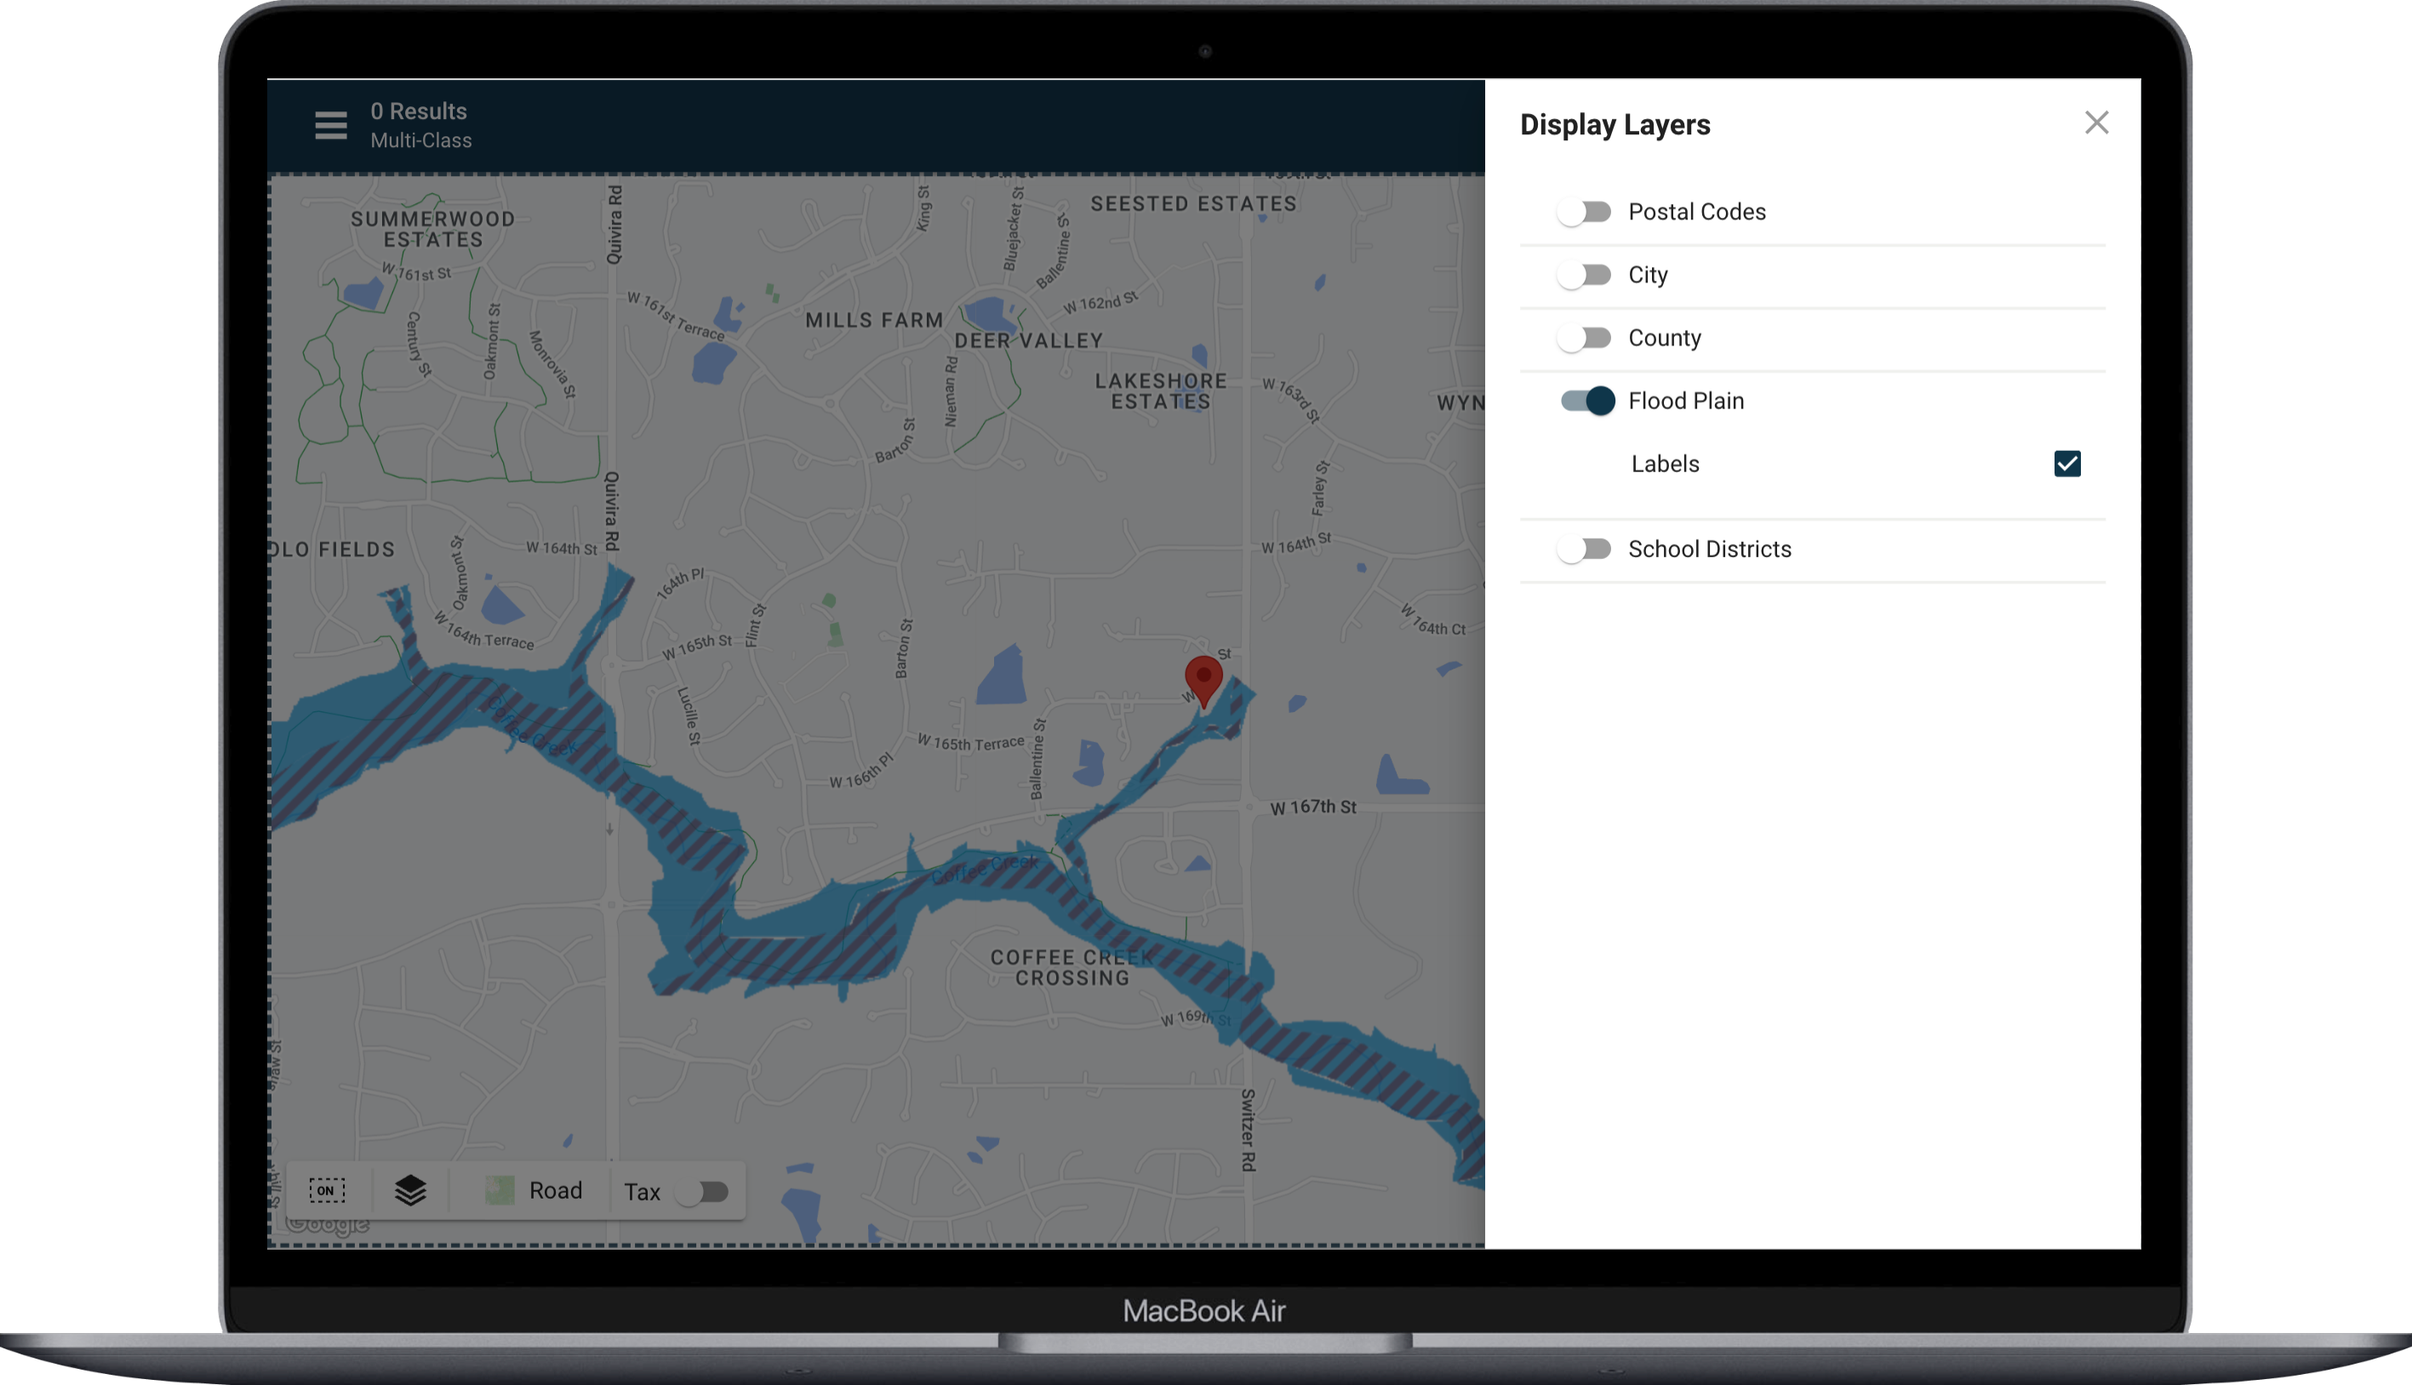

## Restb.ai Photo Upload Compliance for RETS

With our latest enhancement, Restb.ai photo compliance now extends to RETS uploads, scanning for any compliance issues after photos are added. This seamless integration keeps your listings compliant effortlessly, no matter how the photos are uploaded!

*Please note: this enhancement is available only for organizations who have opted-in for Restb.ai Compliance*

## Paragon Connect Listing Cart Updates

We’ve given the listing cart cards a fresh upgrade! With a refined layout and a new “last updated” date, it’s now easier than ever to see when your listing carts were most recently refreshed. Stay organized and up-to-date at a glance!

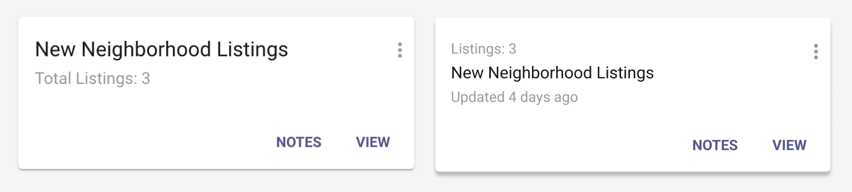

After

Before

## Consumer App Invitation Code – Collaboration Center Prospect Emails

To boost excitement around the new Collaboration Center Mobile app, we’re adding the invitation code section right into email notifications sent to consumers whenever there are new updates. This makes the invitation code front and center, encouraging easy app access!

*Please note: this enhancement will be visible only for organizations that have purchased the mobile app suite.*

