
08

08
Fall

Fall

Paragon 9.4 Release Enhancements

21 November 2024

1. Corrected Paragon Issues 2
2. MLS Customizations and Administration 3
2.1. New Reverse Prospecting in Paragon Connect 3
2.2. New Auto-Generation of Public Remarks via Restb.ai 3
3. Paragon Connect 4
3.1. Paragon Connect Corrections and Improvements 4
3.2. Reverse Prospecting 5
3.3. New Dashboard Customization 11

Corrected Paragon Issues
Ticket# | Module | Organization | Summary
DEV-14834 | Admin | BCRES - REB2 Residential | CCR - obscure the "agent" mode flag in the CCR URL
DEV-14974;DEV-14981 | Email |  | CCR - restrict the office logo width on updated email templates
DEV-15006 | Email | PRIMEMLS - Prime MLS (NEREN) | Reverse Prospect Email Template is not displaying the agent's website
TK-18630 | Admin | IRMLS - Indiana Regional MLS | Admin Billing Export not running
TK-20547 | Data | CCAR - Coastal Carolinas AOR;COLUMBIA - ConsolidatedMLS;MAAR - Memphis Area AOR;PRIMEMLS - Prime MLS (NEREN) | New Collab Center Site - Selecting View in Paragon Link is no longer available error
TK-20628 | Configuration | BCRES - REB2 Residential | Price Change Arrows do not display in CCR Site
TK-21135 | Print | PRIMEMLS - Prime MLS (NEREN) | CCR and CL: hide the Print PDF option in Assoc Docs
TK-21300 | View/Reports | BCAR - Baldwin County AOR | Collab Center Custom Collab Field Name/Label not appearing on CollabLink
UXR-78 | Other | PRIMEMLS - Prime MLS (NEREN) | My Content > Listing Carts > Add + FAB button to create cart

MLS Customizations and Administration

New Reverse Prospecting in Paragon Connect
Action Item: If you want to disable the new Reverse Prospecting feature within Paragon Connect please reach out to your SSM.

New Auto-Generation of Public Remarks via Restb.ai
A new feature is available within Paragon Connect for all customers who have purchased the Photo Label/Tagging feature from Restb.ai. This new option allows users to instantly create compelling, descriptive Public Remarks with the push of a button.
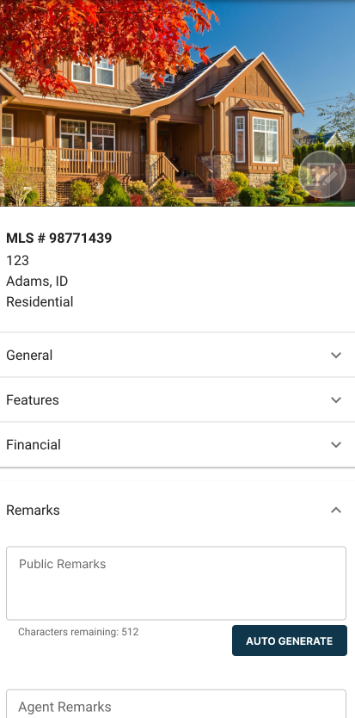
On the Listing Input Form a new button will appear next to your Public Remarks field. When users select this option the AI engine will use the address data populated for the listing along with any uploaded photos to automatically create a property description and insert it into the remarks field. From there the user may choose to make any changes to the text.
To use the new auto-remarks feature the listing must include data for the street Address, City, State/Province and a minimum of 3 listing photos. This option is available for published and unpublished listings.

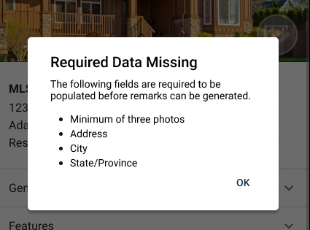

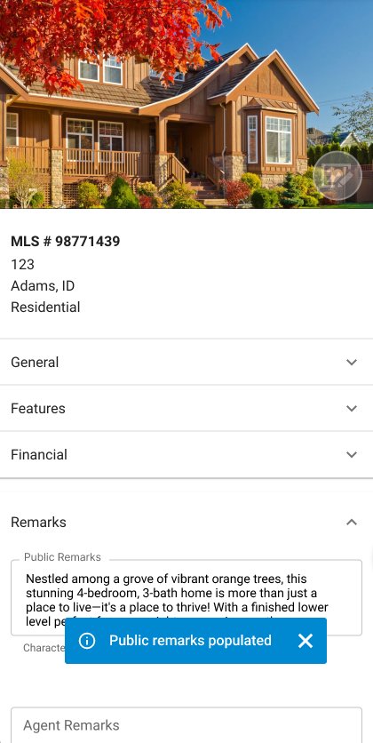
This feature will be included automatically when the Photo/Tagging feature is enabled. No additional action is needed. If you are interested in this feature, please reach out to your sales representative.

Paragon Connect

Paragon Connect Corrections and Improvements
- Correction to display the Custom Collab Center field label on CollabLink
- Improvement to show an Info Tip regarding Agent Mode on the new CollabCenter
- Improvement to display the CollabCenter filter options in a full screen side bar
- Improvement to create a new Listing Cart from the main Listing Cart page
- Improvement to display the Update Date on Listing Cart cards

Reverse Prospecting
We’re thrilled to bring Reverse Prospecting to Paragon Connect! While it’s already available in Paragon Pro, we've reimagined it in Connect with fresh workflows and exciting new features.
This new feature has several key benefits:
- All agents and contacts are eligible to participate without any setup
- Listing agents can see counts of all contact matches, but never the identity of the contact
- Reverse prospect emails are sent individually to each contact’s agent, no other agents will see details about your matching contacts
- New ‘Search by Reverse Prospect ID’ to identify matched contacts easily
- Individual agents may choose to opt out of receiving Reverse Prospecting emails and the new ‘Match My Contacts’ feature

Ready to explore the possibilities? Let's dive in!

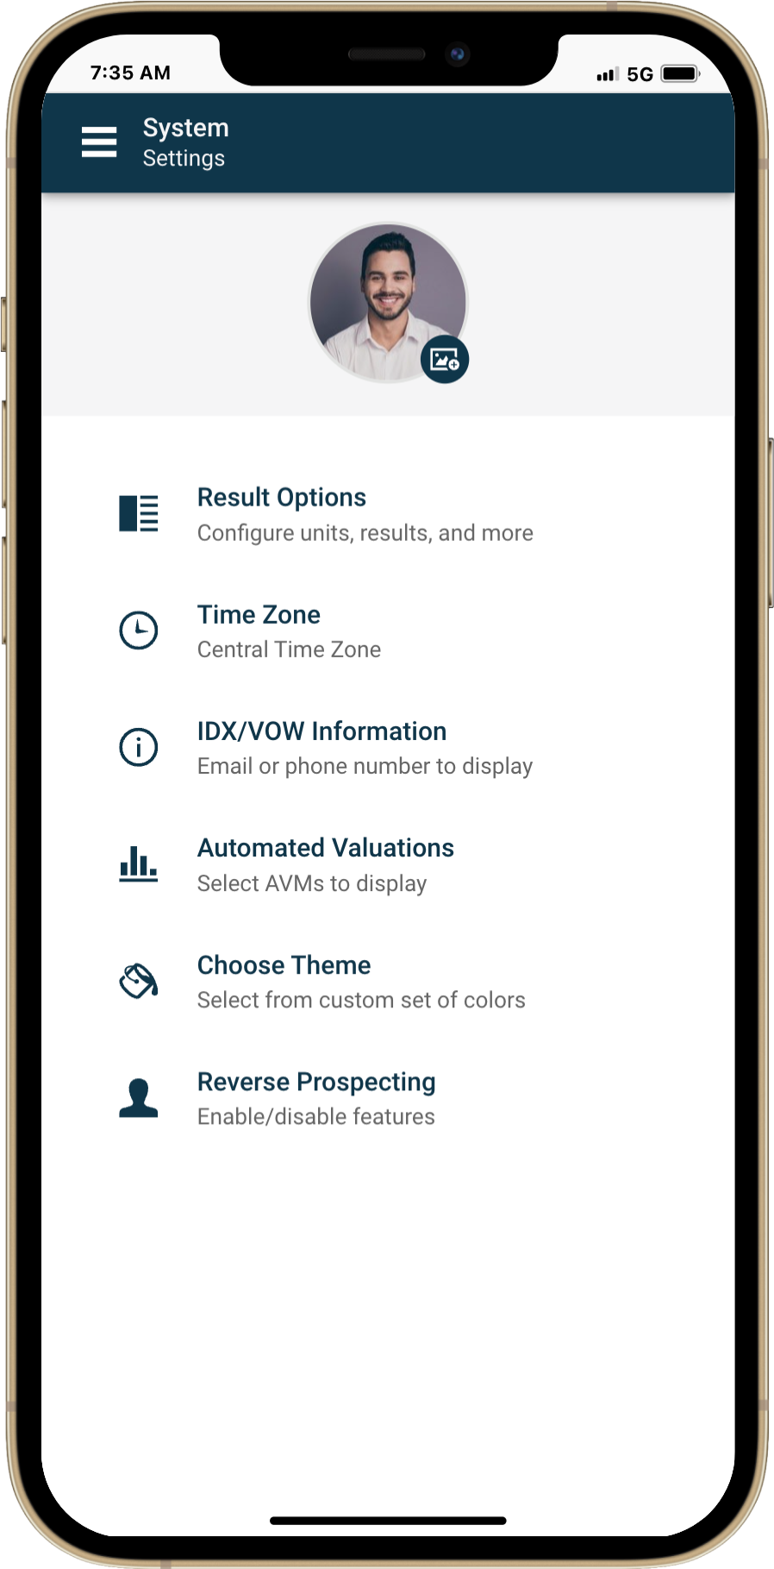
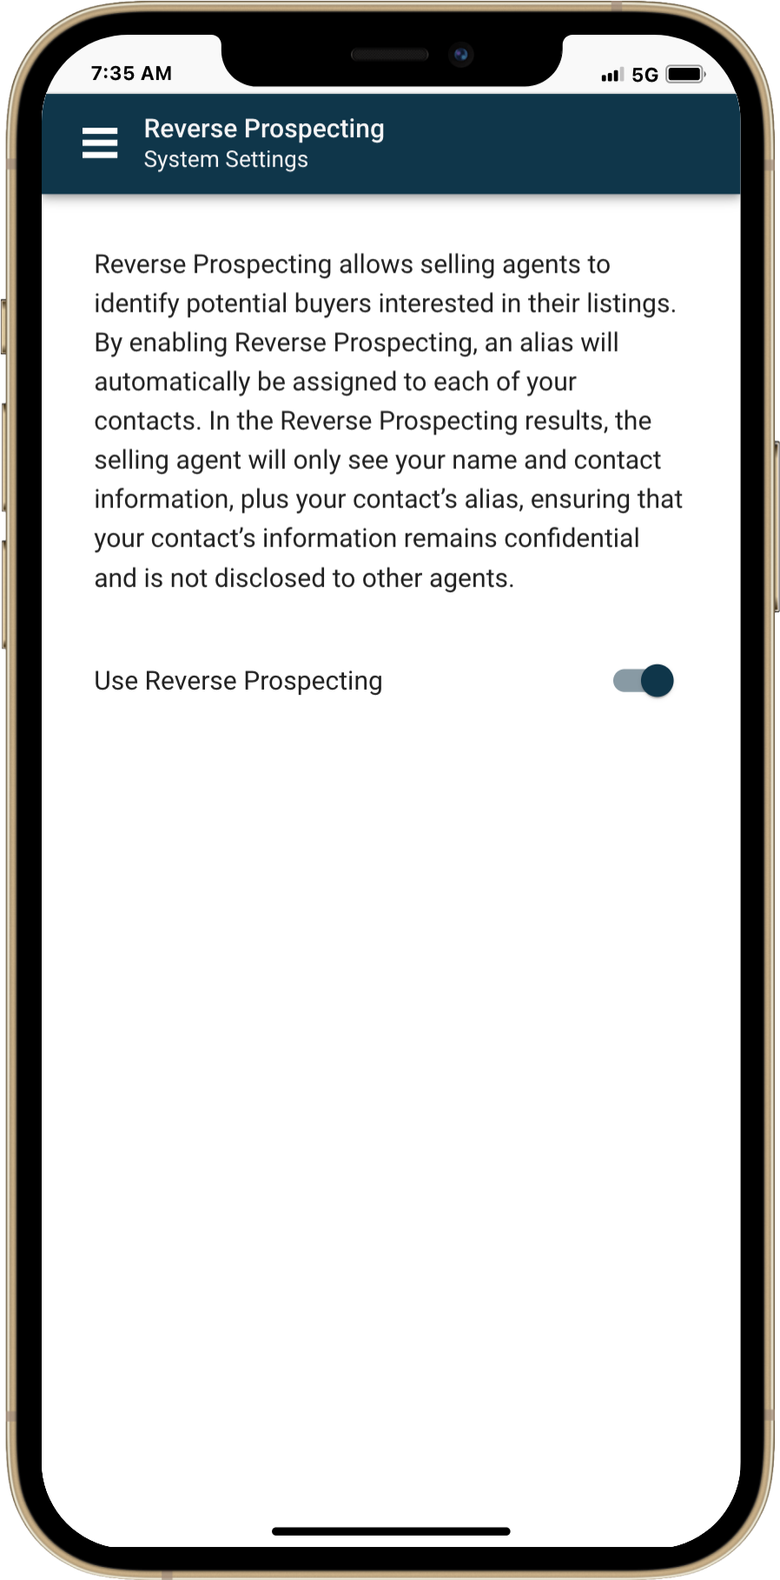
Settings:

It all begins with a new setting! In your system settings, you’ll find our Reverse Prospecting feature, automatically enabled for all users by default. Make sure this setting is active to unlock the full power of Reverse Prospecting!


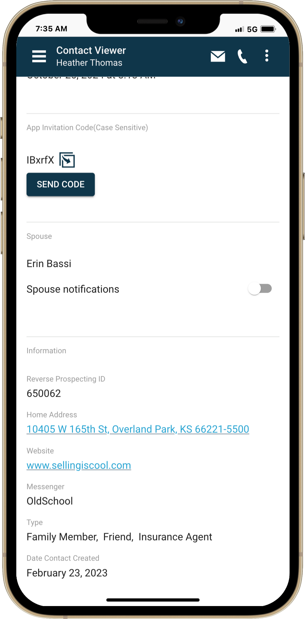
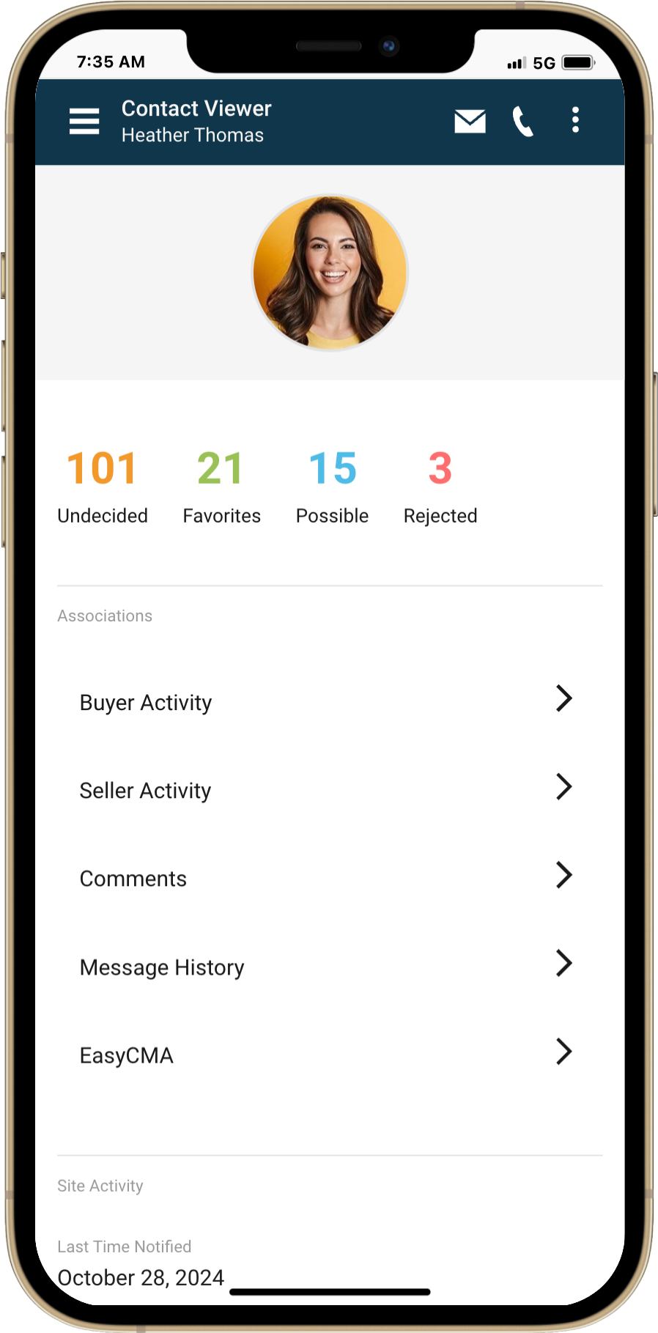
Reverse Prospecting ID:

Say goodbye to manually setting up aliases for contacts in Paragon Connect! Now, each contact automatically receives a unique Reverse Prospecting ID, making your workflow faster and more efficient. Just open any contact, scroll down, and you’ll find the Reverse Prospecting section with their assigned ID—it's that simple!

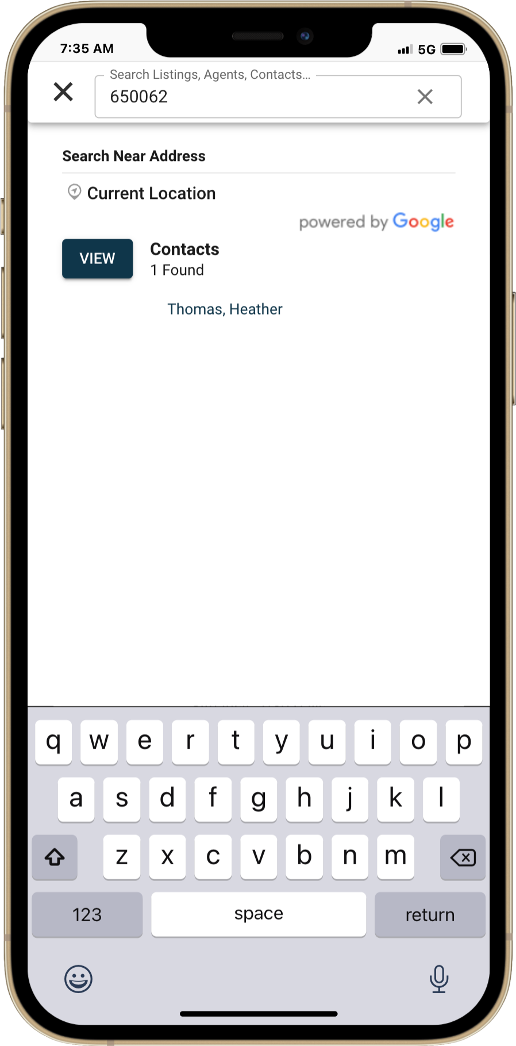
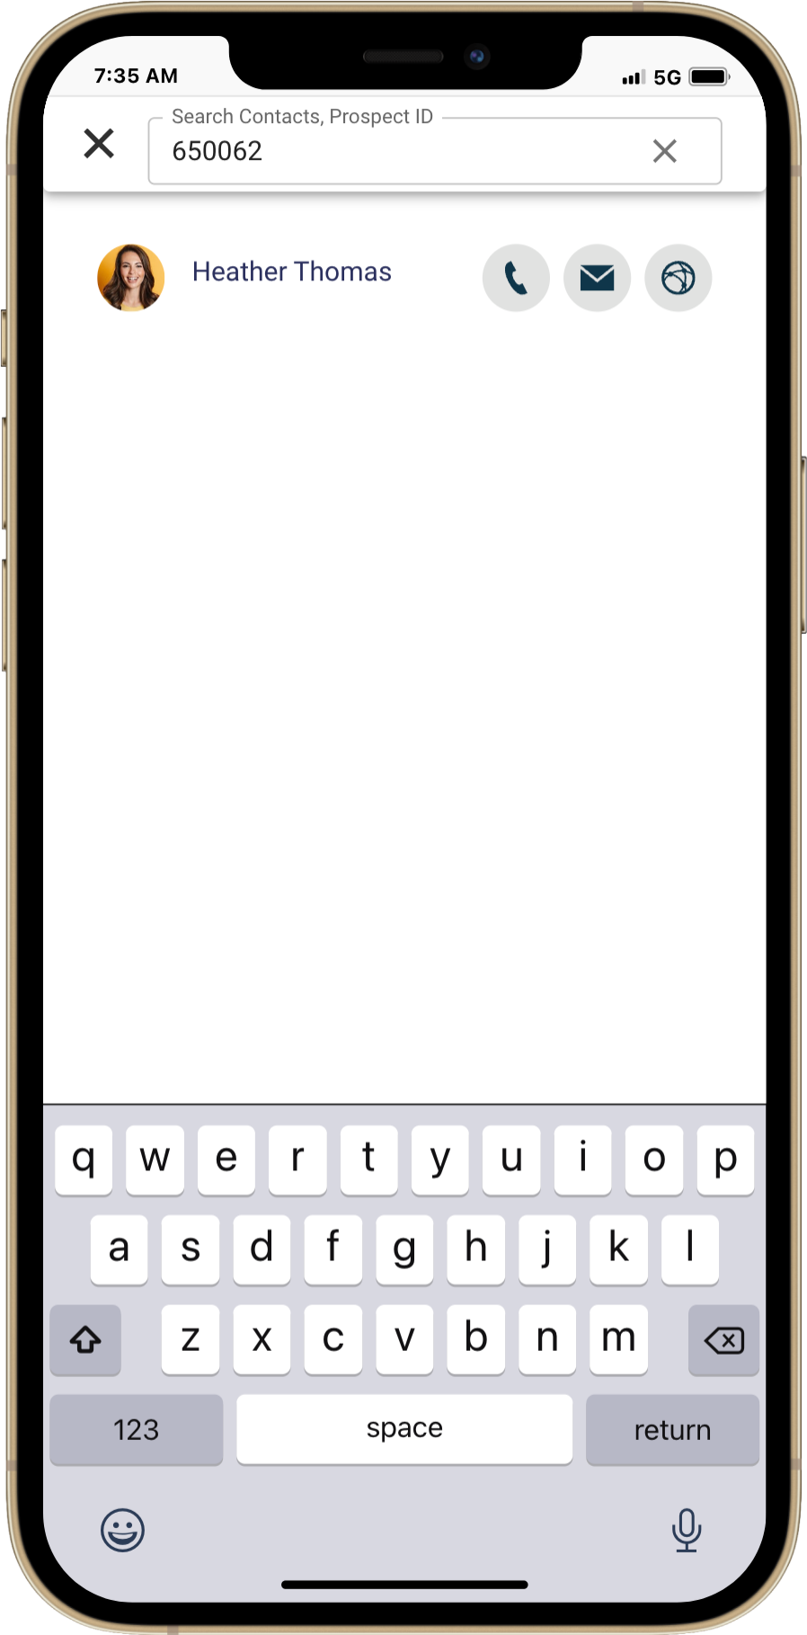
Search By: Reverse
Prospecting ID:

We’ve enhanced both Power Search and Contact Search in Paragon Connect, allowing you to find contacts instantly with just their Reverse Prospecting ID.

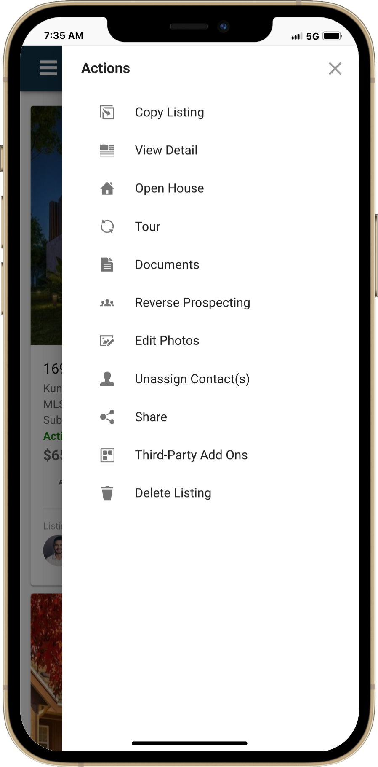
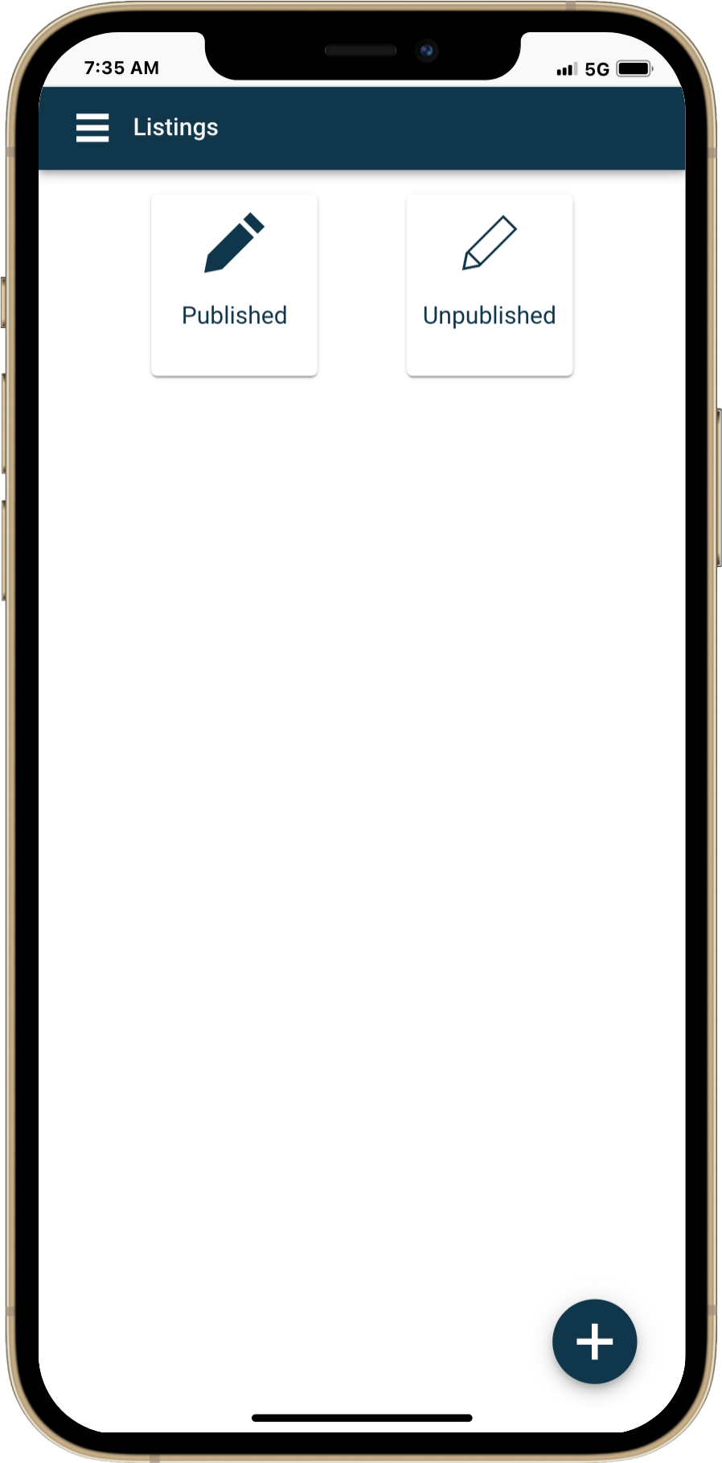
Reverse Prospecting Location:

Find the powerful Reverse Prospecting report for Paragon Connect right within the Published Listing module in Listing Maintenance! This feature lets you prospect on listings you manage with ease. Simply access it as a quick-link action in your overflow menu.

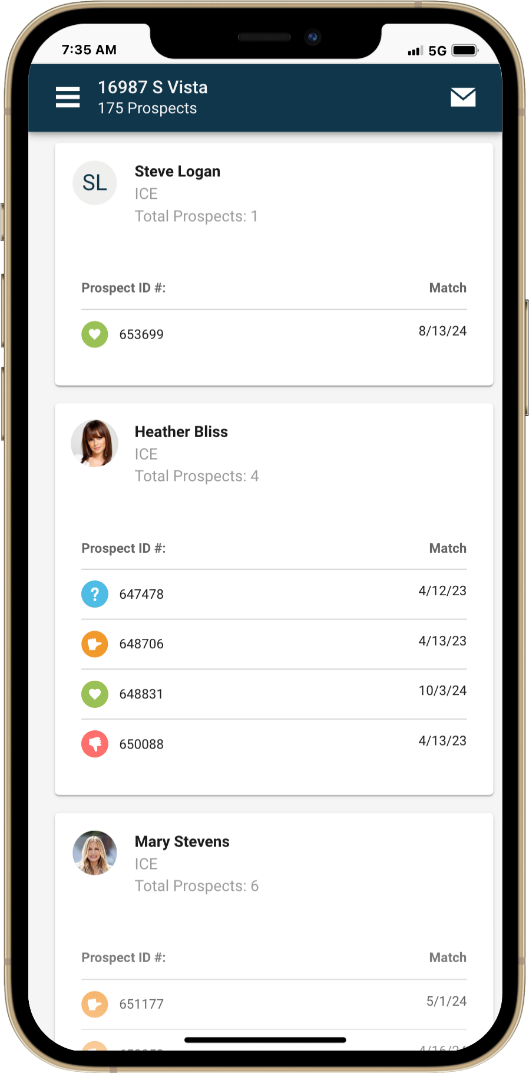
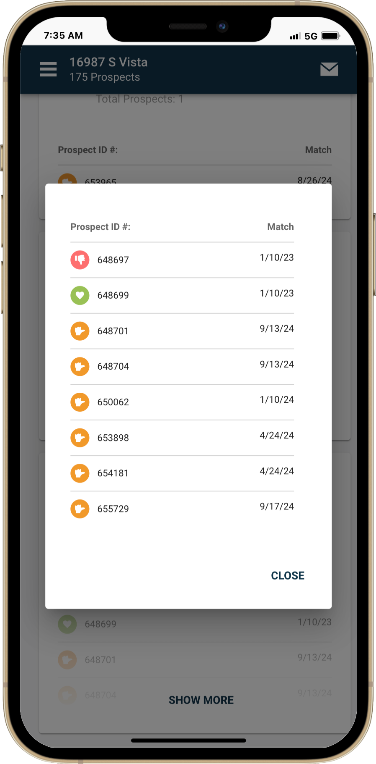
Reverse Prospecting Report:

When you run a Reverse Prospecting report, it identifies agents who have a search with your listing matched to a contact. Each result appears as an individual card, showcasing the agent, their office, and a list of Reverse Prospecting IDs.

Each ID highlights the match date and listing categorization, giving you valuable insights into buyer interest levels. Rest assured, client information remains fully protected—other agents won’t see or contact your client directly. Instead, they’ll reach out to you, keeping you in full control of the communication.

Contact Agent:

Effortlessly connect with agents using three intuitive options!

To get started, simply tap the overflow menu to call, text, or email an agent directly. Need to contact everyone at once? With the bulk email feature, just click the email icon in the app bar, and craft one message that’s sent individually to each agent—ensuring privacy and ease.

Want to reach out to select agents? No problem! Tap the profile image on their card to choose them, then use the email icon in the contextual bar to send your message directly.

Fast, secure, and hassle-free communication—exactly what you need to stay connected!

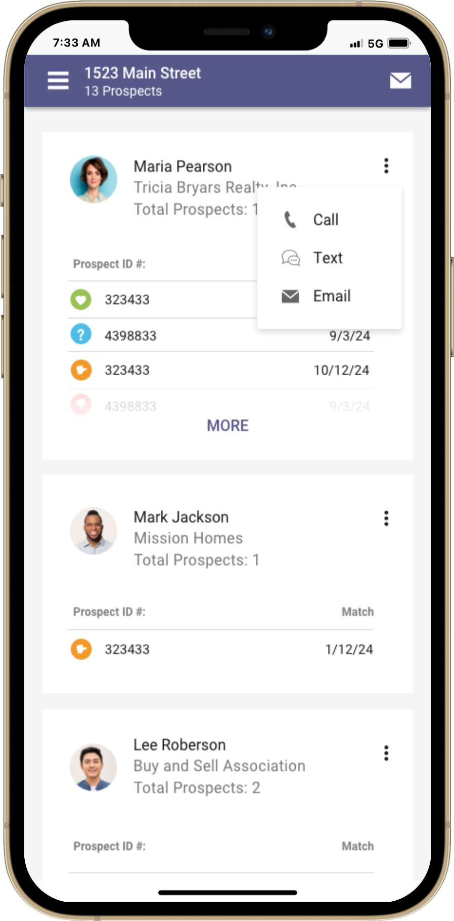
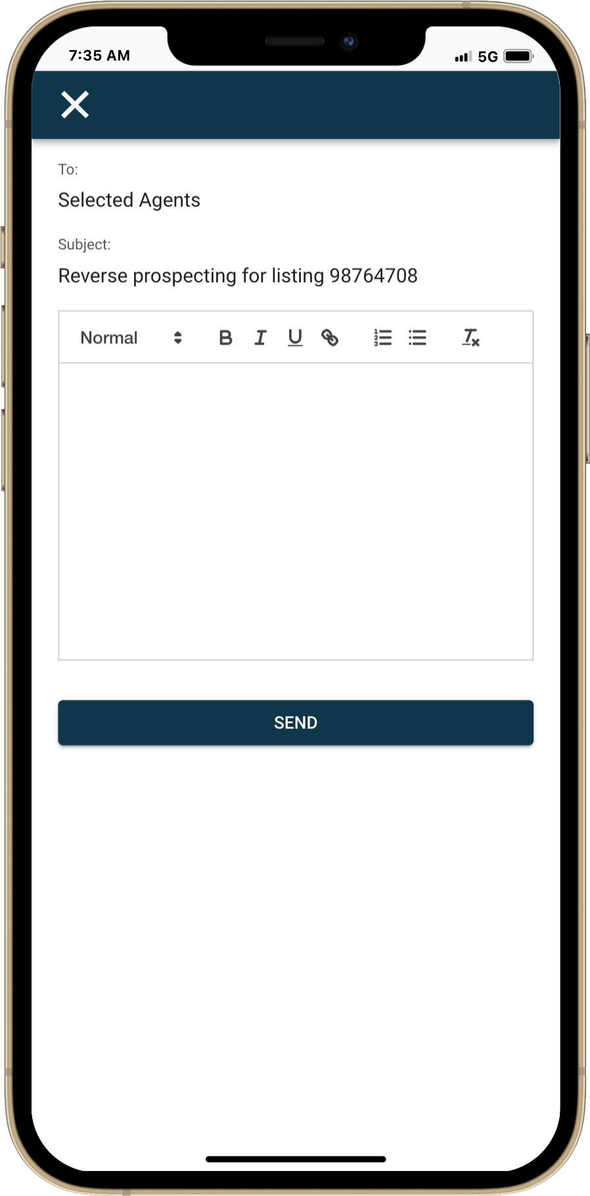
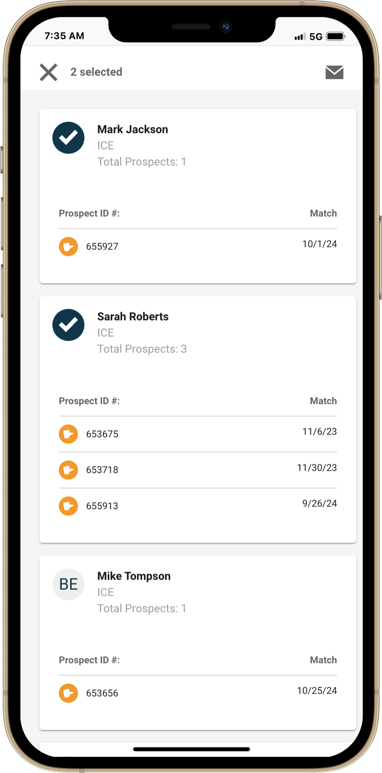
Create Email Message
Select Multiple & Email
Bulk Email All
Call, Text, Email

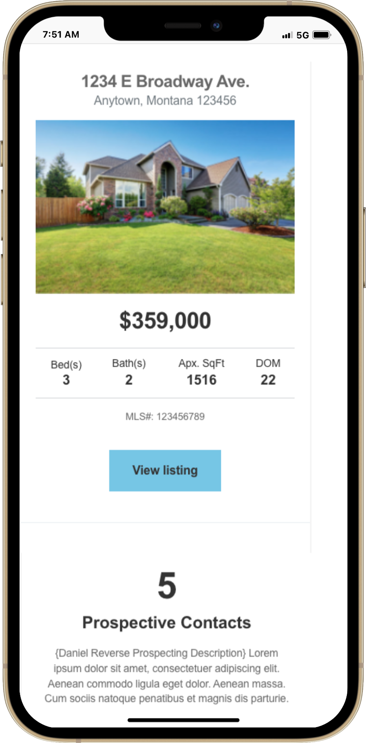
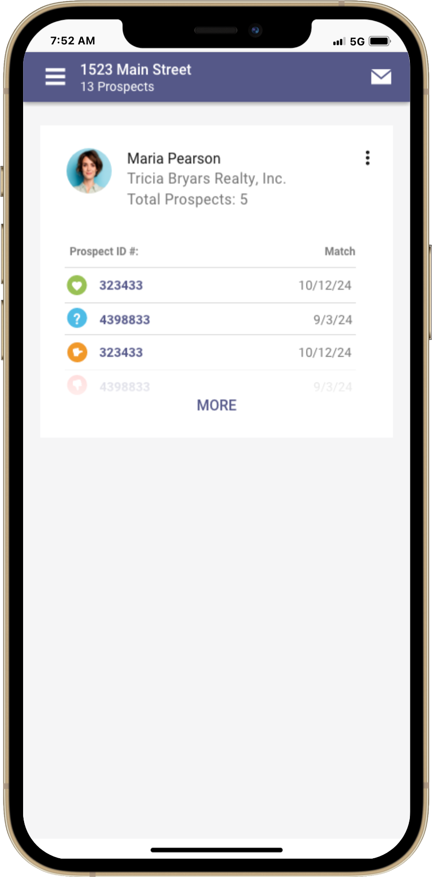
Email Review


Agents receiving reverse prospecting get an instant snapshot of your listing, including the number of interested contacts and their level of interest. With just a click or tap on the "View Listing" button, they'll be seamlessly directed to Paragon Connect, where they can access a detailed report showcasing the list of contacts who are interested in the property. It’s quick, easy, and designed to help agents take action—right when they need it most!

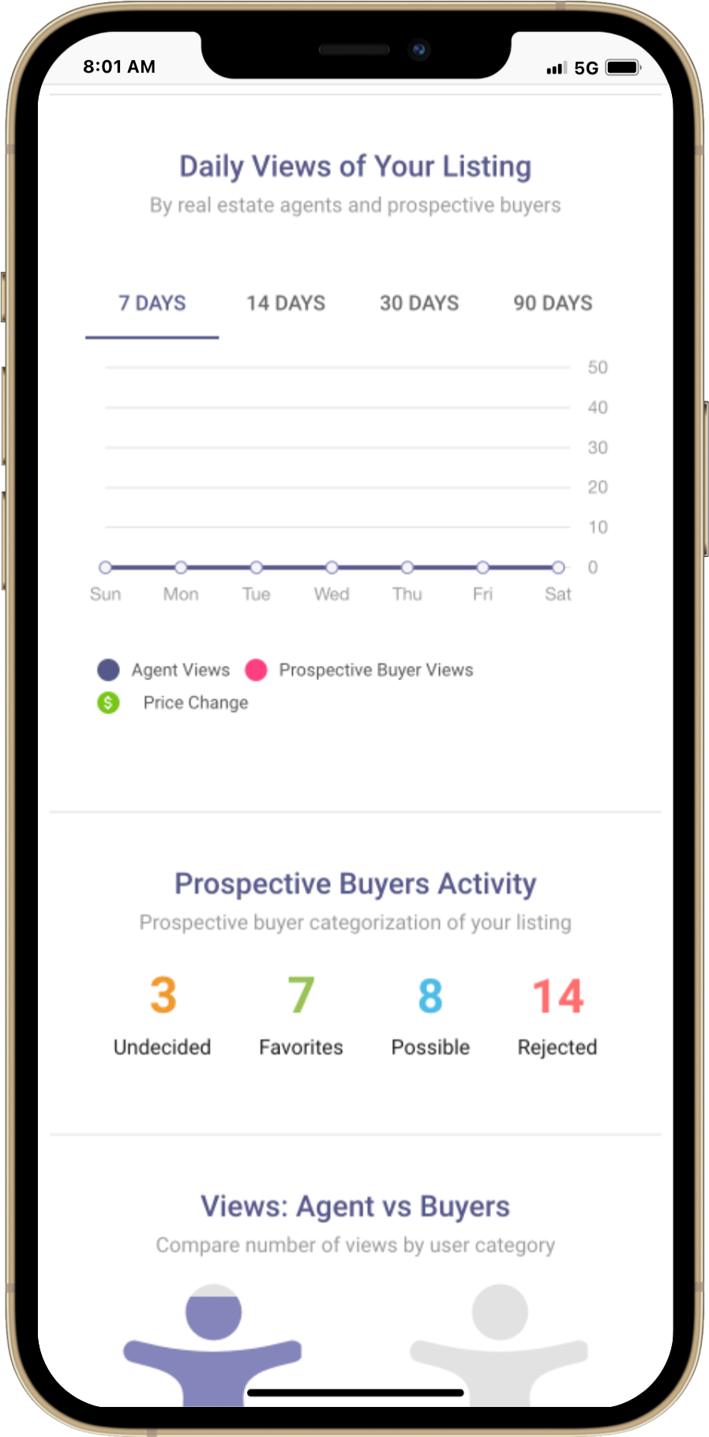
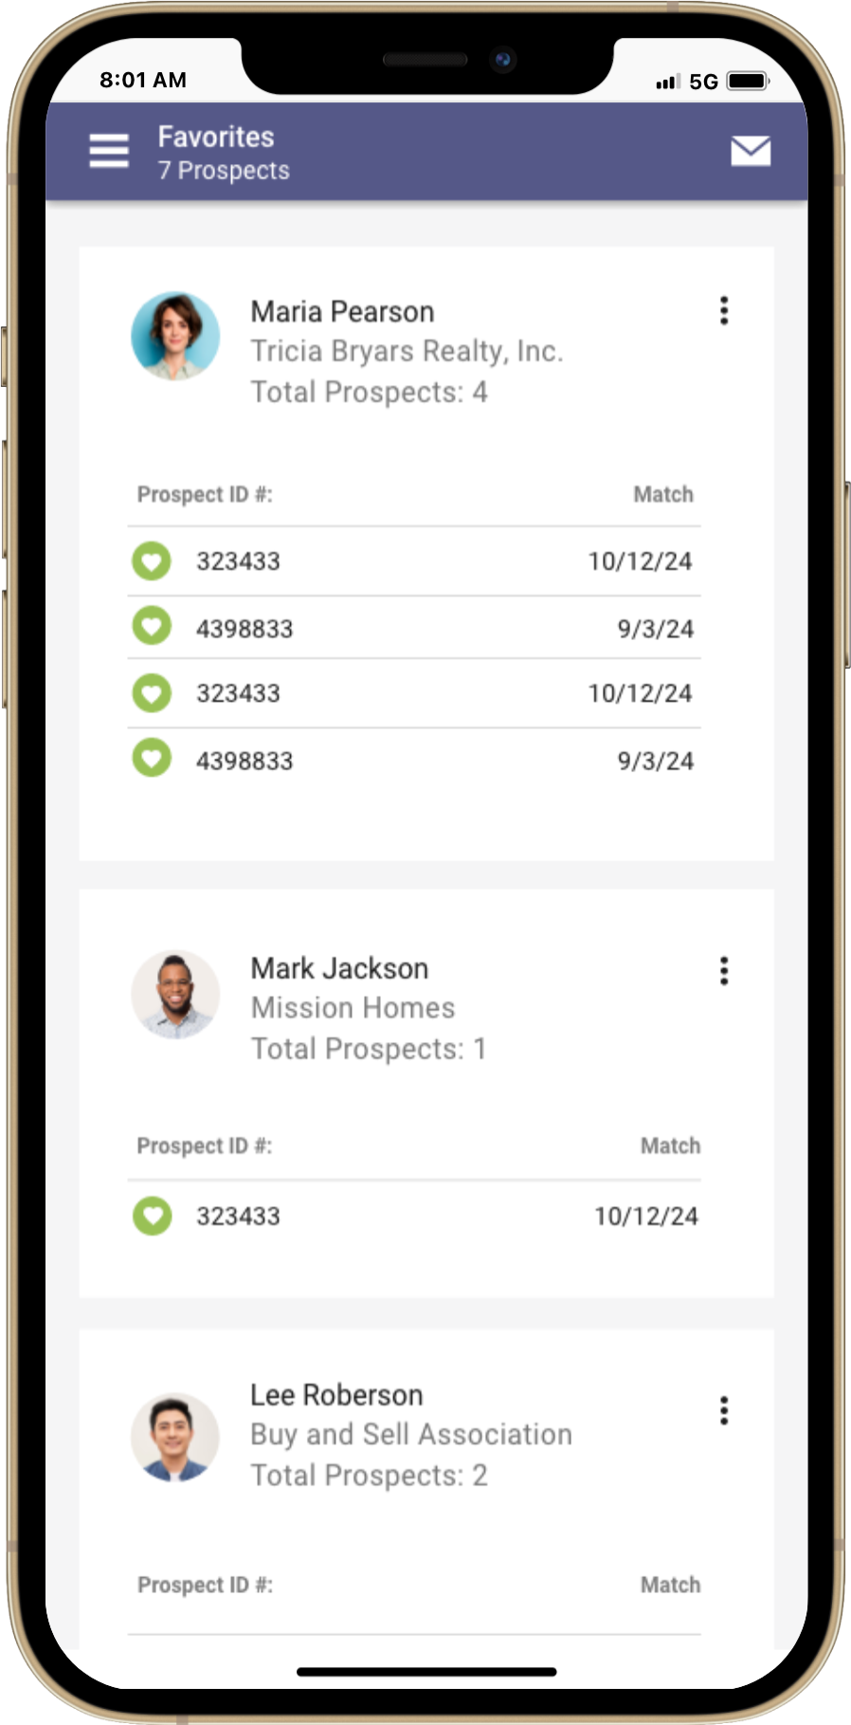
Sell Side Report

We've taken Reverse Prospecting to the next level with exciting new updates to the Sell Side Report! The report includes a dedicated section that tracks the total categorizations of all prospective buyers—giving you clear insights into how your listing is performing in the market. You’ll see the total counts for favorites, possible matches, and rejections, all in one place.

Agents can now click directly on these counts to access the same Reverse Prospecting report, allowing them to easily reach out to agents representing interested buyers. It’s a smarter, more connected way to track and engage with the market—helping you stay ahead of the competition!
Match My Contacts

If you're excited about all you've seen so far, it gets even better with an exclusive new feature in Paragon Connect! Imagine viewing a listing and wondering if any of your contacts might be interested. Now, with "Match My Contacts," you can get instant answers. Simply select "Match My Contacts" from the overflow menu while viewing a listing, and a report will show you which contacts have shown interest, the search name, and their level of interest. Plus, with just a tap, you can quickly call, text, or email those contacts directly from the report.

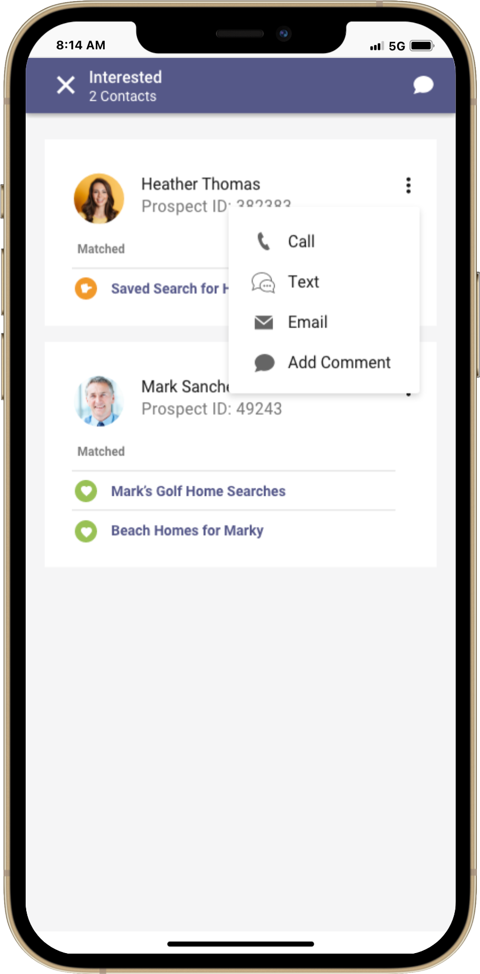
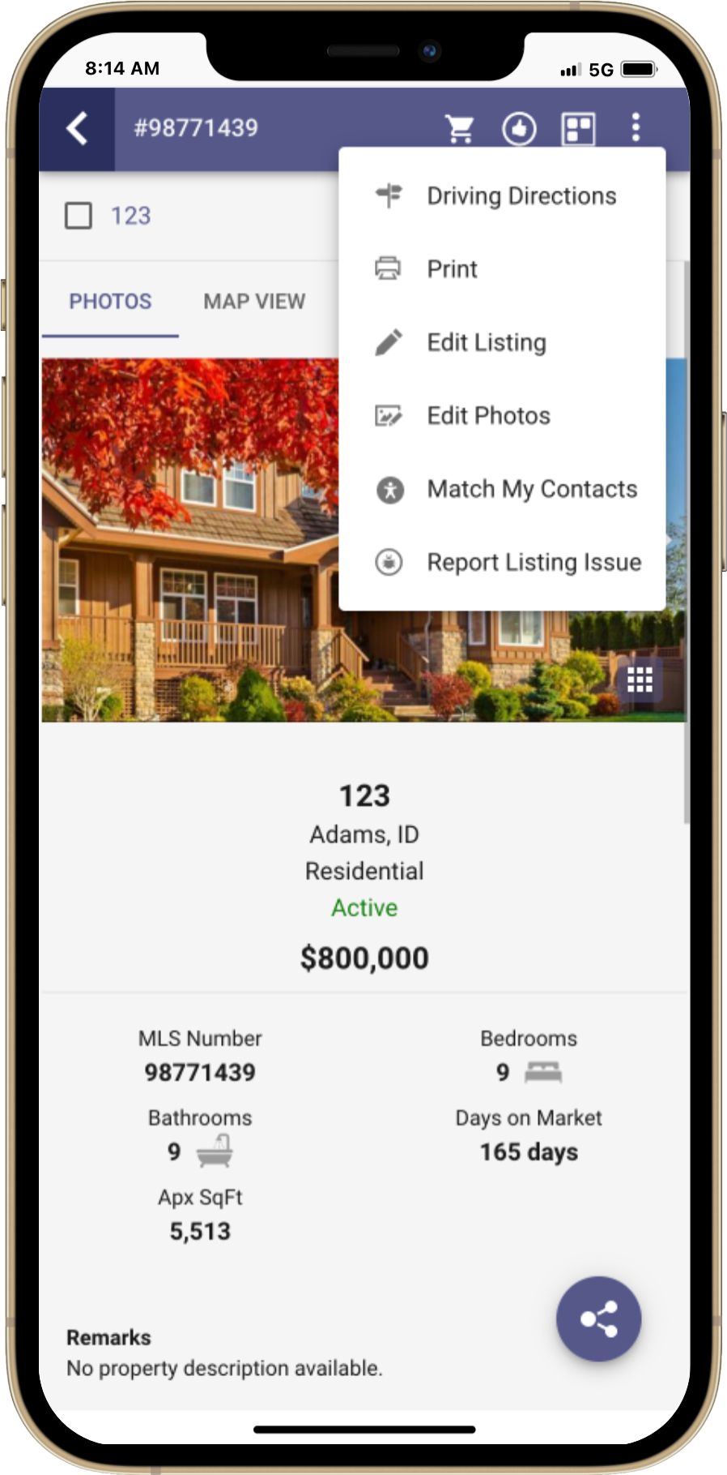

Note: Reverse Prospecting within Paragon Connect is separate from Paragon Pro. It does not use the same setup configurations nor the same email process. If agents/contacts are not participating in Reverse Prospecting within Paragon Pro, those settings are not applied to Paragon Connect.

This distinction allows Connect Reverse Prospecting to run against all contacts within the system providing accurate insights for contact matches. It also completely masks your Contact’s identify from the Listing Agent as well as any other agents who may have matching contacts.

New Dashboard Customization
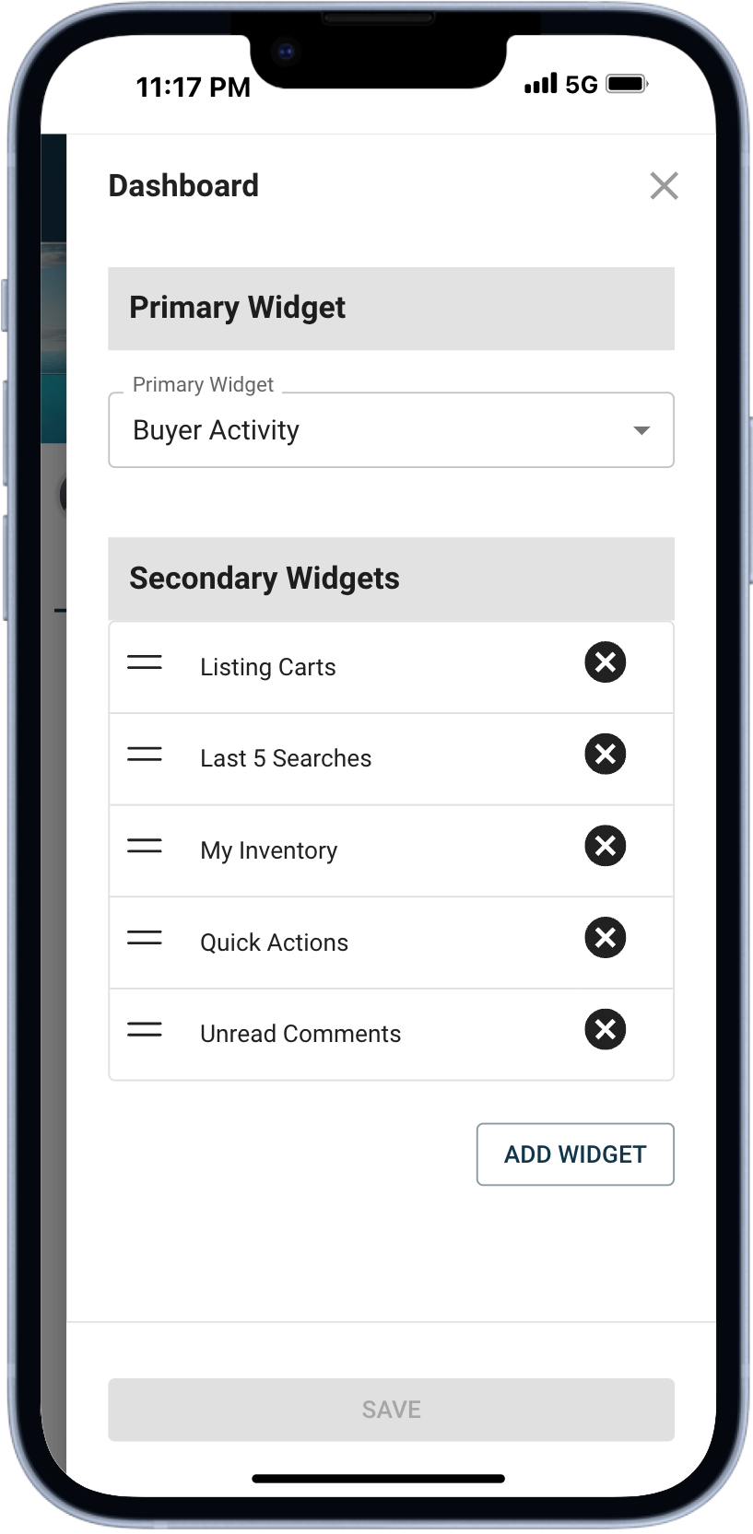
We are excited to introduce a game-changing upgrade to your dashboard experience! With this latest release, you now have the power to personalize your homepage like never before. Whether you want to reorder widgets, remove what you don’t need, or add new features, it’s all at your fingertips. This is just the beginning! Expect a growing library of widgets rolling out over time to make your dashboard even more dynamic and tailored to your needs. Ready to explore the possibilities? Let’s dive into the details of these exciting updates!
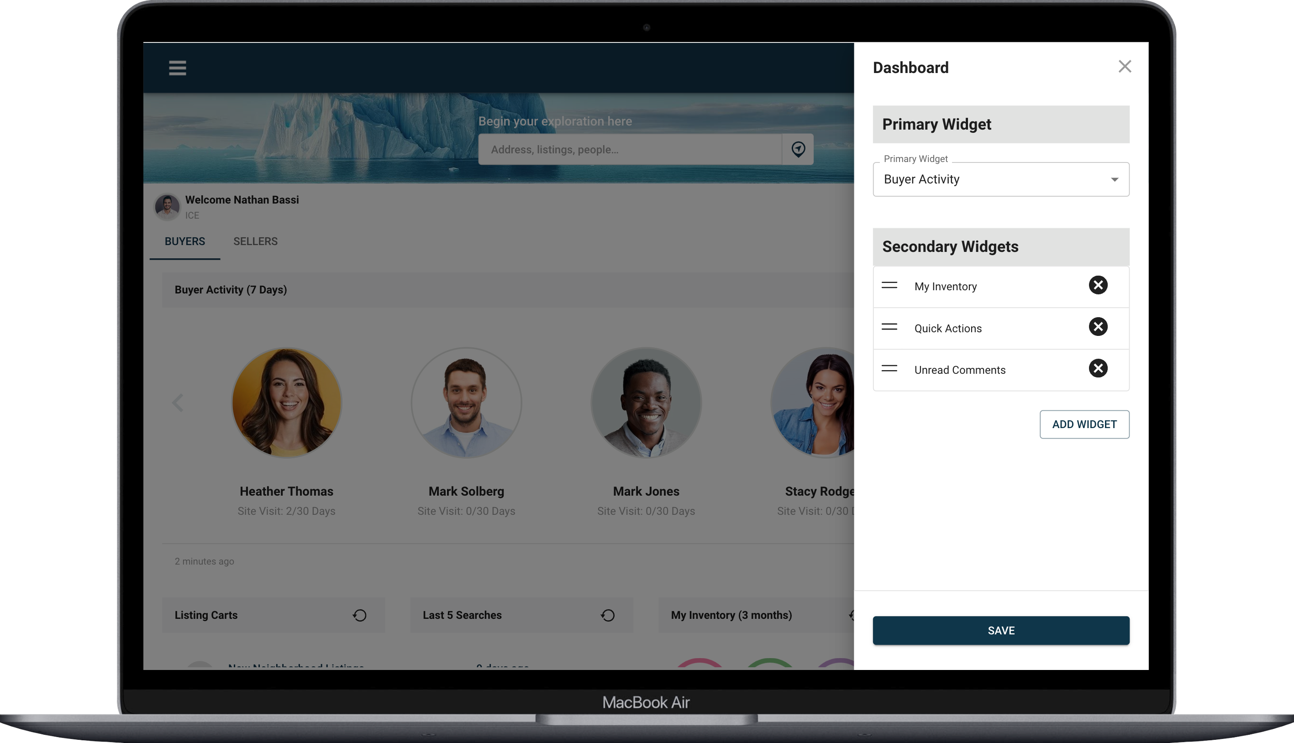

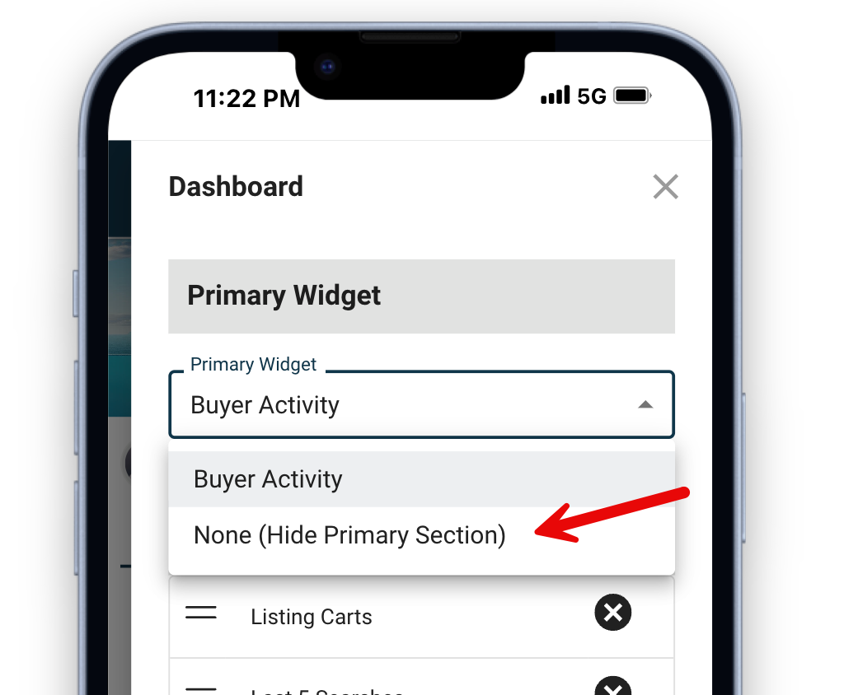
How to Customize
To customize the dashboard, simply click or tap on the new customize gear icon in the top app bar. This will open a customization screen that will allow you to adjust two types of widgets.

Primary Widget
The first type is called the “Primary Widget.” This is the large widget that expands to the width of the screen depending on the device you use. Today, there is only one widget called “Buyer Activity.” Soon, there will be additional primary widgets to choose from. If you are not interested in using a primary widget, you can also remove it from your dashboard.
Secondary Widgets
Say hello to Secondary Widgets, your go-to for adding flexibility and functionality to your dashboard. These compact, uniform widgets adapt perfectly to any screen size, delivering big value in a small package. You can remove, reorder, and even add new widgets. That's right, with this release there are four new widgets that you can add to your dashboard.
- Last 5 Searches
- Listing Carts
- Property Watches
- My Saved Searches
To add a new widget, you click/tap the gear to open the customization screen. Next you will click on the "Add Widgets" button. A new list will appear showing you all widgets not currently in use. You can also view a preview of the widget and get a description of what the widget will do.
On larger screens, you'll enjoy a sleek row of 4 widgets. Add more? No problem-additional widgets will create new rows, stacking seamlessly to fit your device.
Whether you're on a laptop, tablet, or phone, Secondary Widgets are designed to keep your dashboard looking sharp and working hard for you. Ready to stack your perfect setup? Start customizing today!
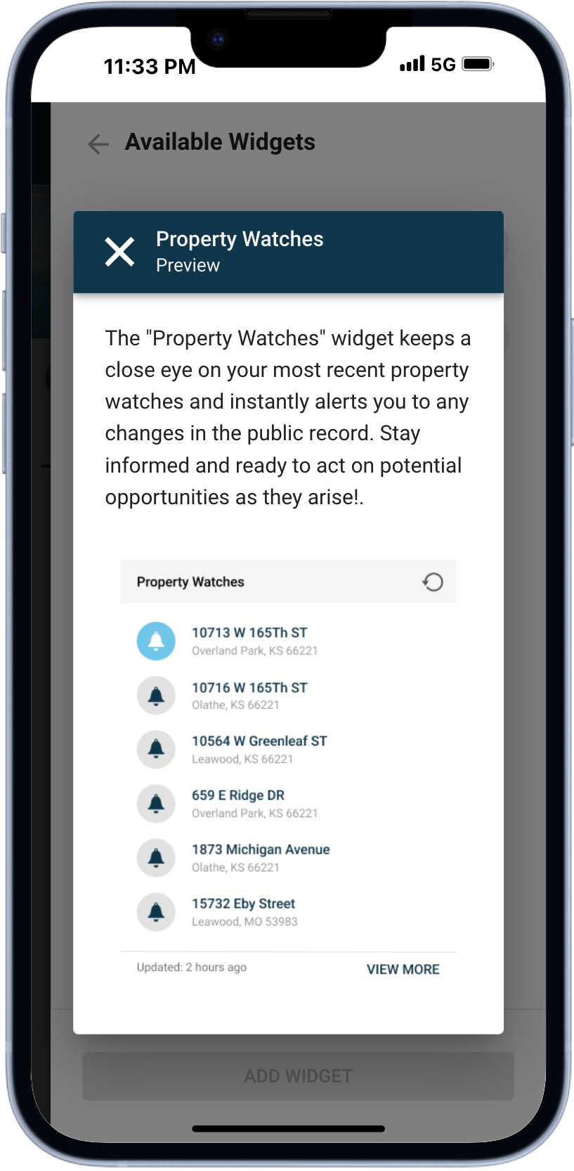
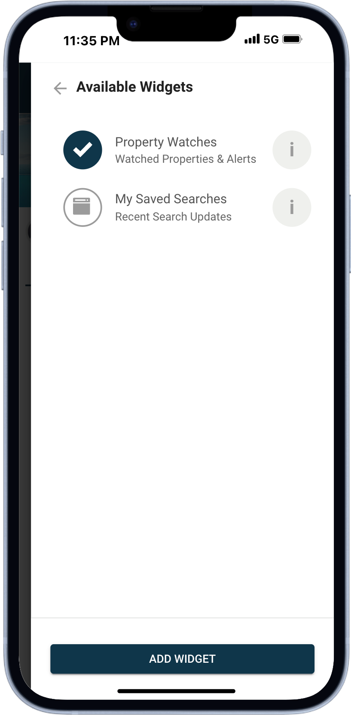
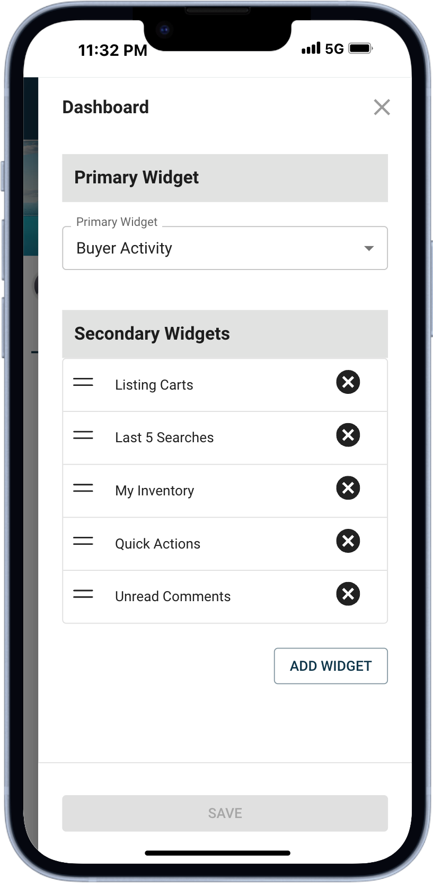

New: Last 5 Searches Widget
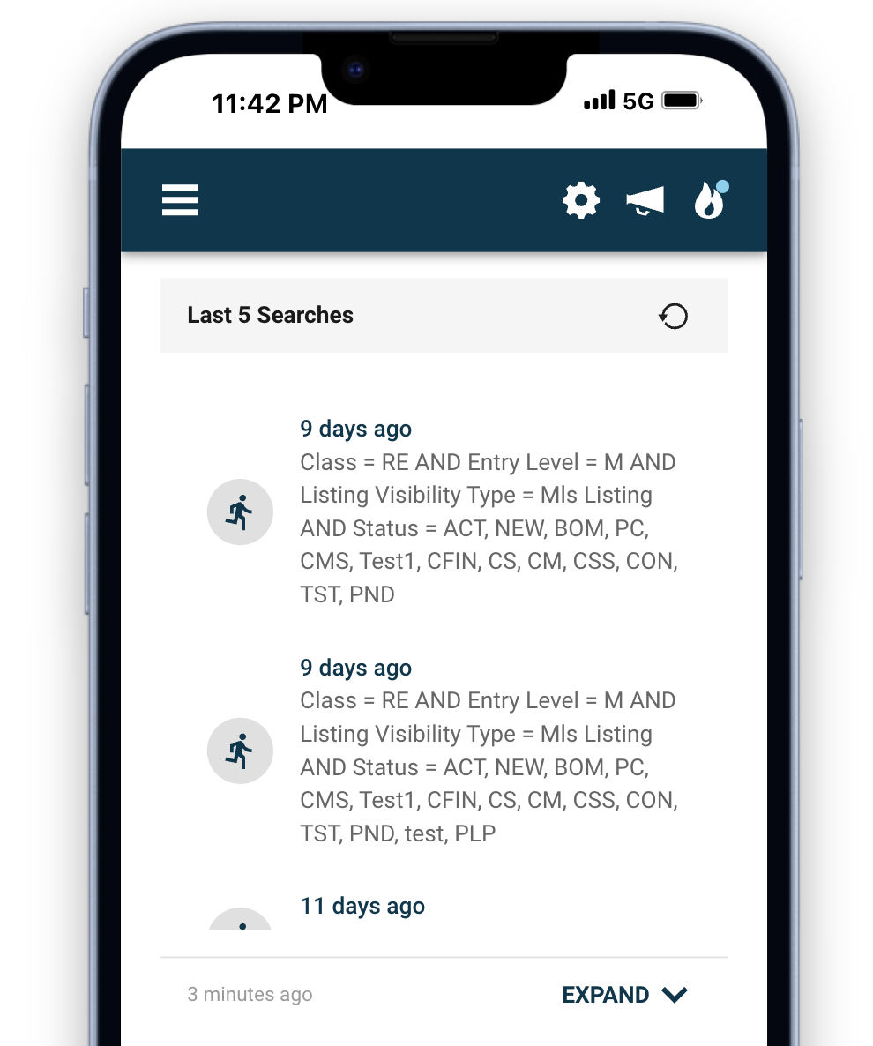
Introducing the Last 5 Searches Widget, designed to save you time and keep your workflow seamless. With just a few clicks or taps, you can instantly rerun any of your last five searches no matter the class!

Here’s how it works:
- Run Search Instantly: Click or tap the circular running icon to jump straight to your results in seconds.
- Edit Search Criteria: Prefer to make adjustments? Simply click/tap the date and criteria, and you’ll be taken to the search form with all your criteria pre-filled and ready to refine.
- Quick Refresh: This widget features a handy reload icon, so you can instantly refresh the data with a single click or tap.
- Expand/Collapse: Got detailed search criteria? No problem! Simply expand the widget to view the full content without missing a thing.

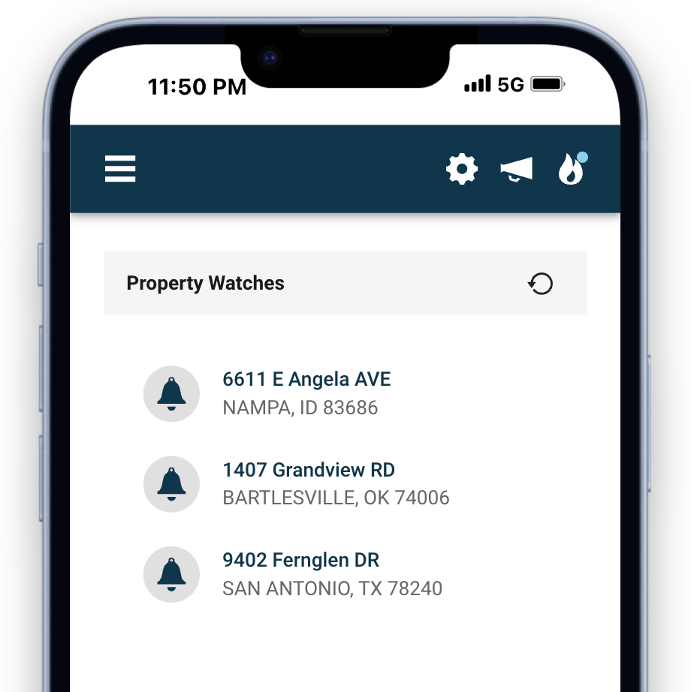
New: Property Watches Widget
Keeping tabs on important property updates just got easier. The Property Watch Widget gives you quick access to your watched properties and keeps you in the loop with any updates.

- Alerts: An alert indicator will notify you of any changes to a public record, so you’re always in the know.
- Full Report: Click or tap on any property to dive into a comprehensive public record report.
- Quick Refresh: This widget features a handy reload icon, so you can instantly refresh the data with a single click or tap.

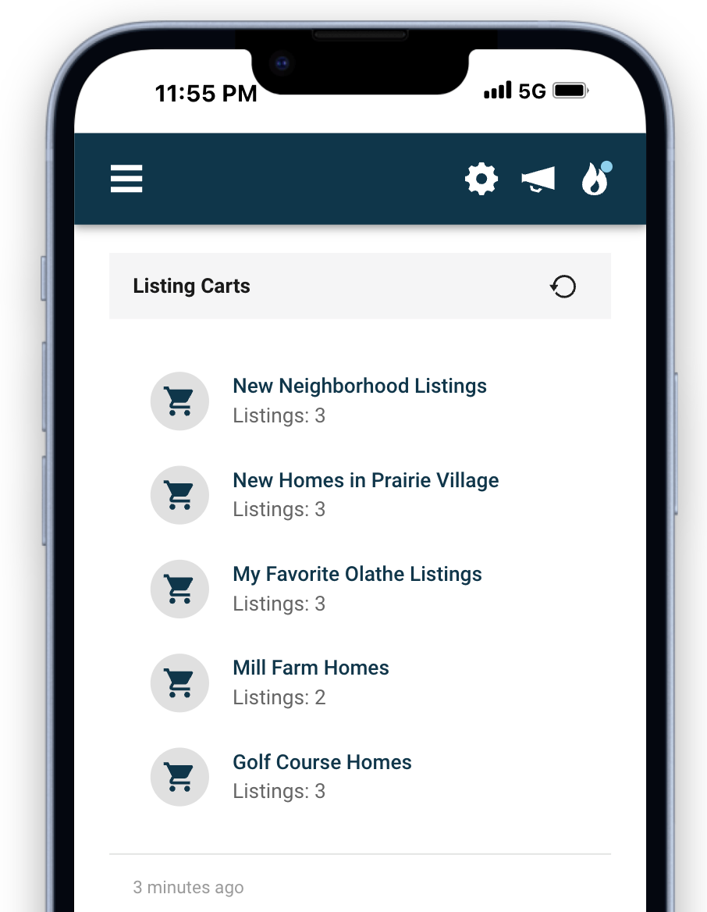
New: Listing Cart Widget
Real estate agents rely on listing carts to organize and store properties for various purposes. With the Listing Cart Widget, accessing your latest updates has never been easier.
- Quick Access: Instantly view and open your most recently modified listing cart directly from your dashboard.
- Quick Refresh: This widget features a handy reload icon, so you can instantly refresh the data with a single click or tap.

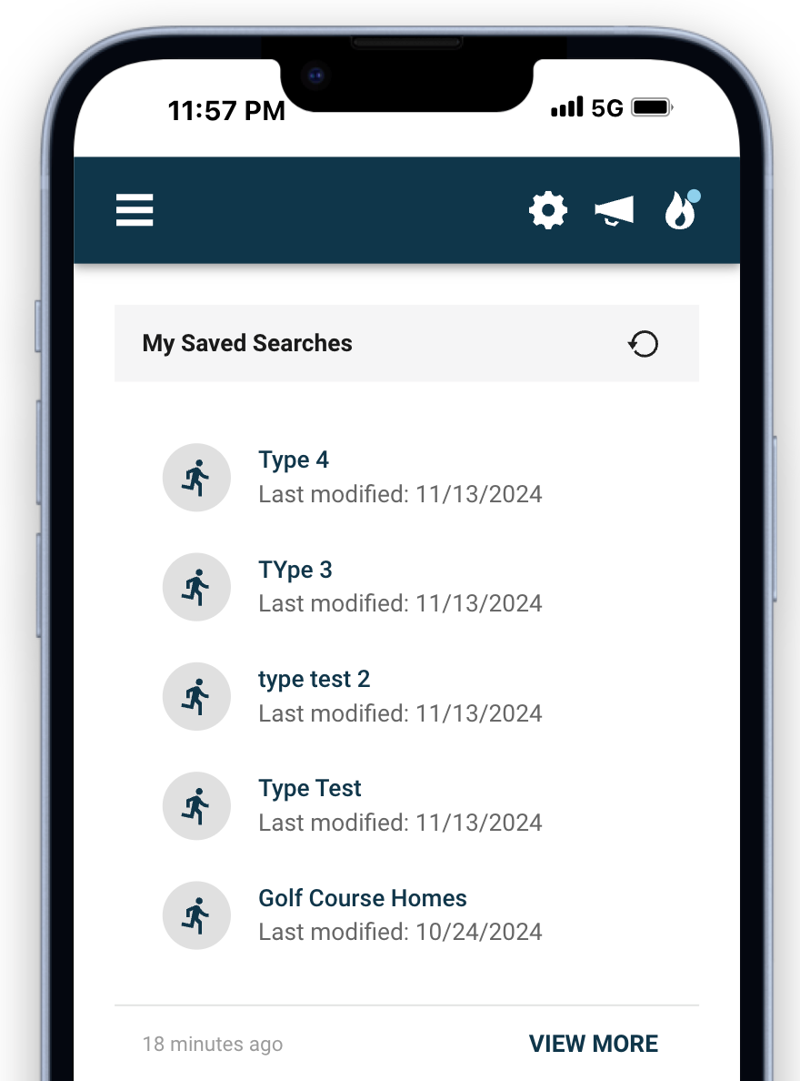
New: My Saved Searches Widget
In addition to the Last Searches Widget, we’re excited to introduce the Saved Searches Widget, giving you quick access to your most recent saved searches across any class.
- Run Search Instantly: Click or tap the circular running icon to execute the search and view the latest listing results in seconds.
- View or Edit Criteria: Simply click the search name to open the search form with all the criteria pre-filled, ready for review or adjustments.
- Quick Refresh: This widget features a handy reload icon, so you can instantly refresh the data with a single click or tap.
- View More: This link will navigate you to the “My Saved Searches” page where you can see all your saved searches

