
08

08
Fall

Fall

Paragon 9.5-9.7 Release Enhancements

13 January 2025

1. Corrected Paragon Issues 2
2. MLS Customizations and Administration 4
2.1. No MLS Customizations and Administration 4
3. Paragon Connect 4
3.1. Paragon Connect Corrections and Improvements 4
3.2. Interactive Map Layer Searching available in Connect 5
3.3. Timeframe option on Collaboration Center Updates Widget 7
3.4. Updates to My Saved Searches in Collaboration Center 8
3.5. New Side-by-Side Comparison View for Seller Competition 10
3.6. Update to the Email Opt-In/Out Subscription Manager 11
3.7. Listings about to Expire Alert 12

Corrected Paragon Issues
Ticket# | Module | Organization | Summary
TK-21870 | Configuration | RAE - REALTOR Assoc of Edmonton | RAE: Enabled new Consumer App, but app invite is not showing up in Paragon Pro or Emails
TK-21860 | WebAPI | NA - Not Applicable | OpenMLS: Typo Present in URL in @odata.context Parameter of Service Document/Root
TK-21828 | Email |  | Reactify email templates: add agent license to agent signature block
TK-21668 | Contacts | BCRES - REB2 Residential | Collab Link Contact Agent Email Your email address was not found
TK-21677 | Other | BCCLS - REB2 Commercial;BCRES - REB2 Residential;PARAGONMLS - Paragon Demo | Price change arrows do not display in the CollabLink
TK-21666 | Contacts | BCRES - REB2 Residential | Collab Center Listings Meet your Criteria 350 Matches displays even when more listings are available
TK-21646 | WebAPI | OBARMLS - Outer Banks AOR | OpenMLS: /Paragon Endpoint is Throwing "Sequence Contains No Elements" Constantly
TK-21549 | Login/SSO | BCCLS - REB2 Commercial;BCRES - REB2 Residential | Generate SP Metadata for both BCRES and BCCLS P130
TK-21523 | Search | RAE - REALTOR Assoc of Edmonton | Expiring Notification for Collab Center Notification Last Access date null, but can confirm Contact have accessed site
TK-18581 | Membership/Roster | NJMLS - New Jersey MLS (Bergen) | PC - display long description in Agent Type modal
TK-21440 | Data |  | EasyCMA: Agent Preferred Phone Number Does Not Display
TK-21241;TK-21486 | Contacts | NGLRMLS - Northern Great Lakes MLS;RANWMLS - REALTOR Assoc of NE WI | P5 & PC - Error Sending or previewing Welcome Email
TK-21085 | Search | SCKMLS - South Central Kansas MLS (Wichita) | Add support for Sale/Rent $0 - Zero price searching
TK-20758 | View/Reports | RMLSA - Regional MLS Alliance (Peoria) | CCR loading and then immediately switching to an error page
TK-3295 | CMA | BCCLS - REB2 Commercial;BCRES - REB2 Residential;GAMLS - Georgia MLS;HLMLS - Highland Lakes AOR;IMLS - Intermountain MLS;SCWMLS - South Central Wisconsin (Madison);SJSR - South Jersey Shore Regional MLS | EasyCMA: Requesting Enhancement of Photo types for ios devices
TK-18432 | LIM | PRIMEMLS - Prime MLS (NEREN) | Selling Team Field in PC LIM Working Inconsistently For Different Users
TK-505 | Configuration | NWBORMLS - Northwest Wyoming Board of REALTORS | P5 Field Admin - Show Default Value setting for bit fields (physnums 700-859)
TK-21358;TK-16269 | WebAPI | NWBORMLS - Northwest Wyoming Board of REALTORS;SCWMLS - South Central Wisconsin (Madison) | OpenMLS: No LookupName Annotation in $metadata When Lookup or Feature is Used as Formula
TK-12548;TK-12104 | Search | PRIMEMLS - Prime MLS (NEREN) | Stats Report Search Configs Incorrectly Being Applied to Inventory Search
TK-11834 | View/Reports | RAE - REALTOR Assoc of Edmonton | Driving Directions not functioning as expected

MLS Customizations and Administration

No MLS Customizations and Administration
Action Item: none

Paragon Connect

Paragon Connect Corrections and Improvements
- Improvement to include the Agent License to email template, when enabled
- Update to the Seller Welcome email to link to the My Property page on Collab Center
- Improvement to sort Reverse Prospecting results by Match Date
- Update to honor the VOW Address field per listing and hide the listing Street Address when viewed outside of professional systems, like on Collab Center and CollabLink
- Correction to update Paragon Pro when Agent Preferred Phone is set in Paragon Connect
- Improvement to display a Tool Tip for AVMs within the Valuations section of Collab Center view, when AVMs are enabled

Interactive Map Layer Searching available in Connect
In the past, Paragon Connect users had access to a basic set of default map layers to assist with their listing searches, offering only limited functionality. But now, we’re taking your map search experience to a whole new level! With this latest release, users can unlock the full potential of interactive map layers, transforming the way they explore and refine their search.

What are interactive layers?
Interactive layers are more than just shapes on a map—they’re your key to smarter, more efficient searches. These dynamic tools let you click or tap on specific shapes to filter listings based on the areas that matter most to you.
Need even more precision? You can apply filters using multiple shapes within a single layer, giving you the flexibility to narrow down your search like never before. And when you want a clean, focused view, simply disable the layer to highlight only the shapes you’ve selected. With interactive layers, finding the perfect listing has never been easier or more intuitive!
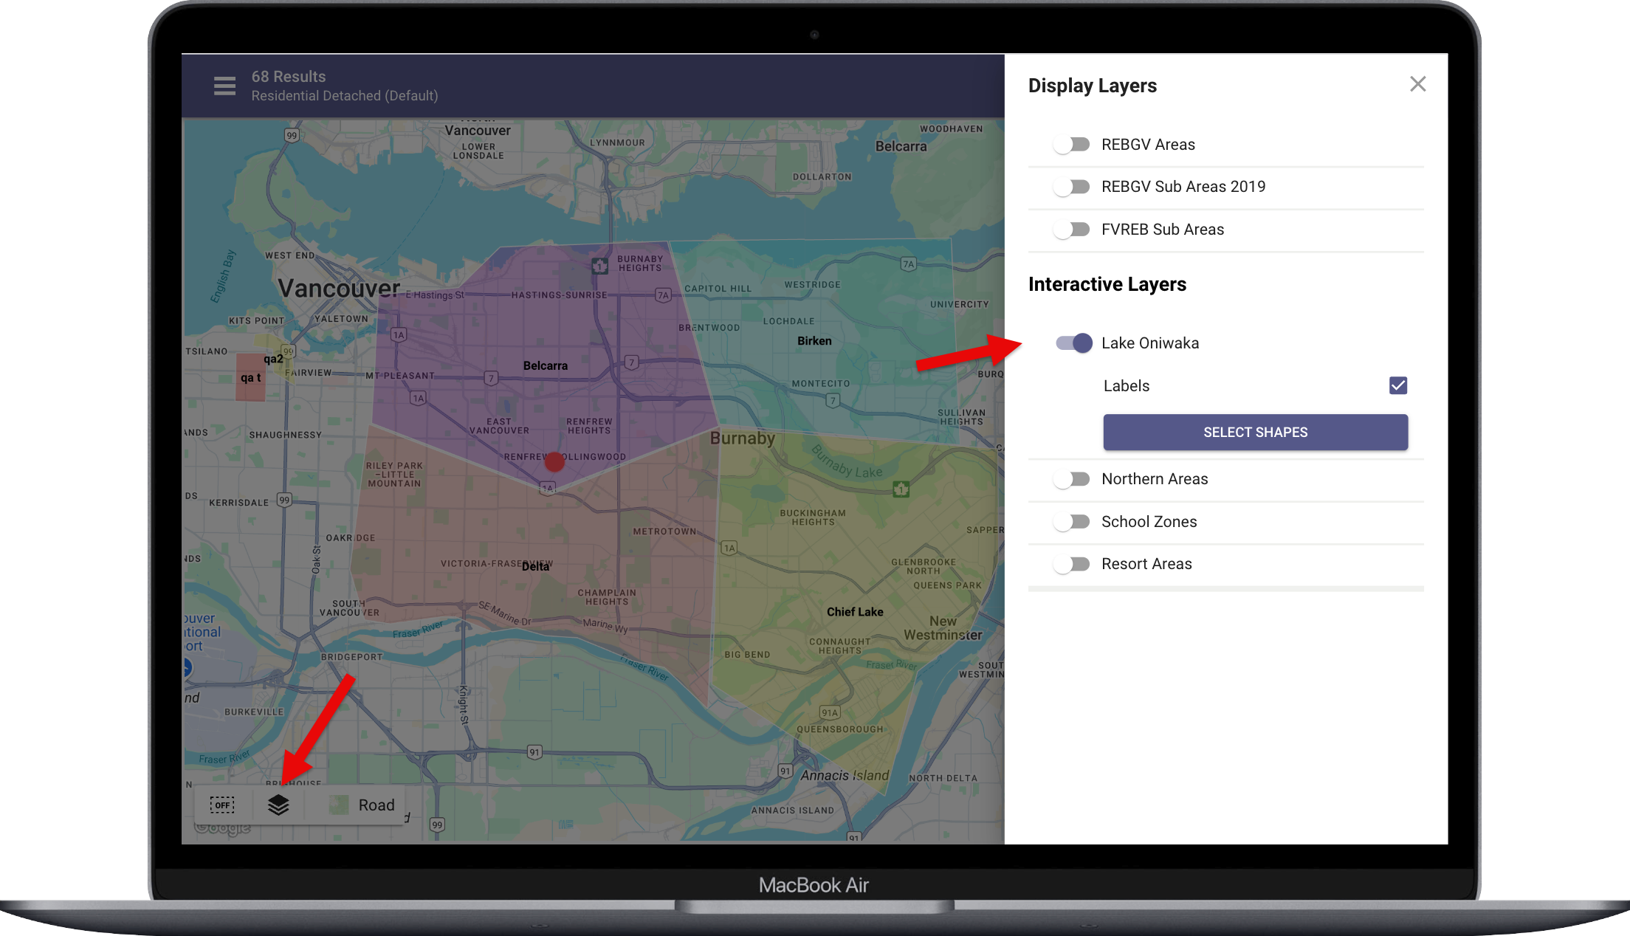
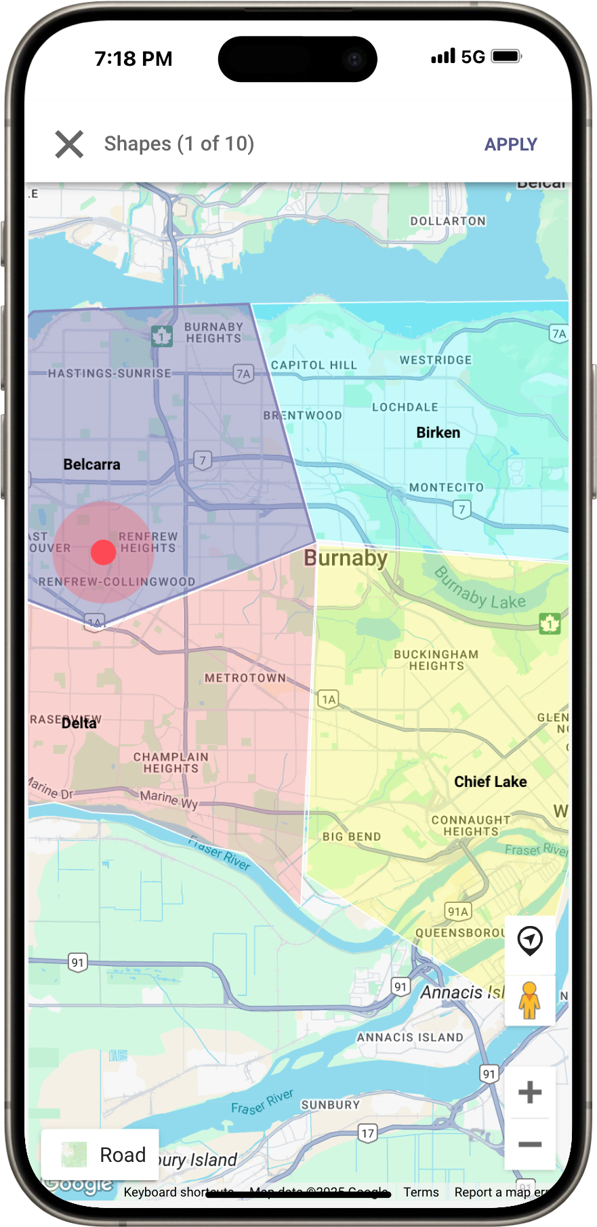

How to select shapes?
To filter listings using interactive shapes, follow these steps:
- Access the Layers Menu
Open your layers menu. Interactive layers will be listed below the “Display Layers” section.
- Enable an Interactive Layer
Select the interactive layer you want to use, then click or tap on the “Select Shapes” button. This action will close the layers menu and display the layer on the map.
- Select Shapes
Click or tap on the shapes you want to use as filters. To complete the process, click the “Apply” button.

Managing Interactive Layers
Interactive map layers are expertly managed by your MLS staff to ensure seamless functionality and availability within the system. For those with the proper permissions, you can take customization to the next level by creating your own interactive map layers in the Paragon Pro system. Simply navigate to Preferences > Interactive Map Layers and unlock the power of tailored mapping for a truly personalized experience.
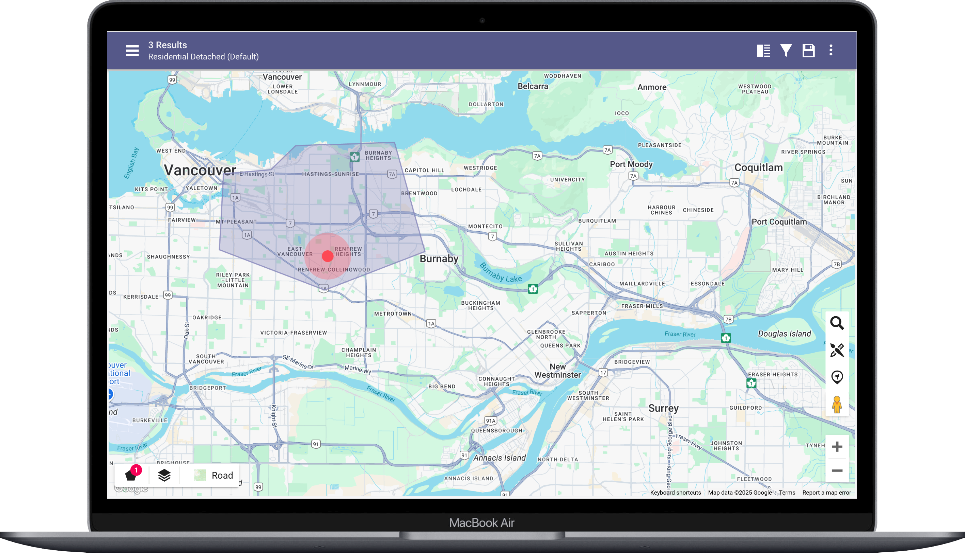
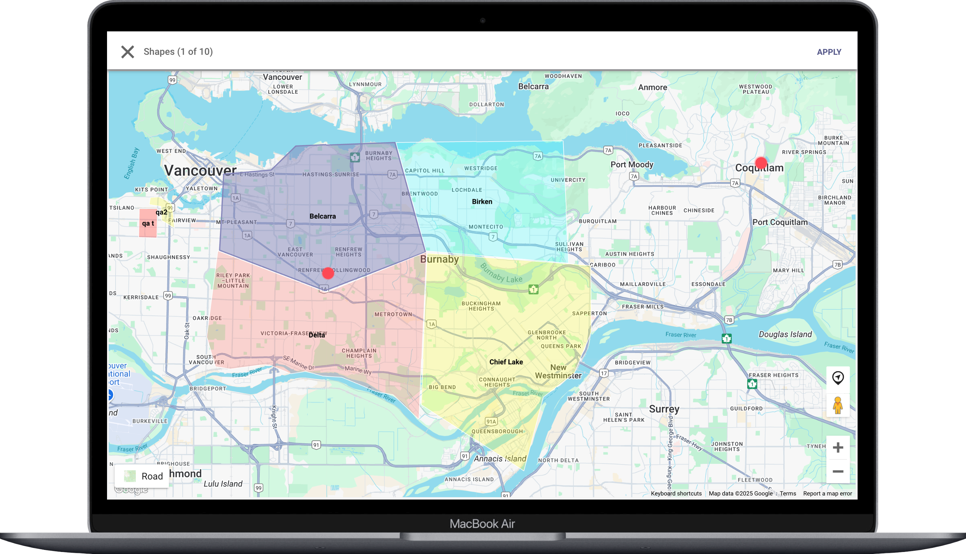

Timeframe option on Collaboration Center Updates Widget
The Updates Widget just got smarter! This essential feature helps your prospective buyers stay informed about new matches and updates to their listing searches—keeping them engaged and excited about their home-buying journey.
Previously, updates were only visible based on the buyer’s last visit. If they had limited time to explore, some updates could get missed and reset the next time they logged in. But not anymore!
With this release, we’ve introduced a powerful new timeframe option that puts control in the hands of your buyers. A simple button on the widget now opens a dialog where buyers can choose how far back they want to see updates.
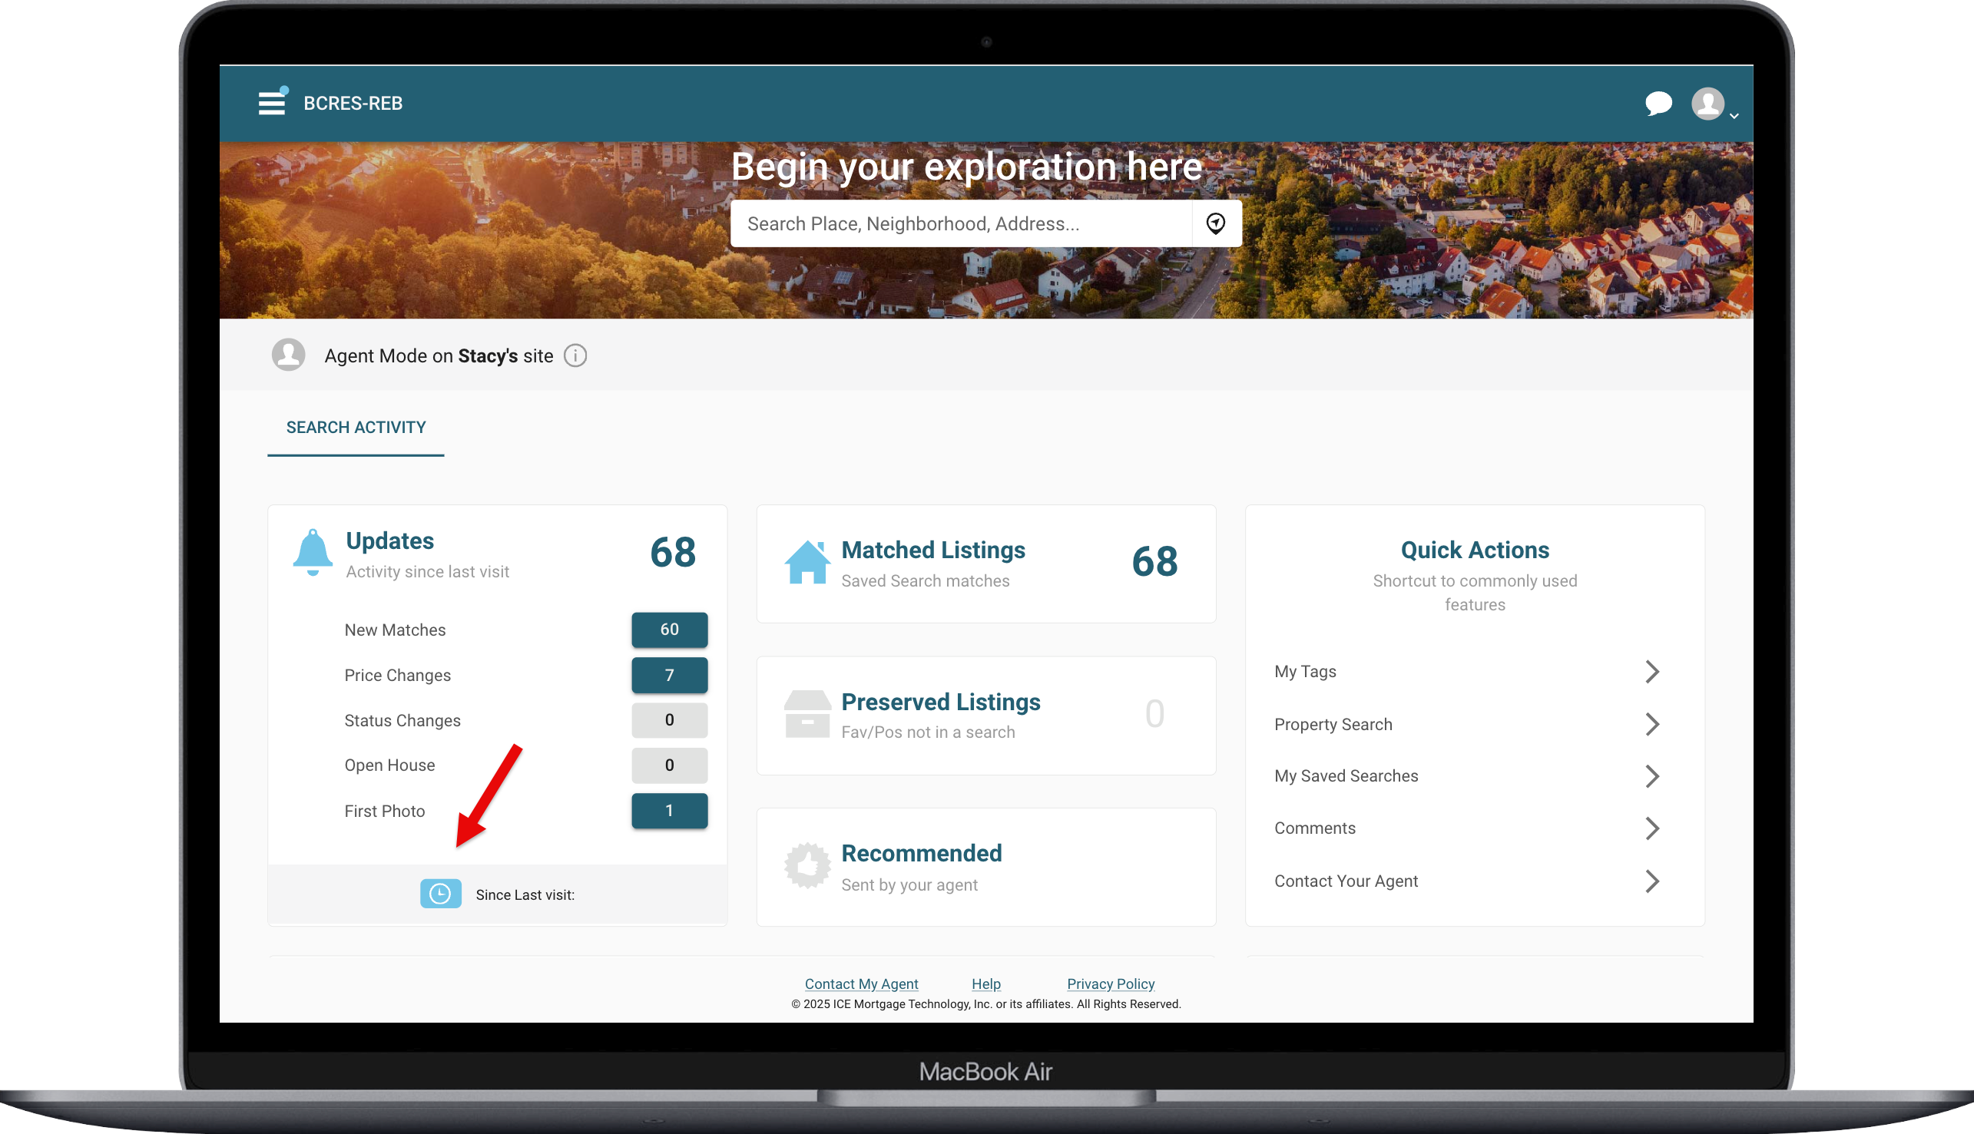

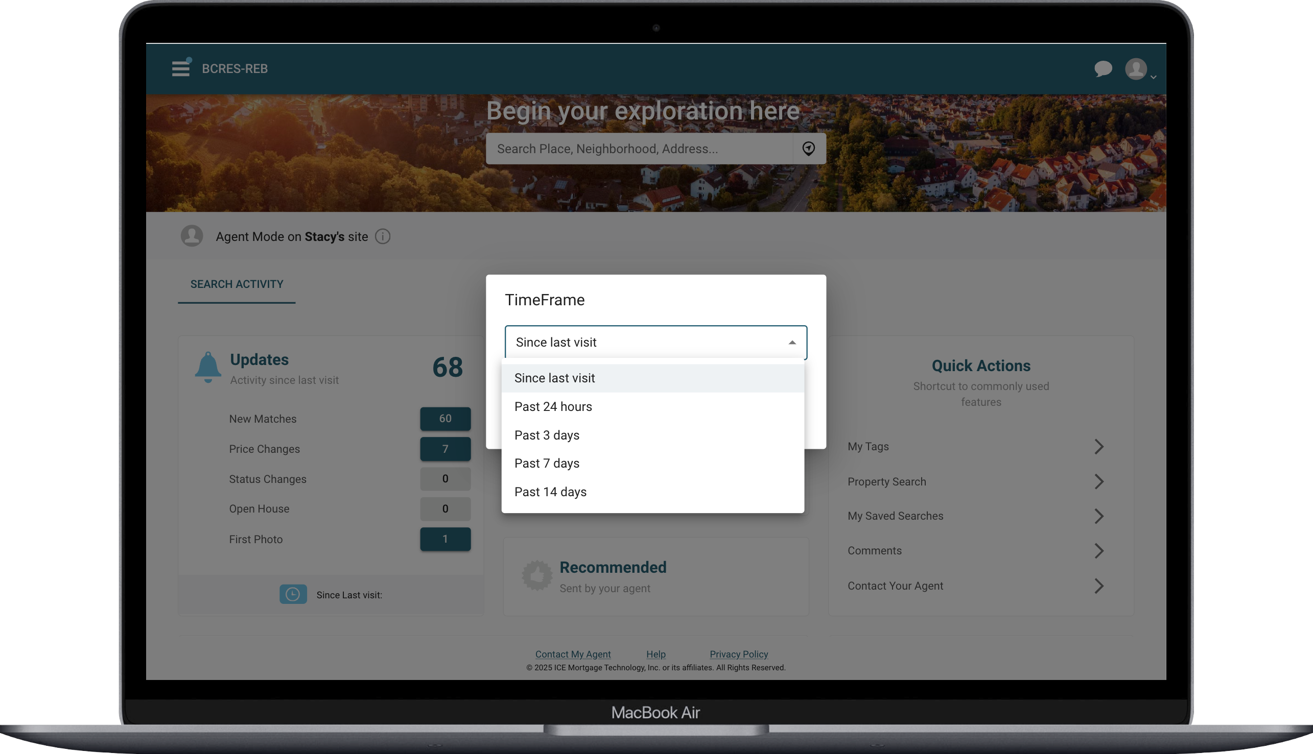

This added flexibility ensures buyers never miss important updates, giving them the confidence to make informed decisions at their own pace. With the enhanced Updates Widget, you’re not just offering convenience—you’re delivering a better buying experience.

Updates to My Saved Searches in Collaboration Center
Effortlessly managing your saved searches is essential for a seamless home-buying journey, and with this release, we’ve taken the saved search module to the next level. Previously, buyers could view a simple card displaying the search name, with options to run or edit their search. Now, we’ve supercharged this feature to provide even more value!
Buyers can still access their saved searches, but now each search includes a comprehensive breakdown: the total number of listings, plus counts for undecided, favorites, possibles, and rejected listings. Additionally, searches are now conveniently organized into two categories—buyer-created searches and agent-created searches. While buyers cannot edit searches created by their agent, they now have expanded control over their own saved searches, with even more editing capabilities.
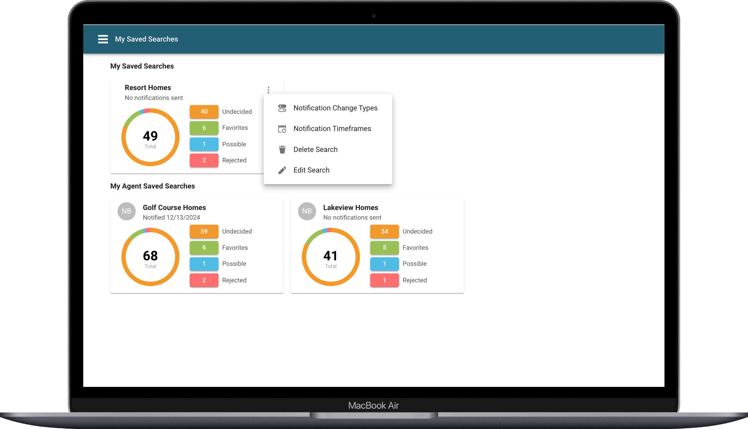
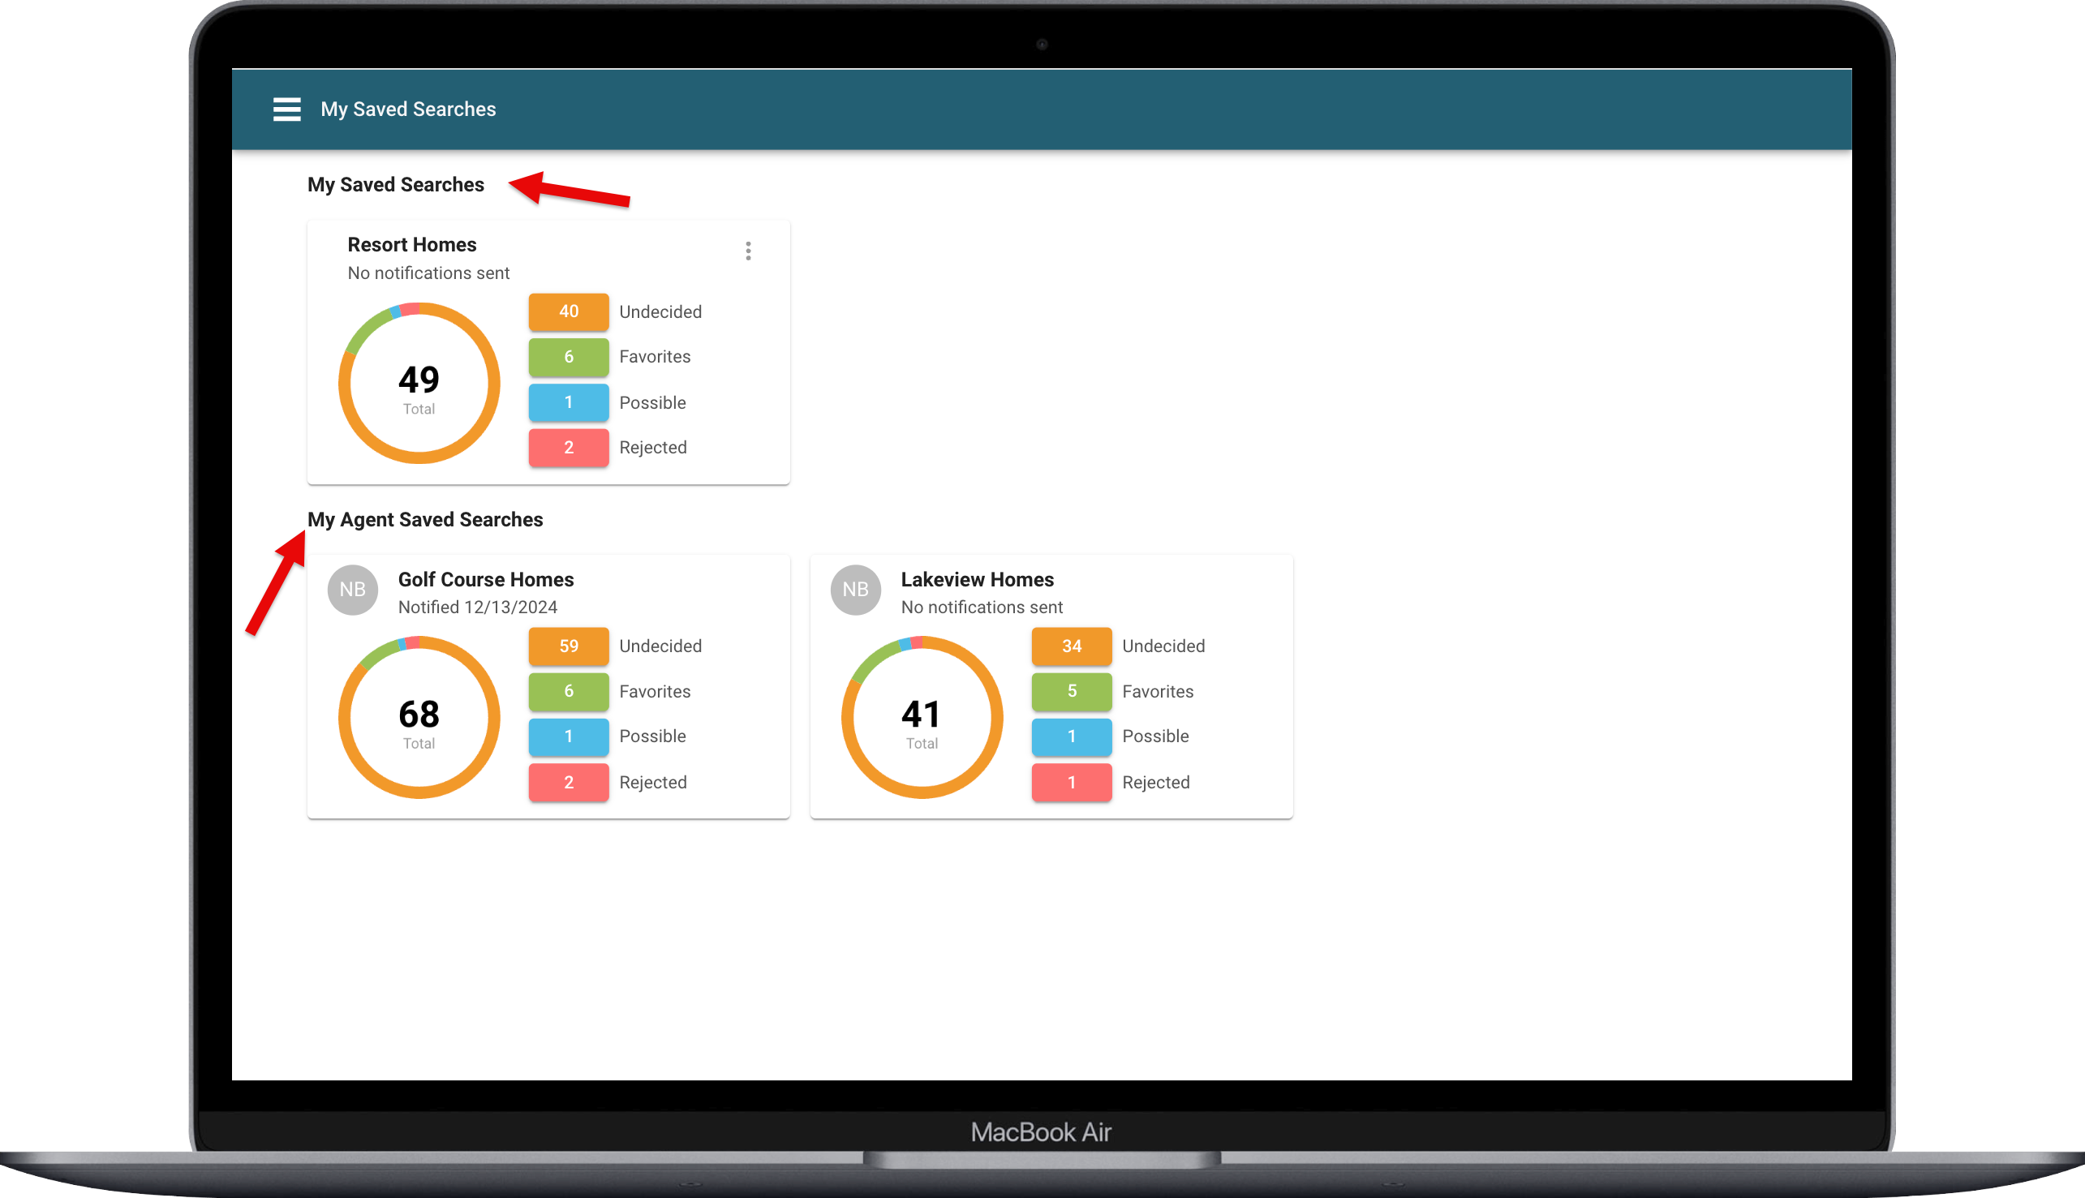

Notification Change Types:
Buyers now have greater control over the types of notifications they receive for the searches they create, ensuring they stay informed about what matters most to them!
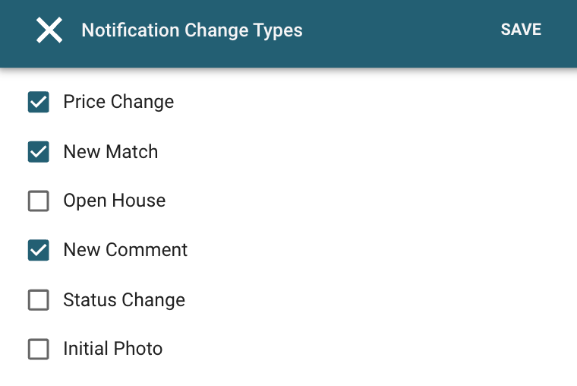
Notification Timeframes:
Buyers now have the flexibility to decide exactly when they receive notifications for the searches they create, putting them in full control of staying updated on their terms!
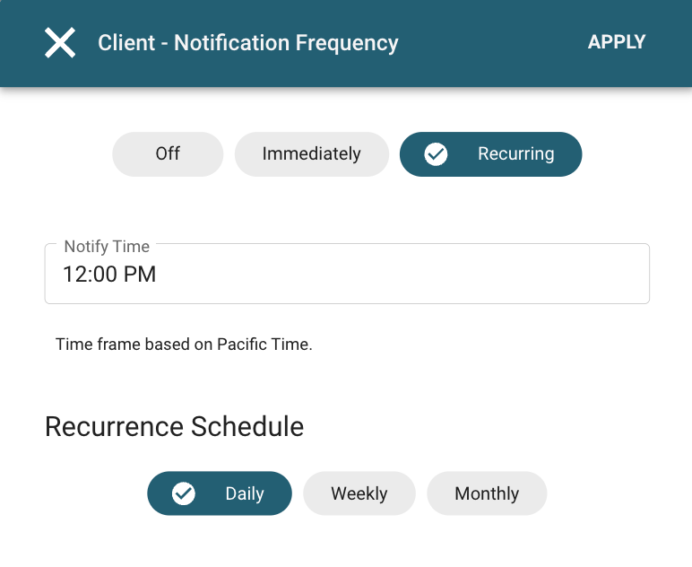

Delete & Edit
The updated search cards now come packed with exciting new features, but rest assured, the ability to edit and delete buyer-created searches is still available. These options have simply been relocated to the convenient overflow menu for a streamlined experience. Buyers can also view and run agent-created searches, maintaining seamless collaboration—though editing or deleting those searches remains restricted to ensure clarity and control.

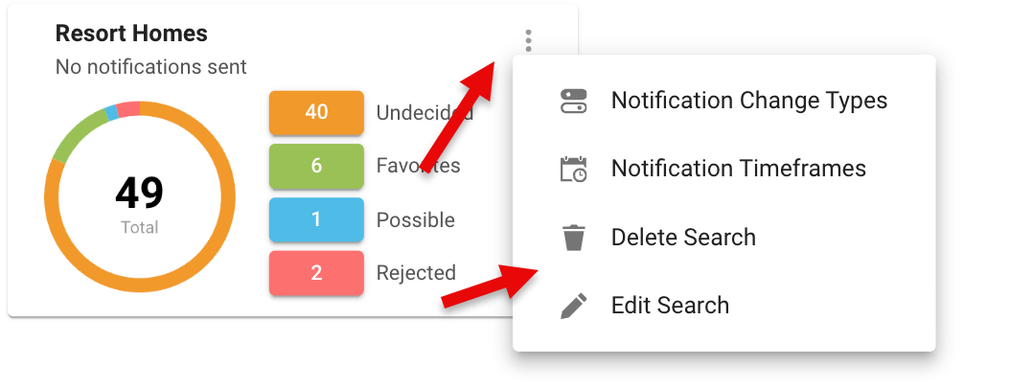

New Side-by-Side Comparison View for Seller Competition
The Sell Side Report just got a powerful upgrade! Previously, the map feature showcased competition properties comparable to your seller's property, with a recent update adding a thumbnail view below the map for quick access to detailed listing information. Now, we’ve taken it a step further with an all-new Compare option. This exciting feature allows you to view a side-by-side comparison of your seller's property and comparable listings, providing valuable insights and empowering you to make more informed decisions. It’s all about delivering the tools you need to succeed!
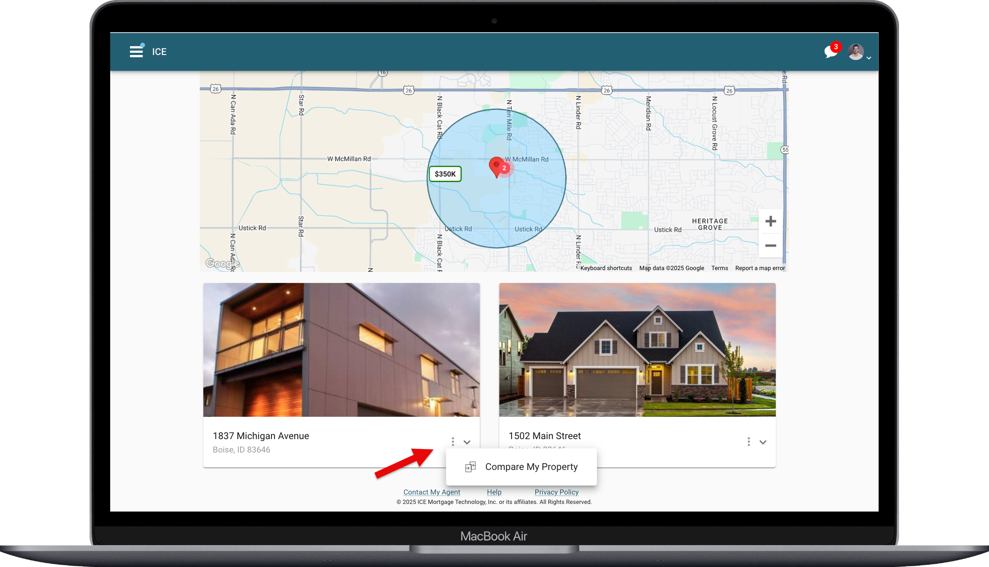

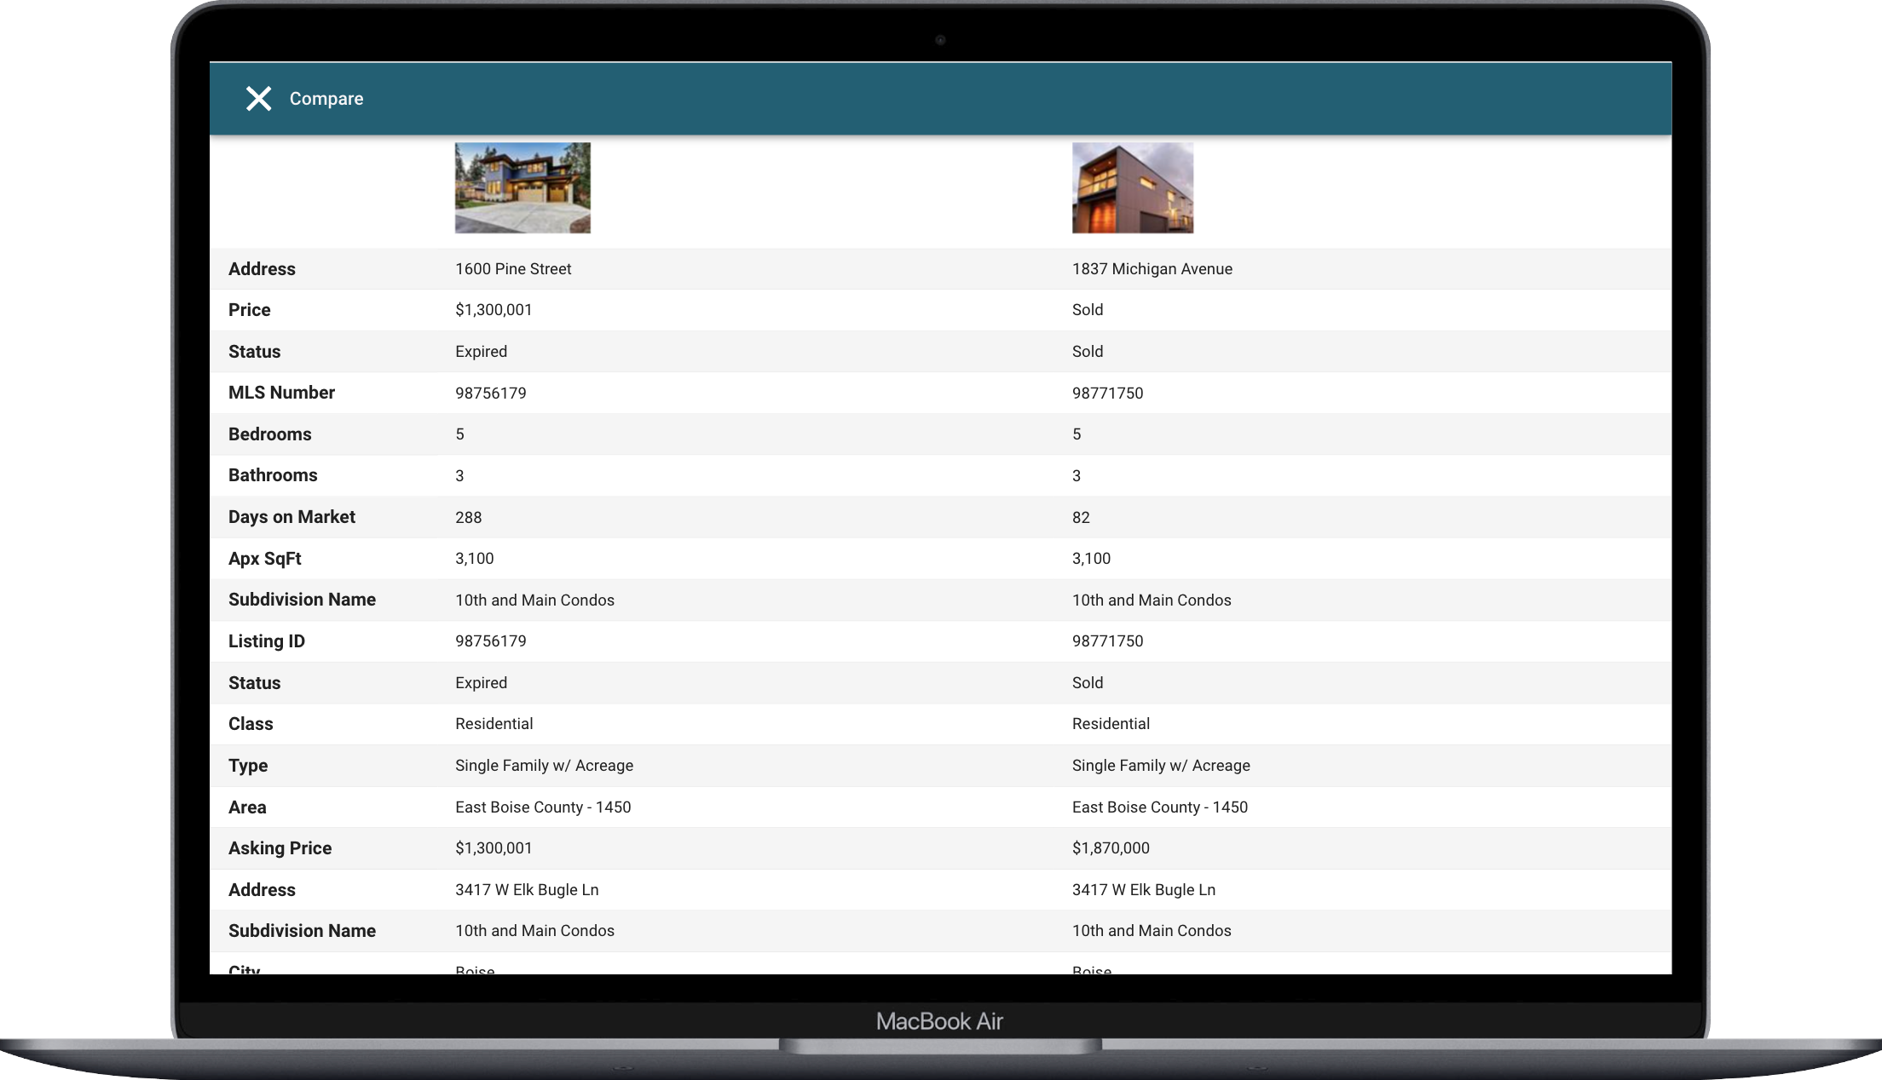

Update to the Email Opt-In/Out Subscription Manager
We’ve enhanced our Opt-In/Out Subscription Manager with exciting updates! These screens have been completely rebranded to align seamlessly with the sleek ICE logo and branding colors. But that’s not all—our streamlined workflow and simplified content make the entire process smoother, faster, and easier to navigate. Managing subscriptions has never looked better or been more user-friendly!
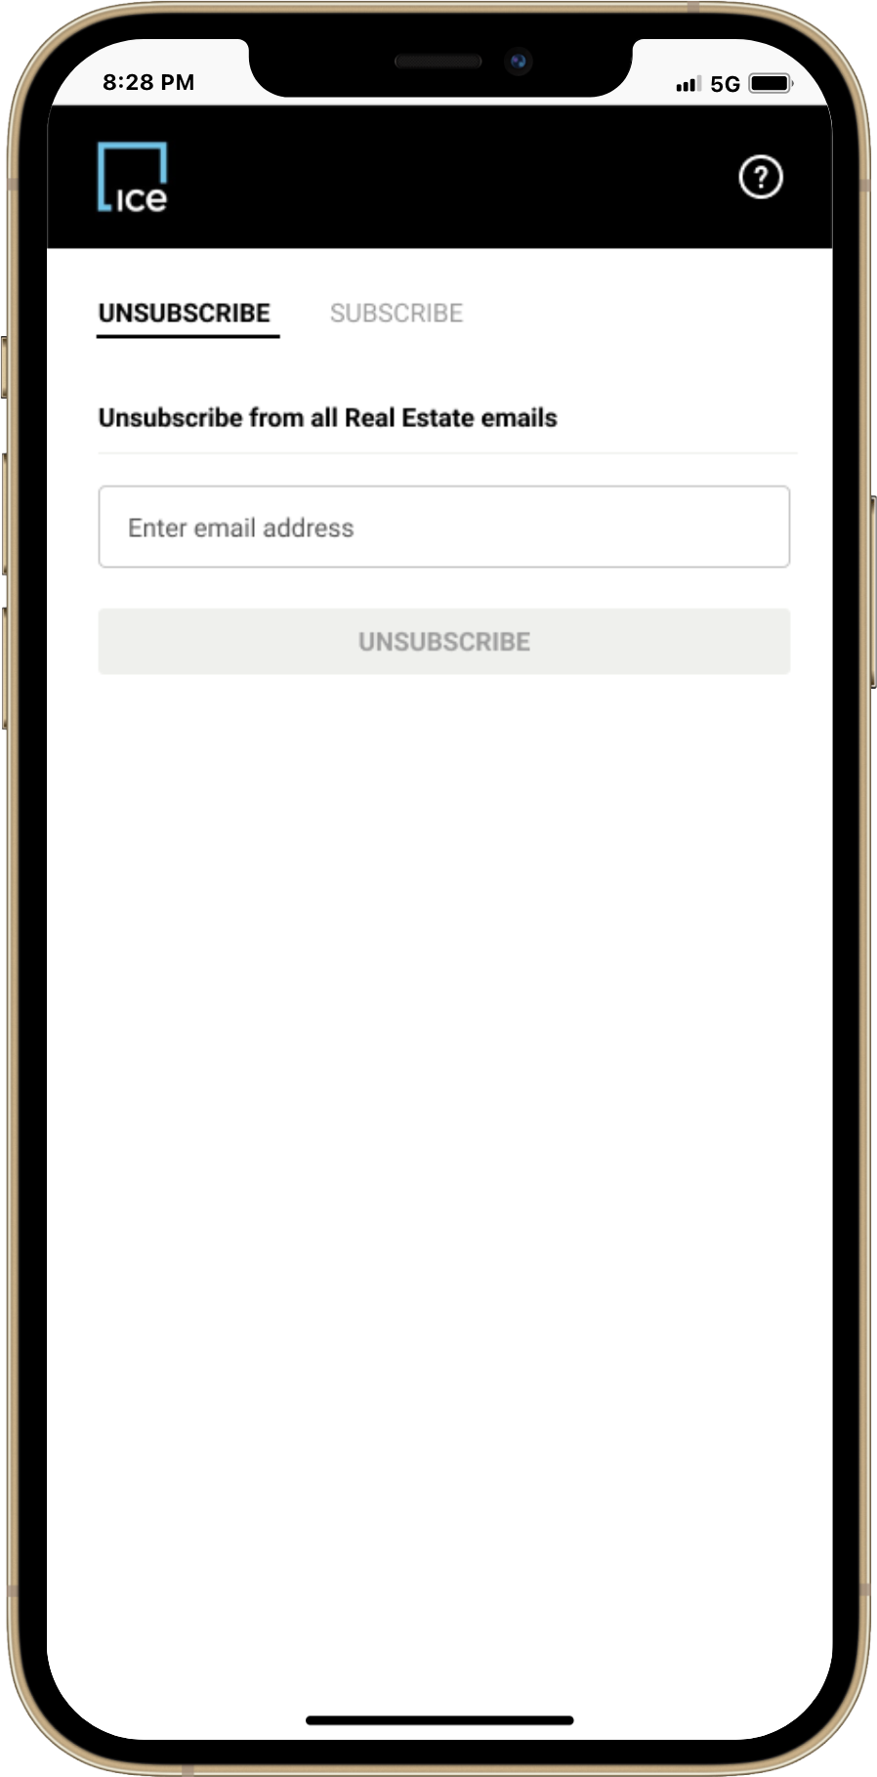
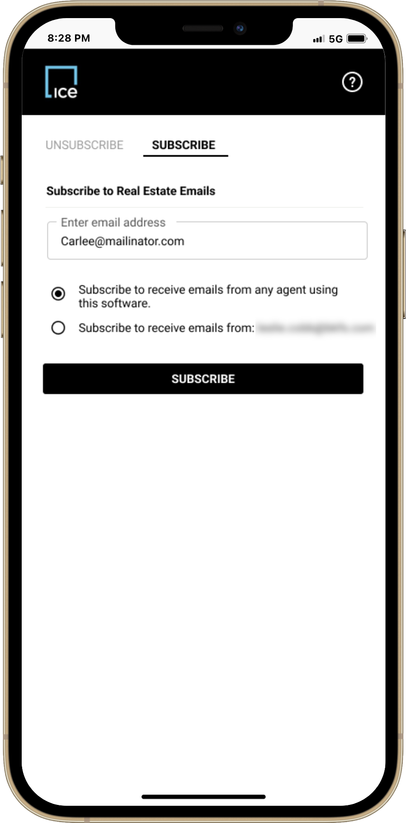

Listings about to Expire Alert
Listings are the lifeblood of any real estate professional. Keeping them up-to-date and live is critical to success. But every listing has a shelf life, and when one doesn’t secure a buyer in time, it’s set to expire. Missing that expiration can cost valuable opportunities. That’s why we’re excited to introduce a powerful new feature in Paragon Connect: Listing Expiration Alerts.
We have enhanced the Messaging Center with a dedicated alert section to notify you when a listing is approaching its expiration date. This ensures you never miss a chance to take action. With just a few clicks, you can jump straight into listing maintenance and update the expiration date to keep your listing active and visible.
But that’s not all. We’ve also streamlined the process with a new overflow shortcut in the LIM published list of listings. This shortcut takes you directly to the expiration date field in the listing edit form, enabling lightning-fast updates.
