
08

08
Fall

Fall

Paragon 7.2-7.3 Release Enhancements

25 April 2024

1. Corrected Paragon Issues 2
2. MLS Customizations and Administration 4
2.1. No MLS Customizations and Administration 4
3. Paragon Connect 4
3.1. Paragon Connect Corrections and Improvements 4
3.2. New Navigation through Listing Detail View 5
3.3. Assign a Listing to a Contact for Seller Dashboard Features 6

Paragon 7.2-7.3 Release Enhancements

Corrected Paragon Issues
Ticket# | Module | Organization | Summary
TK-14301 | Statistics | CREN - Colorado Real Estate Network, Inc, MAXEBRDI - MAXEBRDI MLS | Year to Year Stats Report Displays Incorrect Median Sale Information
TK-13800 | View/Reports | BCCLS - REB2 Commercial;BCRES - REB2 Residential;RAE - REALTOR Assoc of Edmonton | UI: Add a Border to the Listing Photo Selection Checkboxes
TK-18120 | Tax | MLSBOX - Greater Baton Rouge AOR | PC Tax Autofill - County field does not work with custom field label
TK-18090 | LIM | SCWMLS - South Central Wisconsin (Madison) | Off Market Date Being Updated by PC for Existing Off Market Listings When Re-Saved
TK-13798 | Search | BCRES - REB2 Residential;RAE - REALTOR Assoc of Edmonton | PC Hotsheet/TOH - Display current name of search when renaming it
TK-15992 | Hotsheet | CARMLS - CARMLS, Inc. (Arkansas);WVMLS - Willamette Valley MLS | PC - Hotsheet search keeps giving an error
TK-18399 | Search | TOPEKAMLS - Topeka BOR (Sunflower) | Saved Search Result Inconsistency between Paragon Professional and Paragon Connect
TK-18160 | Email | BCRES - REB2 Residential | Broken Image Icons on Seller's Side CC Notifications in Paragon
TK-16478 | LIM | NNRMLS - Northern Nevada Regional MLS | LIM UI - Listing Office 1 and 2 fields layout wraps oddly in LIM when using tooltip
TK-15398 | Data | VALLEYMLS - ValleyMLS / NALMLS (Huntsville) | PC - LIM updates to set LVT fields for proper DOM calculation
TK-5928, | Photos | BCRES - REB2 Residential, CCAR - Coastal Carolinas AOR, COLUMBIA - ConsolidatedMLS, CREN - Colorado Real Estate Network, Inc, GAMLS - Georgia MLS, GREENVILLE - Greater Greenville AOR, IGL - Iowa Great Lakes BOR, IMLS - Intermountain MLS, NSAR - NS and PEI Real Estate Associations, RAE - REALTOR Assoc of Edmonton, RMLSA - Regional MLS Alliance (Peoria), SCWMLS - South Central Wisconsin (Madison) | EXIF Orientation data causing Photos to Photos Appearing Upside Down on Listing in Safari and Apple Devices

MLS Customizations and Administration

No MLS Customizations and Administration
Action Item: none

Paragon Connect

Paragon Connect Corrections and Improvements
- Improvement to view the Listing Detail View for any Unpublished listing
- Improvement to include the social sharing options under Published listings
- Improvement to highlight the checkbox on Listing Photos for better visibility
- Improvement to show address locations closest to the user when typing into the Map Search Address box
- Improvement to include a new Clear Text icon within any open text field to easily remove any value
- Improvement to allow users with explicit configuration-permission the option to Delete Published listings
- Improvement to allow users the ability to Delete Unpublished listings

New Navigation through Listing Detail View
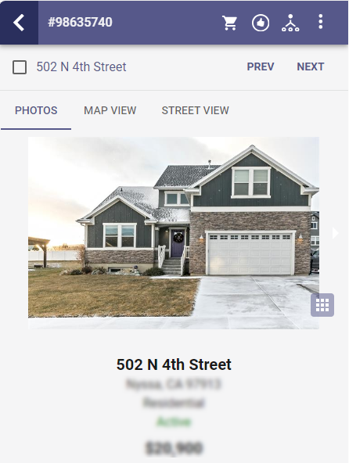
Users now have the option to page through search results using the Detail View.
From search results, after selecting any listing to open the Detail View, a new navigation option is shown near the top of the screen. Users can use the PREV and NEXT buttons to move forwards or backwards viewing the details for each listing through the entire list of results.
A new checkbox is included allowing users to make selections for listings as they review the results.
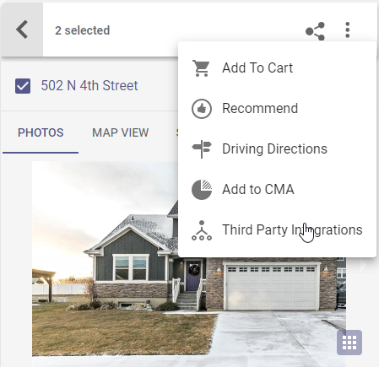
The top bar shows a count of all selected listings. Actions, like Carts, Recommend, Directions, etc are available for the selected listings.
The left arrow in the top bar returns to the previous results view.

Assign a Listing to a Contact for Seller Dashboard Features
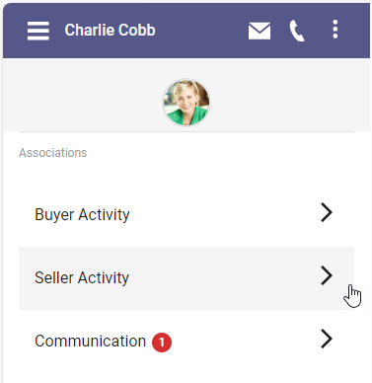
The Seller feature on the Collaboration Center sites is a powerful tool to keep Contacts informed of their listing activity so we made it easier to establish any contact as a seller.

Users have been able to link contacts to listings via the Seller Dashboard on Connect. With this release we added another way for users to link their listings to a contact.

From the Contact Summary page, the ”Seller Activity” option will always appear for all contacts. Any existing listings associated with the contact will continue to display.

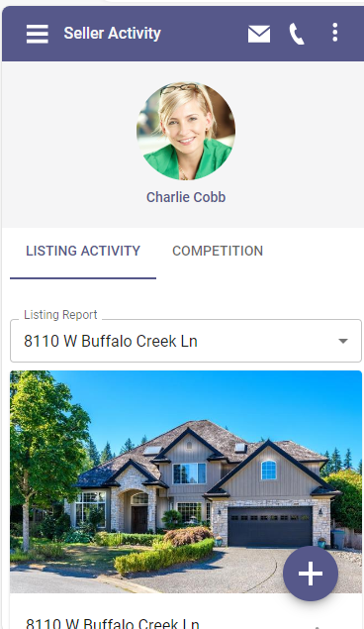
If no listings are currently associated, users will have a new option to add one of their listings to the contact using the + sign. Once the link has been established, the Contact will have all the benefit of the Seller-features on their Collaboration Center site and the agent will see the new association on their Seller Dashboard in Connect.

