
08

08
Fall

Fall

Paragon 7.5–7.6 Release Enhancements

20 June 2024

1. Corrected Paragon Issues 2
2. MLS Customizations and Administration 3
2.1. MLS Customizations and Administration 3
3. Paragon 3
3.1. New Option to Skip Restb.ai Photo Labels 3
4. Paragon Connect 4
4.1. Paragon Connect Corrections and Improvements 4
4.2. New Option to Add Listings to an Existing EasyCMA 4
4.3. Notification Options Now Available when Saving Search 4
4.4. New Page when Listings are successfully Published 5
4.5. New Options to Print the ConnectView 6
4.6. New Option to Show Checked Results 7
4.7. Notification Options Now Available when Saving Search 7
4.8. Agent Preview Process now Supported 8
4.9. New Share feature from Published Listings 9
3.9 New Warnings for Restb.ai Potential Violations 9

Corrected Paragon Issues
Ticket# | Module | Organization | Summary
TK-4345 | Prospecting | BCRES - Residential;RAE - REALTOR Assoc of Edmonton;SCWMLS - South Central Wisconsin (Madison) | Agent preview of client now showing incorrect numbers when selecting it.
TK-18474 | Third Party | MLSBOX - Greater Baton Rouge AOR;NTREIS - North Texas REIS | NTREIS - Integrations and Links missing from Resource page
TK-15764 | Data | GOREALTORS - Greater Owensboro Realtor Association | Duplicate class entries in a config breaks login processes - Add validation to config entry
DEV-13304 | Search | TRIANGLE - Triangle MLS | Easy CMA - Scroll and search together firing off more requests
DEV-13027 | LIM | PRIMEMLS - Prime MLS (NEREN) | PC : Contacts are displayed without name in Published listings > unassign contact pop
DEV-13267 | Search | PRIMEMLS - Prime MLS (NEREN) | Saving a Near Me Search causes issues with multi-class search template when returning for another search
DEV-13448 | CMA |  | EasyCMA: Office Logo Only Appears When There is a Disclaimer
DEV-13386 | CMA |  | EasyCMA: CMA Report Shows Error for Valuations
TK-18795 | View/Reports | NWBORMLS - Northwest Wyoming Board of REALTORS | PC Detail Report - Fix report to load correctly even if listing_room data is bad
TK-18663 | Contacts | PARMLS - Pensacola AOR | Quotation marks in Listing Cart Name
TK-18765 | View/Reports | PRIMEMLS - Prime MLS (NEREN) | Apostrophe in street address Breaks the 'Driving Direction' Feature
TK-18766 | LIM | NGLRMLS - Northern Great Lakes MLS | P5 - Contract Date of 06/06/79 causes error
TK-18771 | PowerSearch | MIMLS - MiRealSource | Datashare Listings in MIMLS Aren't Available in PowerSearch
TK-18807 | General UI | NTREIS - North Texas REIS | NTREIS - Subdivision overlaps display on extended thumbnail
TK-18853 | LIM | YUMA - Yuma AOR | PC: Yuma - Paragon Tax autofill is not working

MLS Customizations and Administration

MLS Customizations and Administration
Action Item: Contact your SSM to setup Restb.ai Compliance Violation Warnings
If using Restb.ai Compliance feature, there is a new option to enable warnings for specific violations. These warnings are presented to users as new photos are uploaded via Paragon Connect. If a newly uploaded photo is flagged with a potential violation, and that violation has been enabled for Warnings, then the user has the option to ignore the warning and keep the photo or delete the photo.
As an administrator, you can define which of the available Violation Types should be shown to the user as a Warning. You may enable Warnings for all Violations, or any sub-set. From the Paragon Pro Admin Menu, there is a new option called Listing Media Compliance Warnings. From this option you can set which Violations should be shown as Warnings at the MLS or Board level. Only Violations noted within this Warnings table will be shown to users as photos are uploaded.
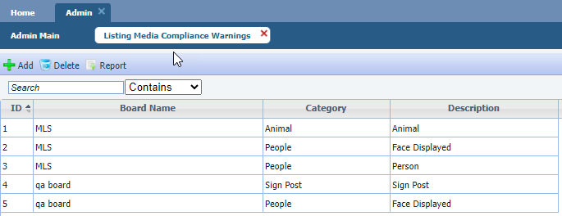

Paragon

New Option to Skip Restb.ai Photo Labels
This is an optional feature and is not available in all systems.

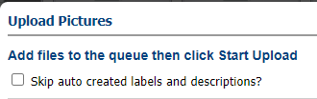
If Restb.ai Photo Label and Description auto-generation is enabled, users now have an option to skip this process. When uploading new photos within Paragon Pro, users will now see a new option. If the new “skip” option is selected then no photo labels or descriptions will be generated and no accessibility screen-reader data will be present for those images.

Paragon Connect

Paragon Connect Corrections and Improvements
- Improvement to the EasyCMA Dashboard search feature allowing users to find reports by the subject property address or any assigned Contact name
- Improvement to update the name under the Contact summary page from “Communication” to “Comments” making it easier to distinguish this option from the Message History
- Improvement to the Comments page layout with a new filter option making it easy to view Read vs Unread comments

New Option to Add Listings to an Existing EasyCMA
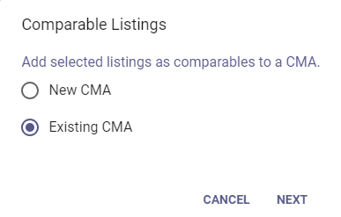
From search results, users have been able to select listings and choose to add those as comparables to a new EasyCMA. With this release, users can continue to start a new CMA or they have a new option to add listings to an existing CMA.
After choosing to add listings to an existing CMA, users will see a list of their existing EasyCMA reports. This list includes a new search feature to quickly find the CMA by subject property address or by any assigned Contact.
After selecting the CMA, the selected listing(s) will be added as new comparables. If any of the selected listings are not available to be included as a comparable, a new warning message will be displayed, and the user may continue to edit their CMA.

Notification Options Now Available when Saving Search
When creating a new saved search for a Contact, users now have the option to see and modify the Email Notification Settings for that specific search.

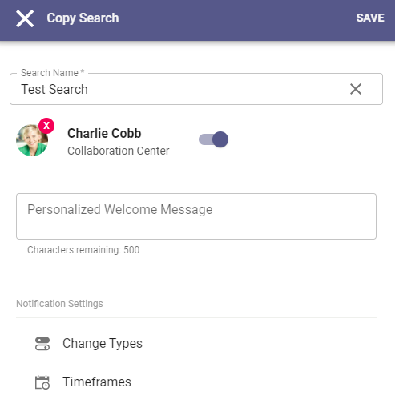
After selecting a Contact from the save, or copy, search option, the updated page will load a new section for notification settings.

The types of changes to be included in notifications along with the frequency timeframes may be adjusted. This gives agents quick access to personalize the notification experience while setting up the new search.

Agents can always go to the Contact Buyer Activity to make any additional, or future, adjustments.

New Page when Listings are successfully Published
When any new listing is created and saved successfully as a full, published listing, users will now see a new Success page.
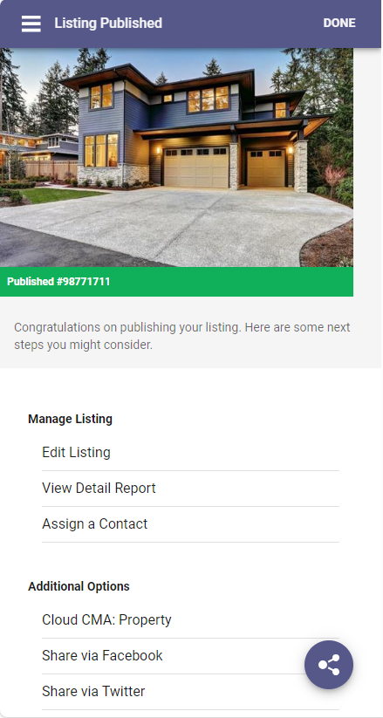
This page provides the new Llisting ID along with some common “next steps”.
Users may continue to edit their new listing, view the detail report, or assign to a Contact to enable the Seller features.

This new Success page also highlights any third-party integrations specifically enabled for Listing Maintenance.

The Share feature allows quick access to email, text, and share the new listing.

New Options to Print the ConnectView
With this release there are 2 new printing options available within Paragon Connect.
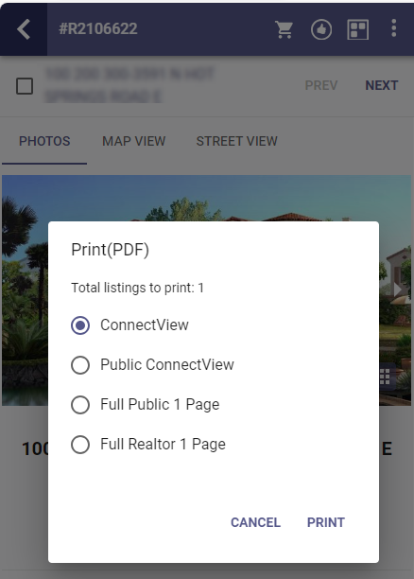
We have updated the existing Print option in the overflow menu from search result and the individual detail view.
With this update users will see options to print the ConnectView, which is the professional-agent version of the listing detail, and the Public ConnectView, which is the public version of the listing detail view.
The ConnectView prints the primary photo, and up to 4 secondary photos, along with all the information within the Property Details section, and the Listing Agent/Office information.
The Public ConnectView also prints the primary and 4 secondary photos along with all the information configured to display in the public CollabCenter detail view.
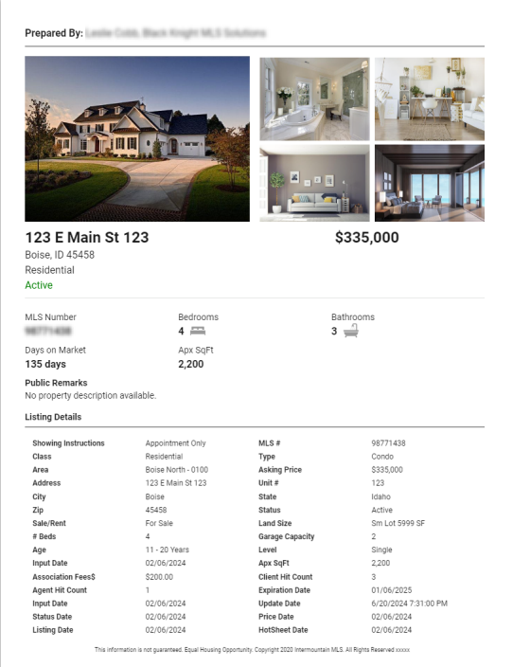
The new print options display in PDF format allowing flexible options for saving, sharing, and making it easy for users to print from their device.
Users may print up to 10 listings at one time.
Note: Any options to print legacy reports from Paragon Professional will continue to be available.

New Option to Show Checked Results
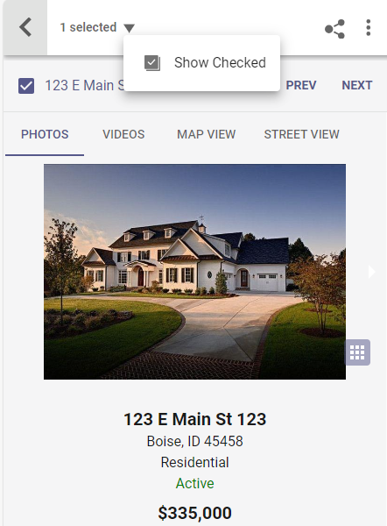
From any property search results set, once any listings have been selected, users will now see a new option next to the selected-count.
This down arrow, or caret icon, allows users to reduce the visible results to only those selected listings.
When “Show Checked” is enabled only the selected listings appear in the view and an additional option appears under the caret icon to “Display All”. Selecting “Display All” will restore the results view so that all matching listings are visible again.
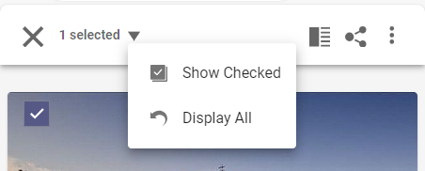

Notification Options Now Available when Saving Search
When creating a new saved search for a Contact, users now have the option to see and modify the Email Notification Settings for that specific search.
After selecting a Contact from the save, or copy, search option, the updated page will load a new section for notification settings.

The types of changes to be included in notifications along with the frequency timeframes may be adjusted. This gives agents quick access to personalize the notification experience while setting up the new search.

Agents can always go to the Contact Buyer Activity to make any additional, or future, adjustments.

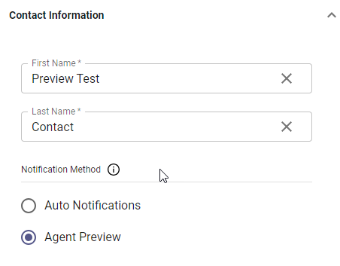
Agent Preview Process now Supported

When creating or modifying a Contact, users now have an option to setup the Notification Method with “Auto Notifications” or with “Agent Preview”.

Selecting Agent Preview allows all new search matches to be sent directly to the agent, not the consumer, so all results can be reviewed before they are sent to the Contact.

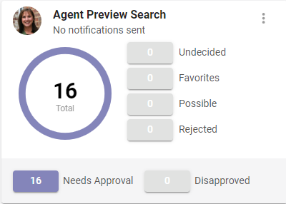

The Buyer Activity section for Contacts configured to use Agent Preview has been updated to include a new section for the listing review process. The updated search cards show matches that need agent approval as well as those that have been disapproved.

Agents can quickly click on the Needs Approval count to review the new matches.

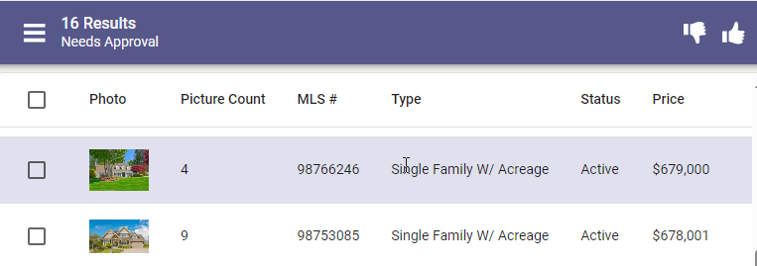
From this Review Spreadsheet users can select individual listings to approve/disapprove or they can update all results at once!

Note: Access to Agent Preview is configurable per organization.

New Share feature from Published Listings
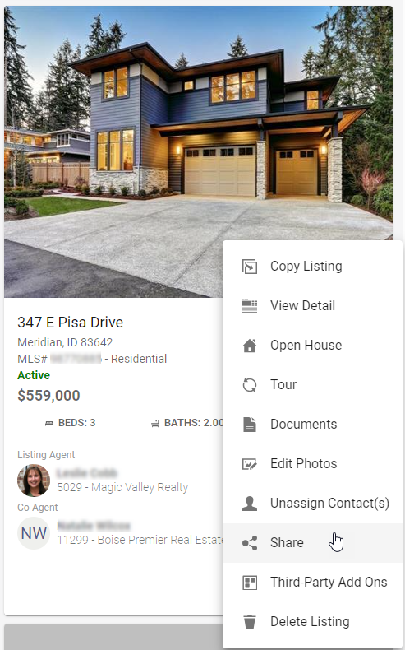
Listing Maintenance supports a unique set of Sharing options, allowing users more flexibility to share their own listings.

The Published Listings overflow menu has been updated to include any Listing Maintenance Sharing options previously enabled for your organization.

Sharing options are configurable per system.

3.9 New Warnings for Restb.ai Potential Violations
This is an optional feature and is not available in all systems.

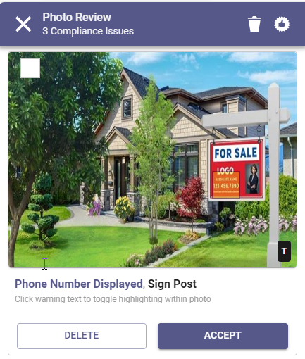
If enabled, when new photos are uploaded through Paragon Connect, those images may be processed through Restb.ai for potential compliance violations. Some violations may be setup to display a warning to users.

If a newly uploaded photo is flagged for a potential violation, users may see a new Photo Review screen. This Photo Review identifies any potential violations and gives users the option to keep the photo or remove it. Once all potential violations are cleared, users can proceed to the next step of reviewing photo labels.

